Virginia

Good Government, Communities of Interest, and Proportional Representation Congressional Plans

Emma Leeds Armstrong
Stanford Law School
April 4, 2022

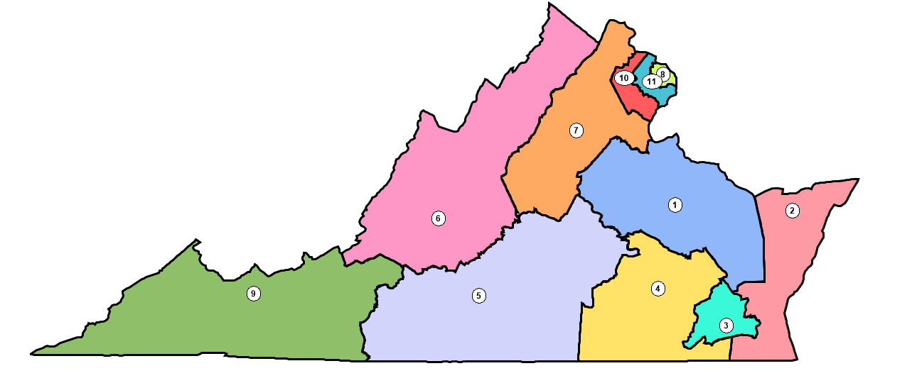
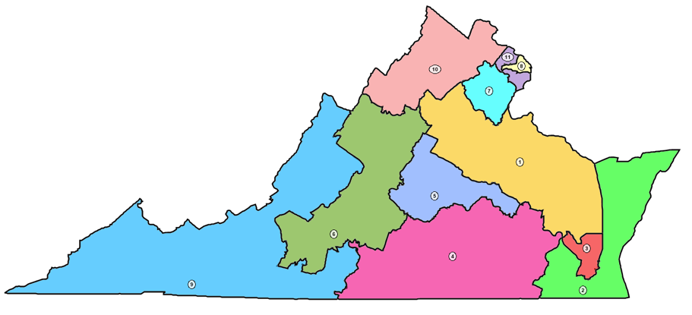

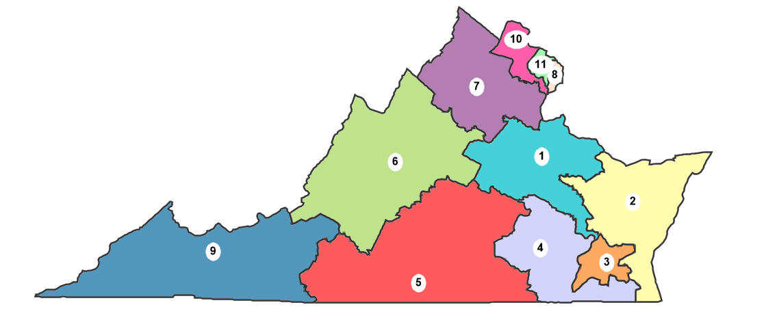
Table of Contents
- Introduction
  - Virginia’s Congressional Redistricting Process
  - Virginia’s Congressional 2020 Redistricting Cycle and Population Changes
  - Federal and State Legal Compliance
    - Equal Representation: Article I § 2 of the United States Constitution and The Code of Virginia
    - Equal Protection and Ability-to-Elect Districts: 14th Amendment, VRA § 2, and The Code of Virginia § 24.2-304.04
    - Compactness and Contiguity
    - Communities of Interest
- Plan 1: Good Governance Map
  - Redistricting Principles and Map Summary
  - Map Explanation
  - Tradeoffs
- Plan 2: Communities of Interest Map
  - Redistricting Principles and Map Summary
  - Map Explanation: Communities of Interest
  - Compactness and Political Subdivision Splits
  - Tradeoffs
- Plan 3: Political Representation Map
  - Redistricting Principles and Map Summary
  - Map Explanation: Partisan Considerations
  - Compactness and Political Subdivision Splits
  - Tradeoffs
- Conclusion
- Appendix

Introduction
This paper presents three alternative plans for the 2020 Virginia redistricting cycle: a communities of interest plan, a good government plan, and a proportional representation plan. The first plan is a good government map. That plan strictly adheres to constitutional and statutory requirements while attempting to draw compact, coherent districts and minimizing county, city, and, to a lesser extent, communities of interest splits. The second plan is a communities of interest plan. This plan aims to maximize the number of intact communities of interest within one congressional district. The third plan is motivated by proportional representation and aims to best reflect the underlying partisan division in Virginia.
Virginia’s Congressional Redistricting Process
Historically, Virginia’s congressional maps were drawn by the State Legislature. In 2010, new congressional maps passed through the Republican State Legislature, were signed into law, without issue, by Republican Governor Bob McDonnell, and received preclearance from the Department of Justice. Although Governor McDonnell solicited the advice of five citizens for that cycle, the Legislature relied on its own maps and ignored the advice of the citizen commissioners.

Virginia’s Congressional Plan Enacted in 2012
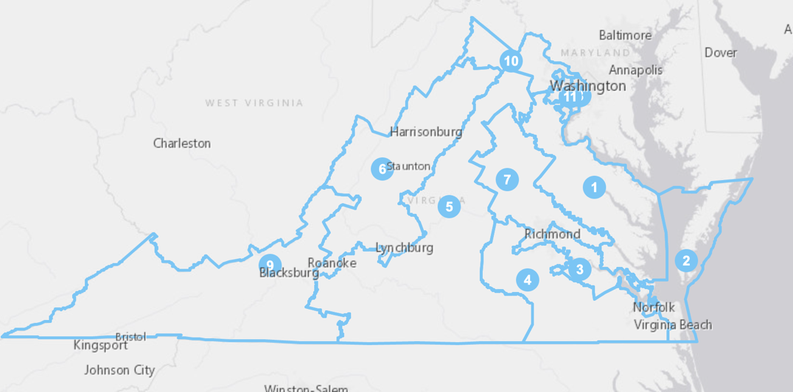

The 2010 congressional plans later faced a successful legal challenge, Personhuballah v. Alcorn, in which the Court struck down the plan for its unjustified predominant use of race. The Court brought in Bernard Grofman as Special Master to redraw the problematic districts within the plan. Calls for reform to Virginia’s redistricting process have complained of excessive city and county splits that contribute to intense partisan divides.
Virginia’s Congressional Plan Post-Personhuballah
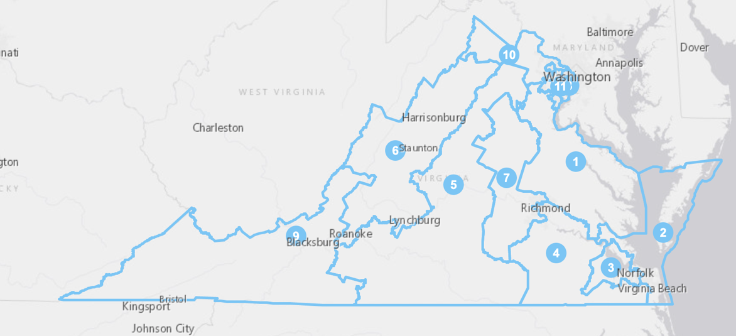
Virginia’s Congressional 2020 Redistricting Cycle and Population Changes
Between 2010 and 2020, Virginia’s population grew 7.9%. Even so, the state retained its 11 congressional districts. However, demographic trends mandated significant adjustments to the existing maps to comply with one-person, one-vote requirements. Since 2010, Virginia saw continued, extensive population growth in urban and suburban areas, especially in the Northern and Northwestern regions of the state. Loudon County, in the D.C. suburbs, grew by 35%, or 108,000 people, leaving its 10th Congressional District with significant deviation from ideal population value. Meanwhile, the former 5th (stretching from the top of the state to its southern border), the 2nd (Chesapeake Bay area counties), and 3rd (the majority-minority district tracking the Hampton Roads Beltway) Districts deviated at least 3% under the ideal population value.
As a result, voters needed to be shifted from the D.C. suburbs towards the Southside and southeastern corner of the state. These regions span the entire North-South distance of the state, presenting the major challenge of Virginia’s 2020 cycle. The state’s largest racial minority, Black Virginians, only grew 9% over the last decade, modest in comparison with the 40-plus% gains seen by Hispanic and Asian populations. Nevertheless, Black Virginians make up the largest racial minority in Virginia at 19.9% percent of the state population. They primarily reside in Richmond, which saw only modest topline population growth since 2010, and Hampton Roads, which saw population decline since 2010. Adjusting for this modest population growth amongst Virginia’s Black community presented another challenge.
Separately, Virginia drastically changed its redistricting process in this cycle. 2020 brought reform in the form of an independent redistricting commission to lead redistricting. However, the Virginia Redistricting Commission could not agree on a single plan, so the Virginia Supreme Court delegated the process to two experts, Democrat-nominated Bernard Grofman and Republican-nominated Sean Trende. The Court accepted the Special Masters’ map in January 2022. Because the 2020 redistricting cycle in Virginia had already concluded by the time the plans in this paper were drawn, this paper will compare its three alternative plans both to the Grofman-Trende plan enacted this cycle and the 2016 court-ordered plan in place before.
Federal and State Legal Compliance
Equal Representation: Article I § 2 of the United States Constitution and Code of Virginia
Both the Constitution and the Code of Virginia impose equal representation constraints. Congressional districts must have “. . . nearly as practicable” equal populations. Similarly, Virginia law requires that “[d]istricts shall be so constituted as to give, as nearly as is practicable, representation in proportion to the population of the district.
In all three plans presented in this paper, all districts are compliant with one-person, one-vote. Based on the 2020 census of Virginia’s population, the ideal size of each of the eleven districts is 784,672 people. As such, all districts within these plans were kept in a range between 784,671 and 784,673. In other words, each plan contains no more than a one-person deviation between districts. In this respect, this plan is superior to the Grofman-Trende plan, which deviates from the ideal value in every district by anywhere from 306 to 1,797 people.
Equal Protection and Ability-to-Elect Districts: 14th Amendment, VRA § 2, and Code of Virginia § 24.2-304.04
The Code of Virginia § 24.2-304.04 Clause 3 mandates compliance with the 14th Amendment of the Constitution, the Voting Rights Act of 1965 Section 2, and “relevant judicial decisions relating to racial and ethnic fairness.” The Equal Protection Clause of the 14th Amendment guards against vote dilution or racial gerrymandering. Race can only rarely be used as the “predominant factor” in redistricting, meaning race cannot ordinarily be used over race-neutral redistricting principles. In the case that race is the “predominant factor” used in redistricting, a court will apply strict scrutiny in reviewing the legality of that map.
Separately, VRA Section 2 violation enables protected classes to have the same opportunity as “other members of the electorate to participate in the political process and to elect representatives of their choice.” The Virginia Code similarly requires that “[d]istricts shall be drawn to give racial and language minorities an equal opportunity to participate in the political process and shall not dilute or diminish their ability to elect candidates of choice either alone or in coalition with others.” VRA Section 2 is triggered when three Gingles “prongs” are met. Under Gingles, a minority community must be “sufficiently large and geographically compact to constitute a majority in a single-member district,” “politically cohesive,” and the white majority must vote sufficiently as a bloc to enable it . . . to defeat the minority's preferred candidate.” Where these criteria met, and some “Senate Factors” establish whether the practices in question result in prohibited discrimination, race may be used as a predominant factor, so long as its use is narrowly tailored to comply with the VRA.
As in North Carolina in Gingles, Virginia has a history of discrimination against Black people in nearly every arena, including, but extending well beyond, voting. Specifically, education, employment, housing, and healthcare have all been areas in which Black Virginians experienced state-led discrimination. As such, the Senate Factors are present. As are the Gingles prongs because Black Virginians reside mainly in the Hampton Roads and Richmond areas and very often participate in racially polarized voting. As such, these racial fairness laws apply with greatest force to Virginia’s 3rd and 4th Districts, which contain Hampton Roads and portions of Richmond, respectively in all three proposed plans. Originally, the 3rd District was created in 1992 after the Department of Justice mandated the creation of a Black-majority district encompassing majority Black precincts in Richmond and Hampton Roads. These two districts took their currrent forms, however, in 2016 when the Personhuballah Court determined that a 55% Black voting age population (VAP) in the 3rd District was not sufficiently narrowly tailored to achieve the goals of the Voting Rights Act. The court-drawn map shifted Richmond and Petersburg precincts into the 4th District to avoid “stacking.” Post-2016, the 3rd District roughly traced the Hampton Roads Beltway in Southeast Virginia and was a majority-minority, but plurality white district. Since 1992, it has consistently elected the candidate of choice of the Black population, Representative Bobby Scott, originally the only Black representative in the state. The Court held that Black VAP population at or above 45.3% in the 3rd would enable Black voters to elect their candidate of choice (the 2016 map reached 47.2%). The 4th District stretches from the Richmond-Henrico County area in the north to the Chesapeake area in the southeast and Brunswick County in the southwest. It is also a majority-minority, but plurality white, district. Since 2016, it has also consistently elected the candidate of choice of the Black population, currently Representative Donald McEachin, the only other Black representative from Virginia besides Scott. The Court held that Black VAP population at or above 40% (which it had in the 2016 maps) would enable Black voters in this district to elect their candidate of choice.
Communities of Interest Plan with VTDs shaded by proportion of VAP identifying as Black
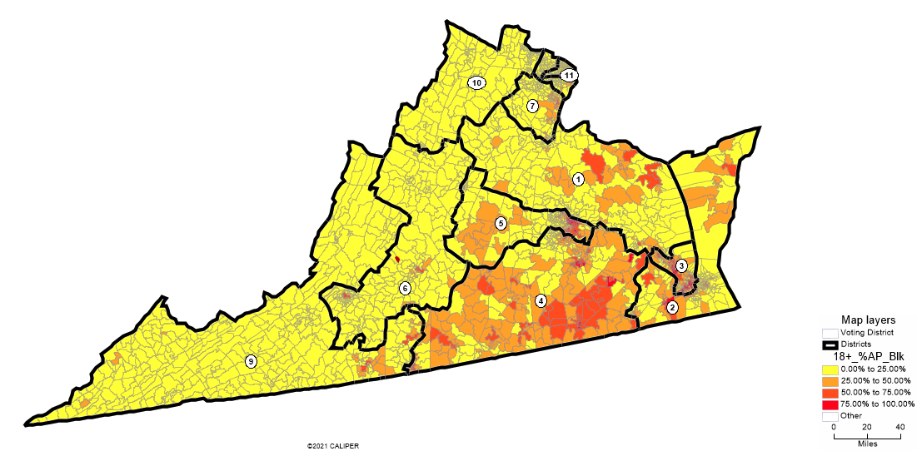

To comply with the Shaw mandate, the two ability-to-elect districts, the 3rd and 4th Districts in all three proposed plans, were drawn first according to least change principles, adjusting the existing district lines only to reach population equality, and second according to good government principles so that subdivision splits occurred along county, municipality, and highway lines. For all three proposed plans, racial data was later considered to ensure that Black population did not fall below the levels approved by the Court in Personhuballah. For the Good Government and Proportional Representation Plans, the map gives minority communities opportunities to elect their candidate of choice without packing an excessive number of such community members into a single district. For the Good Government Plan, Black VAP in the 3rd District is 47%, and 40.2% in the 4th, exceeding the Court’s required floors for those values. For the Proportional Representation Plan, Black VAP in the 3rd District is 45.3%, and 41.3% in the 4th, again, both permissible under the Court’s finding. These plans are comparably successful with The Grofman-Trende Plan, which has Black VAP at 44.5% in the 3rd and 45.26% in the 4th.
However, the Community of Interest Plan is notably vulnerable to a VRA Section 2 challenge because the 4th District will likely fall below a level sufficient to give minority voters the opportunity to elect their candidate of choice. The 3rd District has a Black VAP of 44.7%, exceeding the level Grofman and Trende found necessary for the Black community to elect their candidate of choice, but below Personhuballah levels. At 33.6% Black VAP, the 4th District falls well below both Grofman-Trende and Personhuballah benchmarks and would be unlikely to pass VRA muster. Compliance with the VRA-Personhuballah levels for the 4th District necessitates splitting Black communities in Richmond and combining them with rural, white communities in Southside, in conflict with the principles of keeping such communities intact that motivated the Communities of Interest Plan in the first place.
Compactness and Contiguity
Clause 6 of the Code of Virginia provides that “Districts shall be composed of contiguous territory, with no district contiguous only by connections by water running downstream or upriver, and political boundaries may be considered.” All districts in all proposed plans comply with this requirement. In all three plans, however, the 2nd District presents a minor problem for functional travel continuity. Because the District in all plans is composed of the Delmarva Peninsula and portions of the Chesapeake Bay coastline, there is necessarily a travel contiguity issue under most circumstances. Additionally, the Great Dismal Swamp presents a second functional travel continuity problem in the Communities of Interest Plan. These travel contiguity issues persist across Grofman-Trende plan and in the 2016 maps due to Virginia’s natural geography.
Clause 7 provides that “Districts shall be composed of compact territory and shall be drawn employing one or more standard numerical measures of individual and average district compactness, both statewide and district by district.” All districts in all plans attempted to maximize compactness to the extent possible. All available compactness measures were considered and have been included in this plan.
Communities of Interest
The Statutory Criteria also provides that “[d]istricts shall be drawn to preserve communities of interest. Communities of interest are discussed in detail below in the description of the second plan, but all plans attempted to keep such communities intact to the extent possible. Where the Communities of Interest plan considered every sized community of interest, from neighborhoods to entire geographic regions, the Good Government and Proportional Representation plan plans paid special attention to Virginia’s largest communities of interest, including the Appalachian, Shenandoah, Blue Ridge Mountains, and Tidewater Regions, as well as the D.C. Suburbs, and other major urban areas.
- Good Government Plan
Redistricting Principles and Map Summary
Overall, this plan succeeds at attempting to draw compact, coherent districts and minimizing county, city, and communities of interest splits. As discussed above, it complies with all federal and state requirements, increases Black populations in the 3rd and 4th Districts relative to 2016 levels, and generally follows county and municipal lines, or else highways and other natural boundaries. However, prioritizing compactness and one-person, one-vote and VRA compliance necessitated a higher number of political subdivision splits than was ideal. The 2016 plan splits 14 counties, while the Grofman-Trende plan splits 9 counties. This Good Government plan splits only 13 counties, making it more compact and cohesive than the previously enacted plans but less so than the currently enacted ones. However, the Grofman-Trende is not one person-one vote compliant and therefore did not require as many subdivision splits. This illustrates the difficult tradeoff between seeking perfectly equal representation and keeping political subdivisions intact. I decided to prioritize the former because I believe vote dilution is a greater harm than pulling some, but not all, county residents into a different voting district. Using Reock scores, this map is similarly or more compact than the Grofman-Trende Plan in all but 3 districts: the 5th and 7th, 11th. Given the Grofman-Trende plan is twice as compact as the existing plan, this plan is the most compact of all three.
Map Explanation
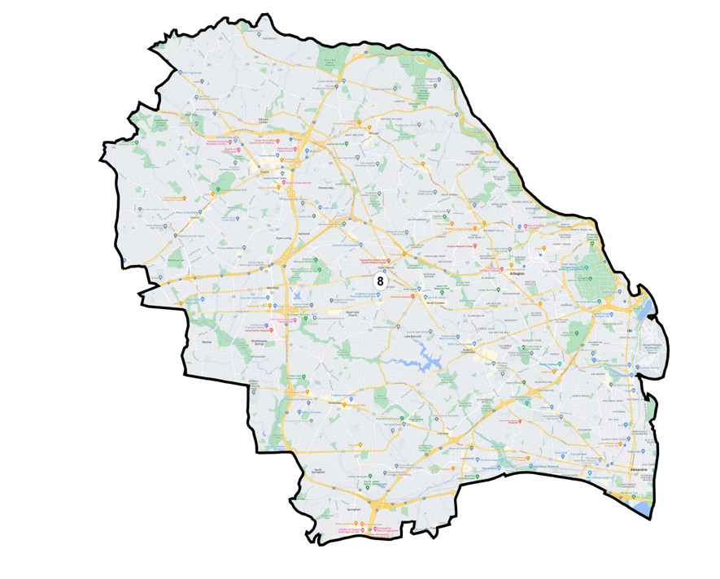
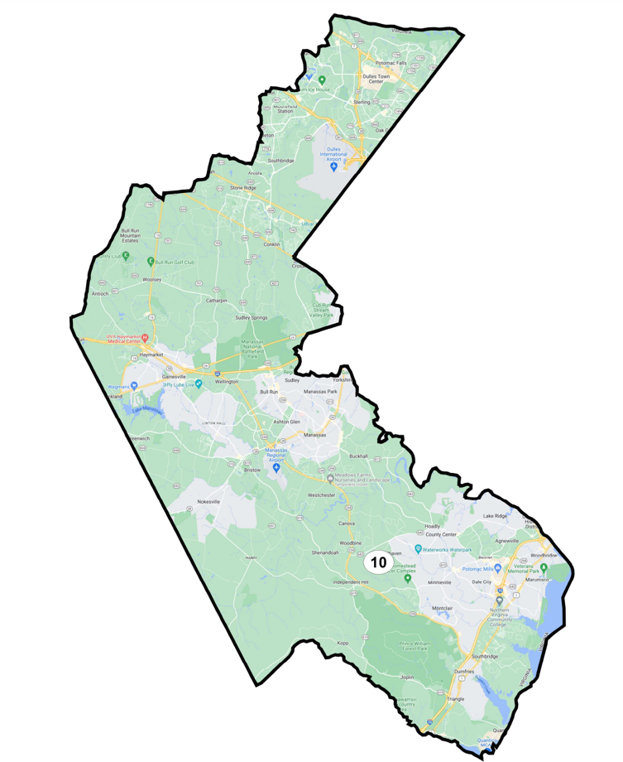
D.C. Suburbs and Northern Virginia : Districts 8, 10, 11

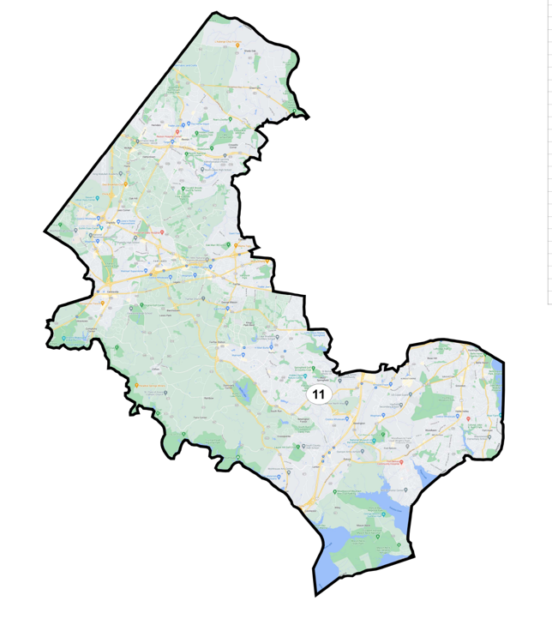
I began by drawing the urban and suburban districts surrounding Washington, D.C.: the 8th, 10th, and 11th Districts. To best preserve communities of interest and draw clean lines, I drew these districts as three nested within each other. I began with the 8th District, tracing the Capital Beltway (Interstate 495) as closely as possible. Because the area is densely populated, the 8th District contains only Arlington and parts of Fairfax. The 11th contains Fairfax exclusively, while the 11th contains Fairfax, and portions of Prince William and Loudon counties. In drawing these districts, I minimized municipality splits amongst Northern Virginia towns, keeping Franconia, Sterling, Reston, and Lorton entirely within their own districts.
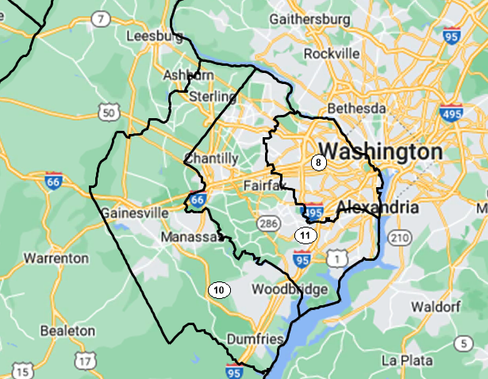
As designated by the University of Virginia’s Weldon Cooper Center, Northern Virginia consists of Arlington, Fairfax, Loudoun, Prince William, Clarke, Warren, Rappahannock, Culpeper, Spotsylvania, Stafford and King George counties. While this area has enough population to fill four congressional districts, the 2016 map divides their populations over seven. In this plan, those counties are split amongst six districts and are split intentionally according to cultural similarities amongst districts. Arlington and Fairfax counties fall entirely within Districts 8 and 11. Loudon is split between District 7 and 10 and combines with Prince William to make up District 10.
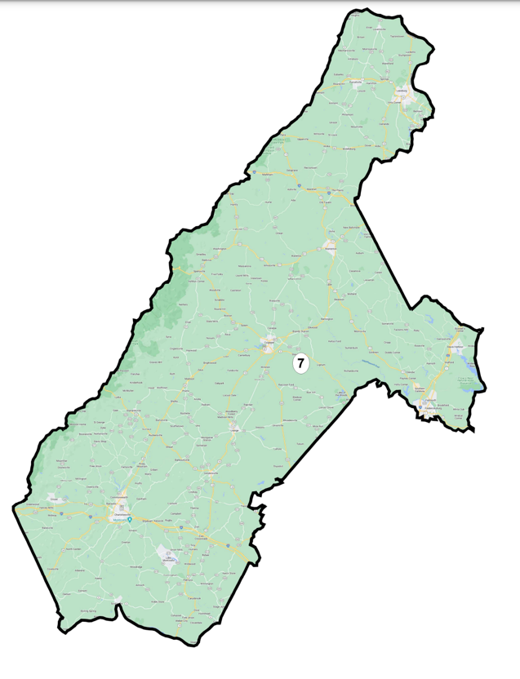
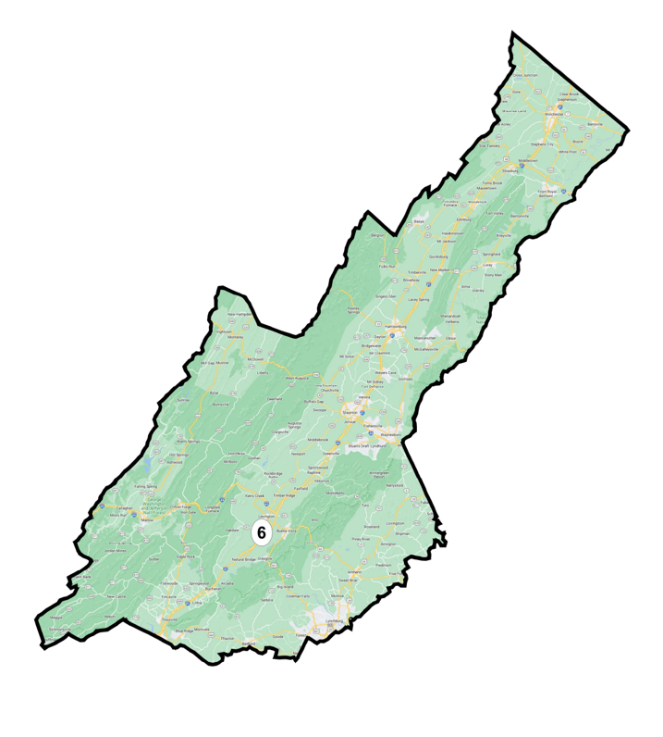
East and West of the Shenandoah: District 6 and 7
The 6th District contains counties east of the West Virginia border, west of the Shenandoah Mountains, and north of the Blue Ridge Mountains. The Blue Ridge serves as a good functional divider with the 9th District as there are very few roads that permit their crossing. Clarke and Warren, technically Northern Virginia counties, are placed in District 6 because of cultural ties to the Shenandoah.
The 7th District takes a new form. Whereas it historically stretched from Culpeper southeast to Nottoway, I aimed to create a district that instead recognized the “Route 29 corridor,” connecting the Central Virginian exurban residents of Charlottesville with those of Culpeper. Charlottesville has historically resided in the 5th District, which stretched from the state’s northernmost point to its southernmost, connecting culturally disparate areas. Instead, I included Fredericksburg and Stafford County, also a suburban-exurban region of the state to reach population equality without disrupting cultural continuity.
District 9: Appalachia
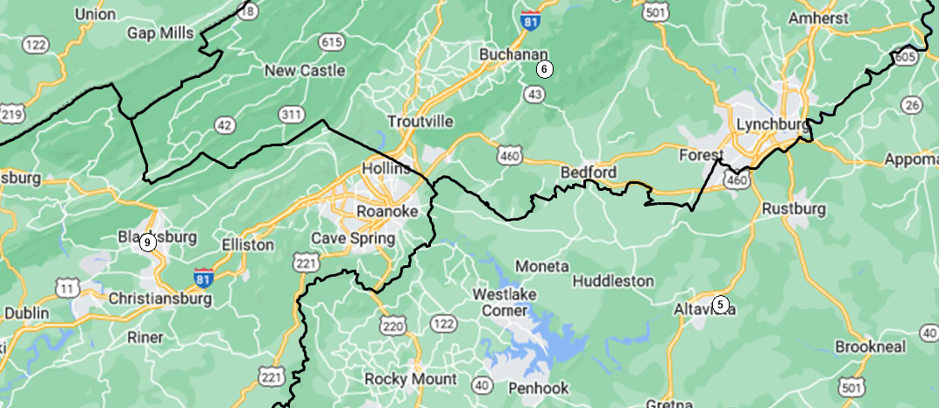
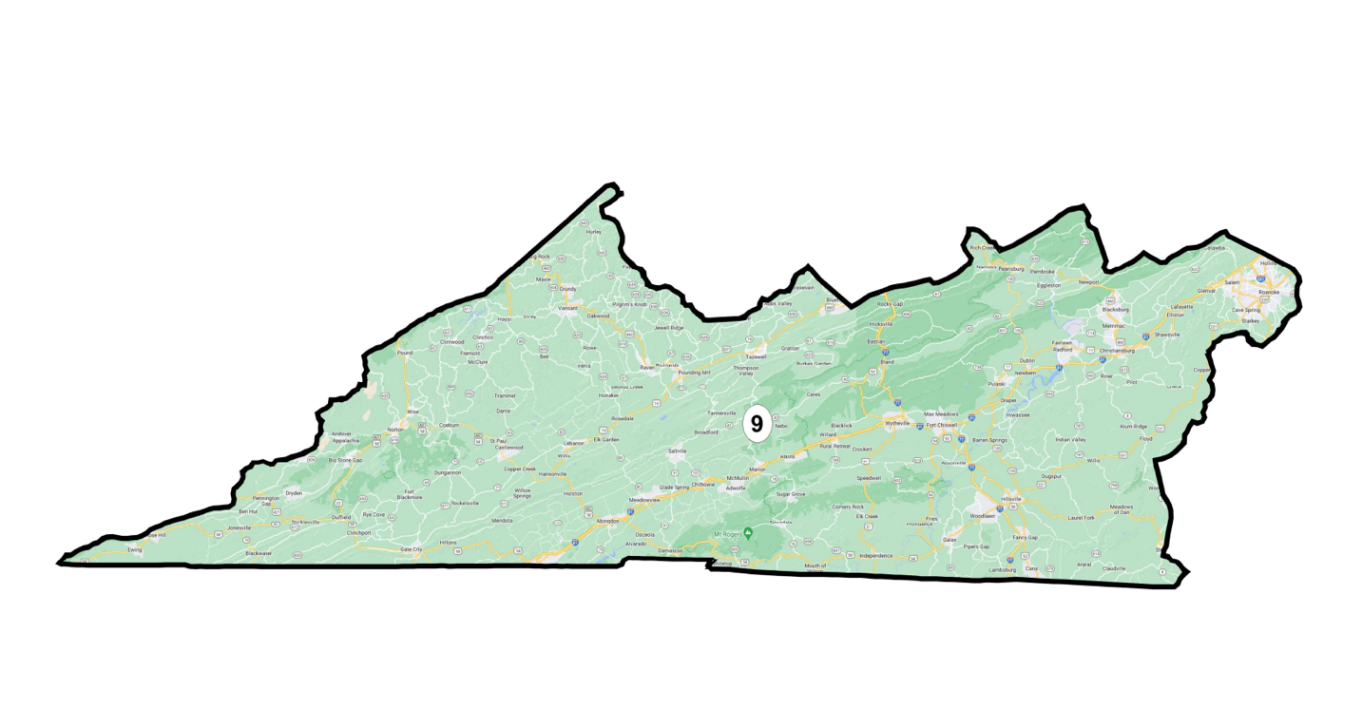 The 9th District captures the Virginia panhandle. It is composed of the majority of Appalachian counties south of the Blue Ridge. Unlike the 2016 and the Grofman-Trende maps, it places Roanoke and Salem together within their surrounding Roanoke County, while still ensuring population equality.
District 2 and 3: Tidewater
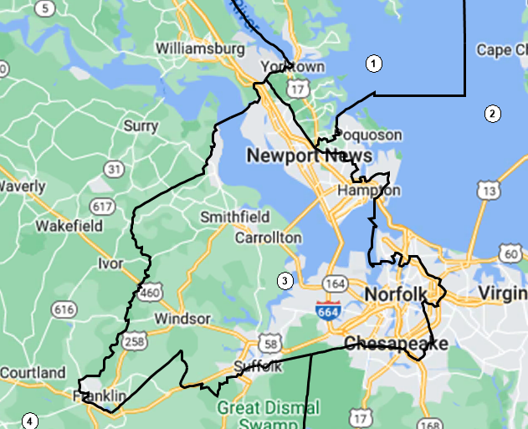
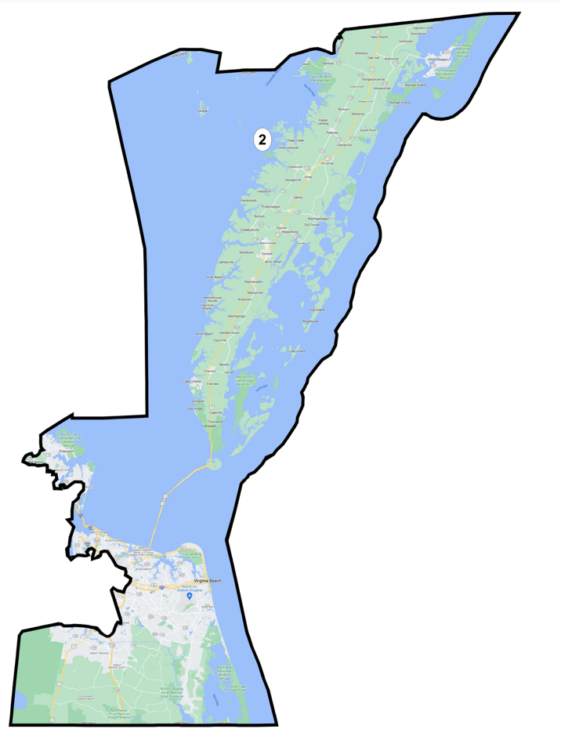
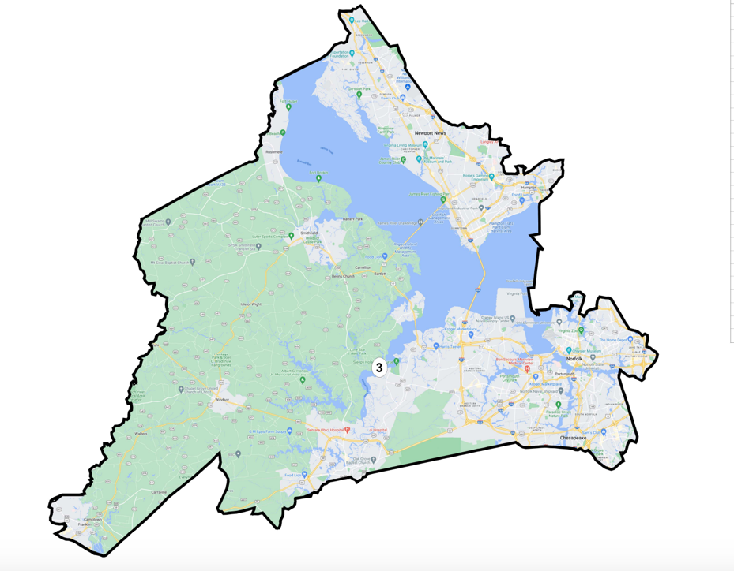
As discussed above, District 3 consistently elects the candidate of choice of the Black community. I drew a compact district partially tracing the Hampton Roads Beltway, keeping the cities of Newport News and Portsmouth intact and splitting parts of Hampton, Norfolk and Chesapeake City roughly along the Beltway. I then pulled in Suffolk City and Franklin to reach population equality. The District as drawn in this plan is both more compact than the Grofman-Trende plan and increases the Black VAP to 47% over their 44.5%.
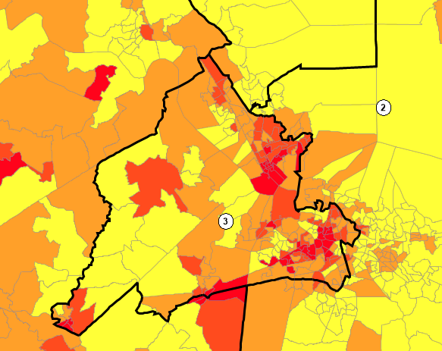
3rd District with VTD colored by % Black VAP (yellow represents 0-25% Black, deepest red represents 75-100% Black VAP)
I then drew District 2 to combine the Delmarva Peninsula with the remaining portions of Hampton, Norfolk and Chesapeake City, and the entire Virginia Beach area. I also had to place Poquoson City and a small portion of York in District 2 for population reasons. However, these counties are all firmly Tidewater in their, sharing the Chesapeake Bay as source of employment. Many of the people who live in these areas commute into the Hampton Roads area for work. Drawing the map this way also includes three Naval bases and their surrounding communities in the 2nd District.
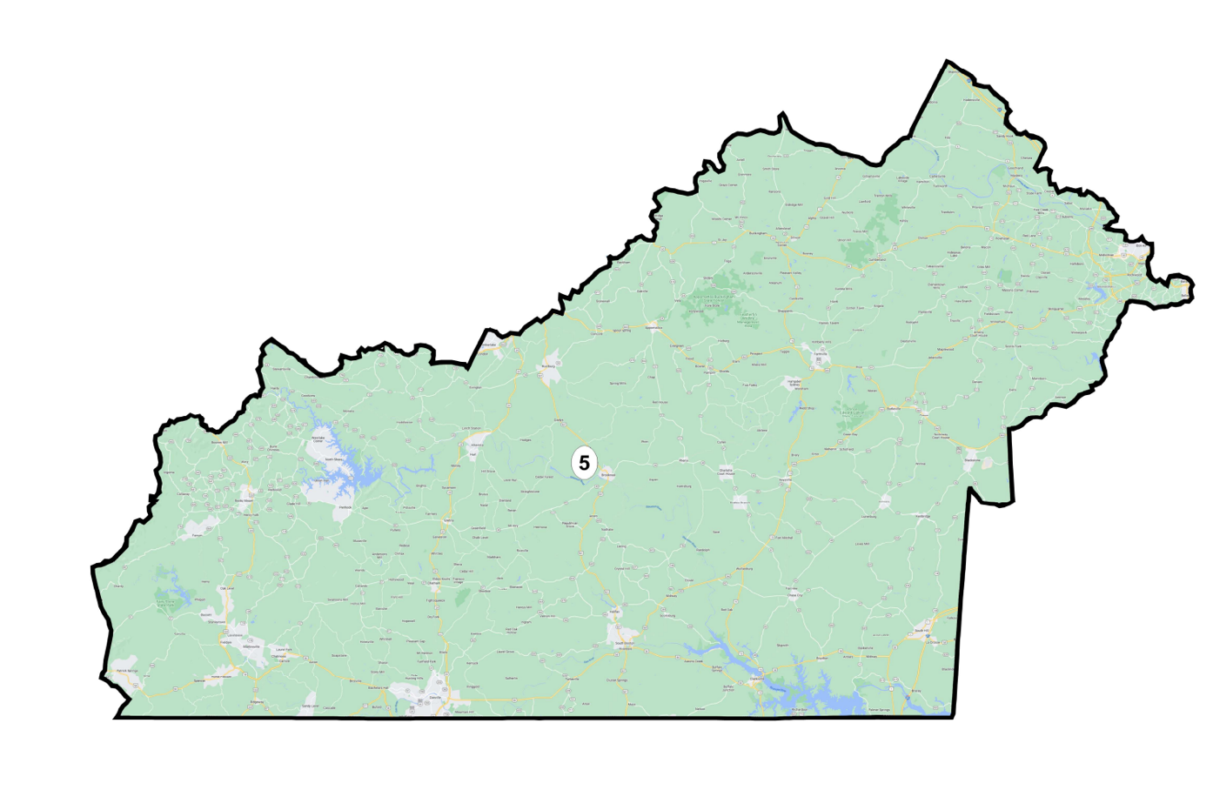
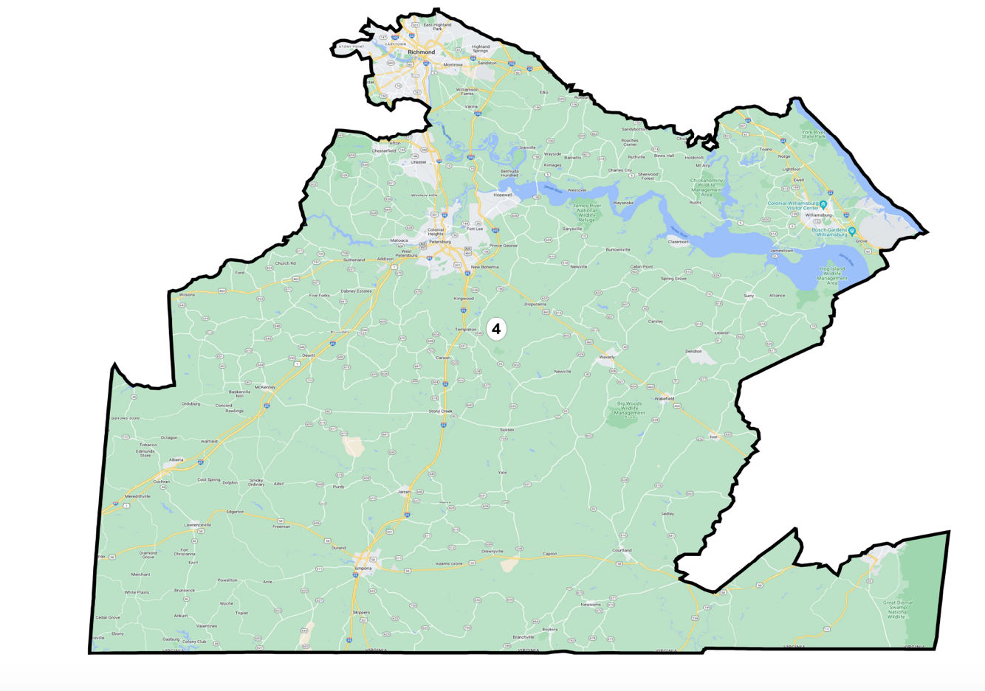
Richmond and Southside: District 4 and 5
I next drew District 4. Its northernmost point is the southeastern suburbs of Richmond and it includes major cities Williamsburg and Petersburg. While it would be preferable to keep Richmond and its suburbs within a single district, doing so would present dilution issues because Black voters would only make up 30% of VAP. Thus, it was necessary to construct a district which combined other urban centers. The resulting Black VAP was 40.2%, legally compliant and likely high enough to permit the Black community to elect their candidate of choice.
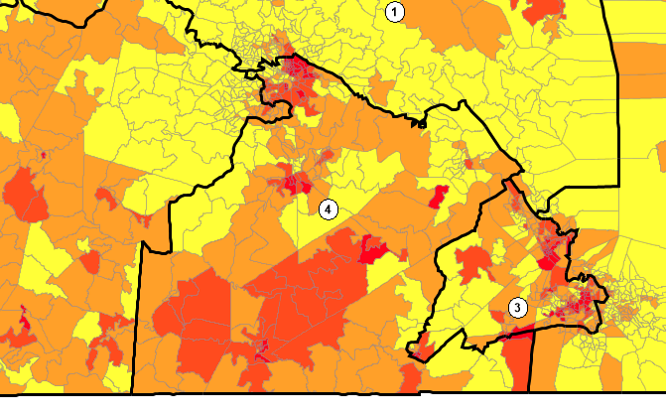
4th District with VTD colored by % Black VAP (yellow represents 0-25% Black, deepest red represents 75-100% Black VAP)

I drew District 5 as a counterpart to 4, containing the remaining southwestern suburbs of Richmond (located in Chesterfield County). District 5 has historically been a Southside district, rooted in Danville, but I needed to include Martinsville and parts of Richmond to reach equal population. Even so, the District is far more compact and culturally coherent than the former 5th District, which essentially stretched from North Carolina to Maryland.
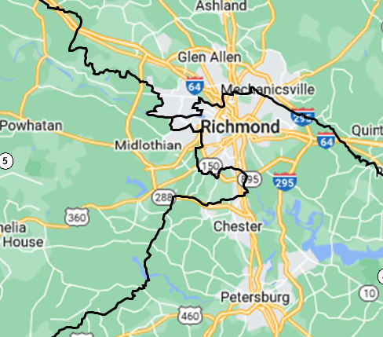
Richmond Divided by the 4th and 5th Districts in the south and 1st District in the north

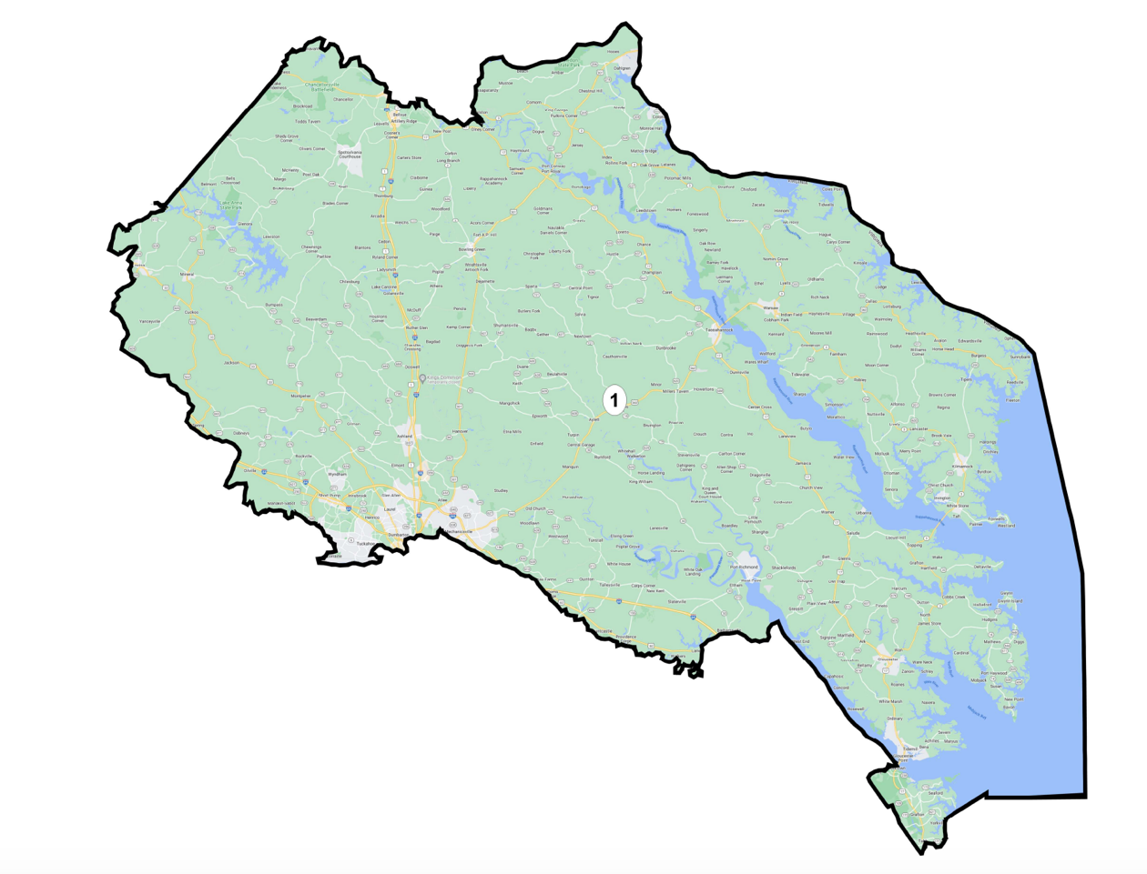
Northern Virginia and Tidewater: District 1
I last drew District 1. Northern Virginia counties Spotsylvania and King George were placed in District 1 because of their locations on the Rappahannock and Mattaponi Rivers, Chesapeake Bay tributaries which touch most counties in the 1st District. This district is firmly rooted in the Tidewater Region, with some Northern Richmond suburbs included for population equality purposes. Unlike the Grofman-Trende Plan, this Plan does not need to pull in culturally disparate Piedmont Region counties (now located in District 7).
Tradeoffs
First, this map departs notably from Virginia’s preexisting map, especially in the 5th , 7th, and 10th Districts. I am concerned that redistricting practices placing certain counties in certain districts are so entrenched that there may be community or candidate-led complaints about the change. However, because there is no legal requirement for least change, I opted to make districts more culturally cohesive in a way I hope makes up for the departures.
Second, drawing lines to properly distribute Black voters between the 3rd and 4th Districts meant splitting more cities and counties than was ideal. The Richmond and Hampton Roads areas, besides being densely populated by Black people, is also rife with smaller urban subdivision lines. Respecting these lines would come at the expense of Black voting power and dilute Black communities into districts where they would be less likely to be able to elect their candidate of choice, so I opted to split more municipalities.
- Community of Interest Plan
Redistricting Principles and Map Summary
This plan attempted to maximize the number of intact communities of interest within one district. According to state law, a “community of interest” is a group of people living in a geographically similar area who share social, cultural, and economic interests. The Supreme Court of the United States has included shared media, public transport, local educational and religious institutions as constituting a community of interest.
Incorporating these statutory and judicial definitions, this plan followed the Grofman-Trende approach and utilized both the communities of interest submitted by Virginians to the Virginia Redistricting Commission and those submitted to Representable, a non-profit organization that solicits and digitally stores communities of interest. This plan radically prioritized preserving these communities of interest, at the expense of VRA compliance and political subdivision split minimization. Avoiding cracking Black Richmond-based communities amongst rural, white communities necessitated violating VRA § 2 anti-dilution principles. Additionally, the plan occasionally divides counties to include culturally disparate portions of such counties in more culturally coherent districts. These tradeoffs illustrate the difficulty of uniformly adhering to communities of interest as the driving principle in redistricting.
Map Explanation
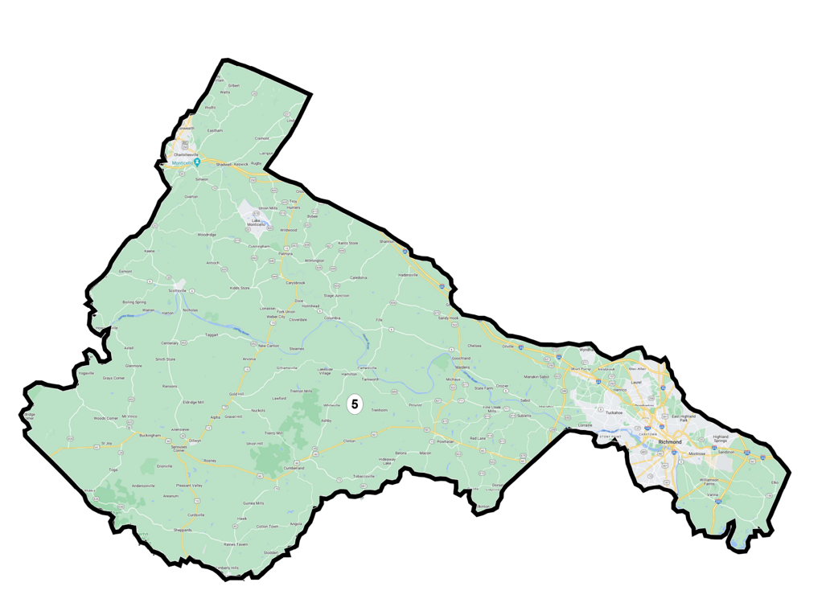
A New Fifth District: I-64 and college towns

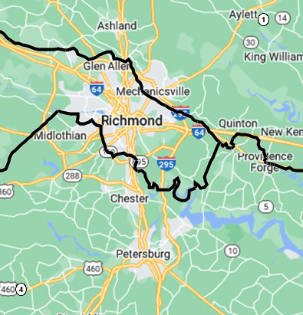
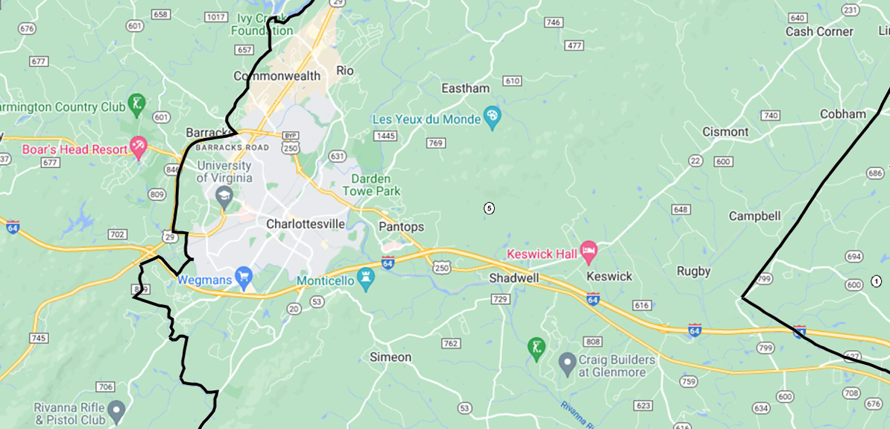

This map was born out of dissatisfaction with the 5th Congressional District and the number of Communities of Interest it disregarded or split. Historically, the 5th District spanned the entire north-south of Virginia, from Danville to Loudon County. Not only were counties throughout culturally disparate, but the District spanned four statewide regions: Northern, Central, West Central, and Southside. By contrast, this map sought to anchor this District in the Piedmont Region, also known as Central Virginia. In the south, only two counties, Buckingham and Cumberland, are included from the Southside Region in order to reach population equality. The 5th District connects the two major cities of Central Virginia, Charlottesville and Richmond via Route 64, which connects them, as the northern bound. Charlottesville and Richmond form a community of interest because they represent two major urban centers, both centered around college campuses. In Charlottesville, the University of Virginia is a central source of employment and education for Albemarle residents. In Richmond, the University of Richmond, Virginia Commonwealth University, and Virginia Union University do the same. The counties between the two are home to residents that work primarily in either city. Route 29 acts as the western boundary line for this district and separates urban Charlottesville from its rural Albemarle County surrounds.
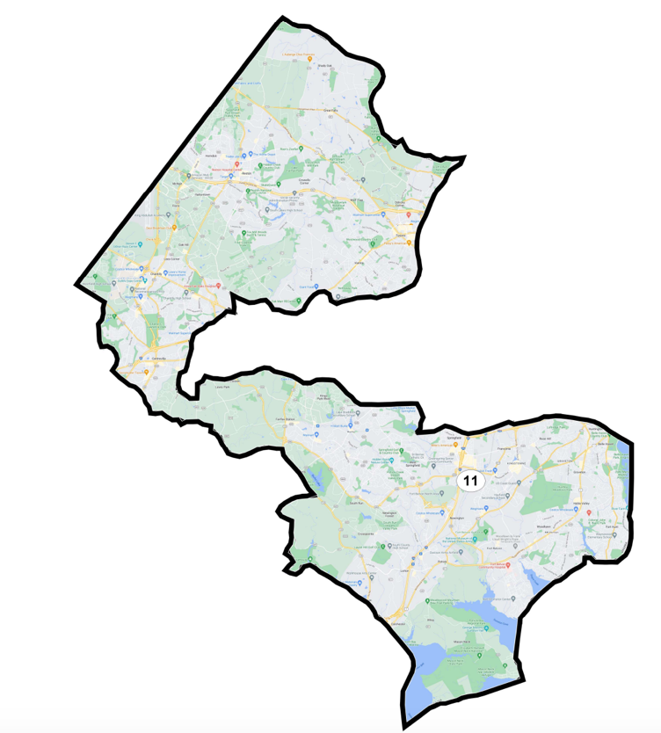
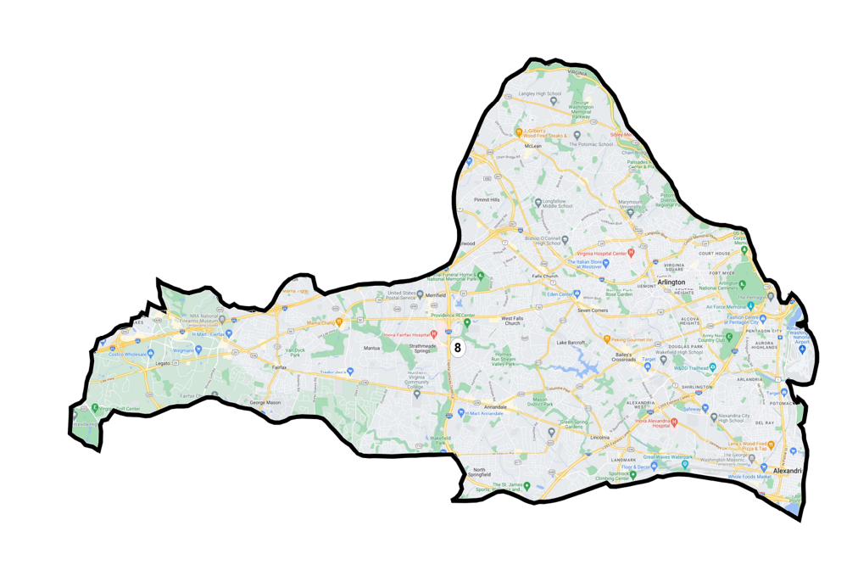
Minimizing Northern Virginia Splits: Districts 7, 8, 10, 11
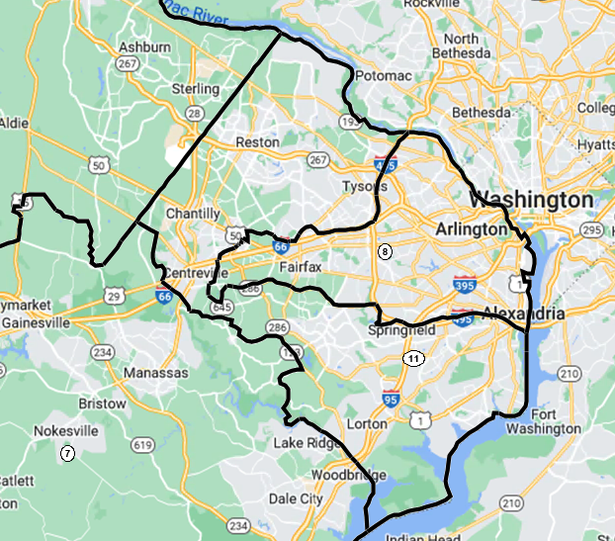
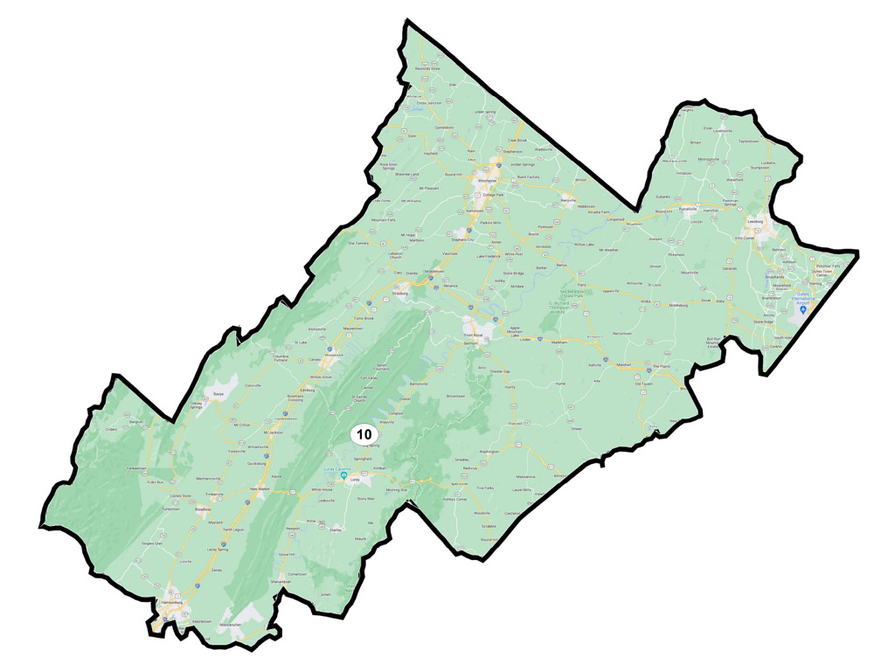
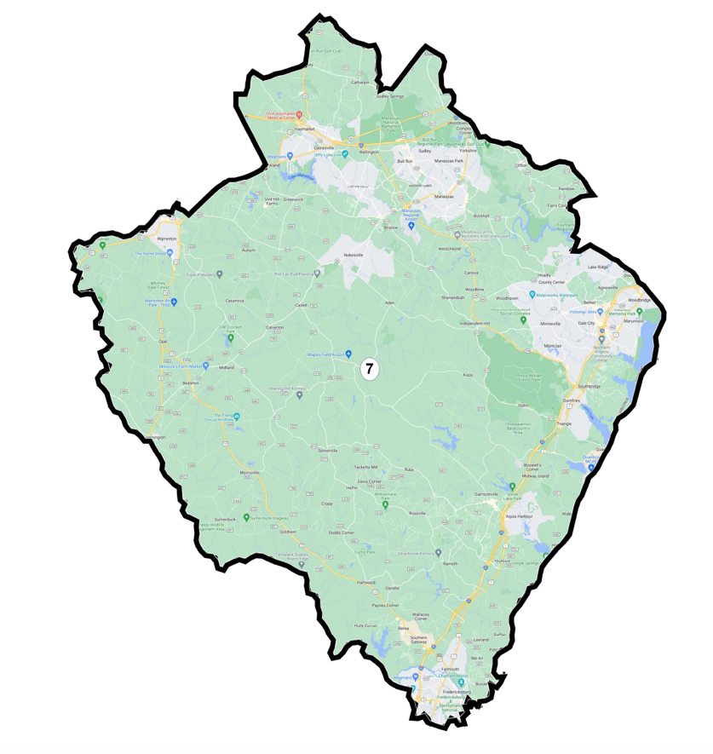
Per the Cooper Center definition, this map splits Northern Virginia counties among only five districts, rather than the seven of the 2016 maps.
I attempted to draw the 8th District entirely within the Capital Beltway, but it was underpopulated by just under 200,000 people. Grouping together small communities of interest from Representable, I built the district out westward along Interstate 66, tracing both that highway and the D.C. Metro Orange Line, both major means of transport for residents of the 8th District into Washington, D.C.. Including the I-66 “tail” makes the District less compact, but I prioritized intact communities of interest, including George Mason University and the Fair Lakes/Fair Oaks area over a compact district.
The 11th District rings the 8th District, incorporating the remainder of Fairfax County into one district. The newly constructed 7th District is anchored in the Quantico Marine Corps Base, including the three counties that touch it: Fauquier, Stafford, and Prince William.
The 10th District accounts for the remaining Northern Virginia counties that abut the Shenandoah Mountains: Warren, Clarke, Loudon, and Rappahannock. Harrisonburg marks the southern border of the District.
Appalachian Region: District 9
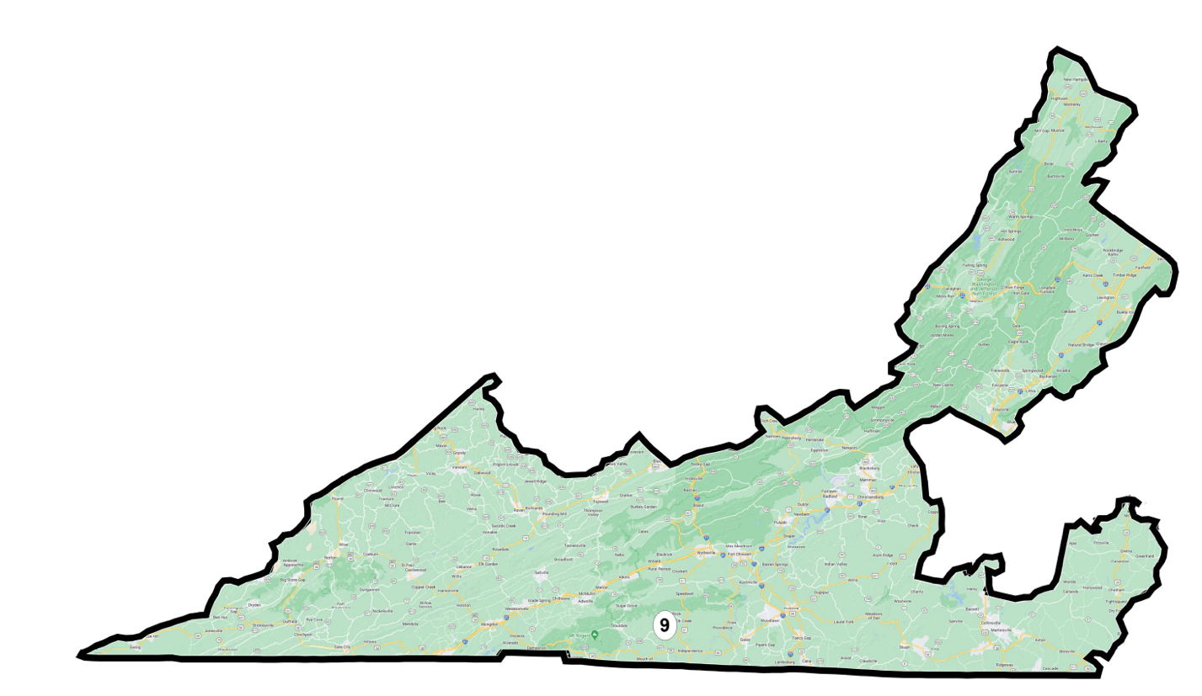 The Appalachian Mountains constitute a significant community of interest. District 9 therefore incorporates every county deemed Appalachian by the United States government. As a result, the district necessarily takes on a strange shape and splits Pittsylvania west of Danville to reach population equality.
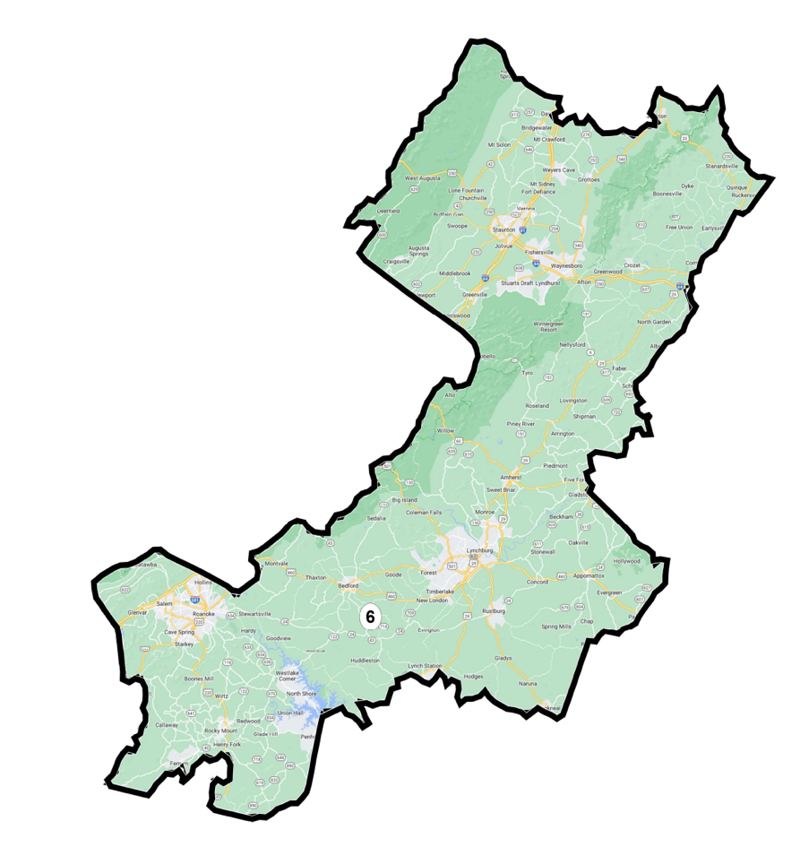
I-81 Blue Ridge District: District 6
The Blue Ridge Mountains and Interstate 81 make up the spine of District 6. Since the Civil War, the Blue Ridge divided Virginia’s districts, so it was used as a southern divider here as well. Major cities within this district, Roanoke, Salem, and Staunton are served by Interstate 81, while Route 29 serves Lynchburg and western portions of Albemarle, therefore making both roads coherent boundary lines for this District.
Black Communities in Southside and Tidewater: District 3 and 4
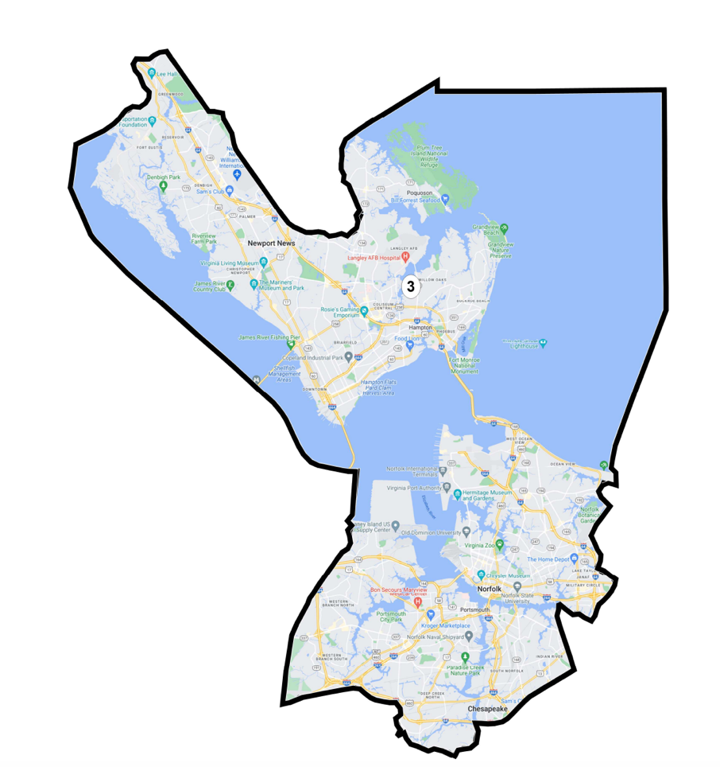
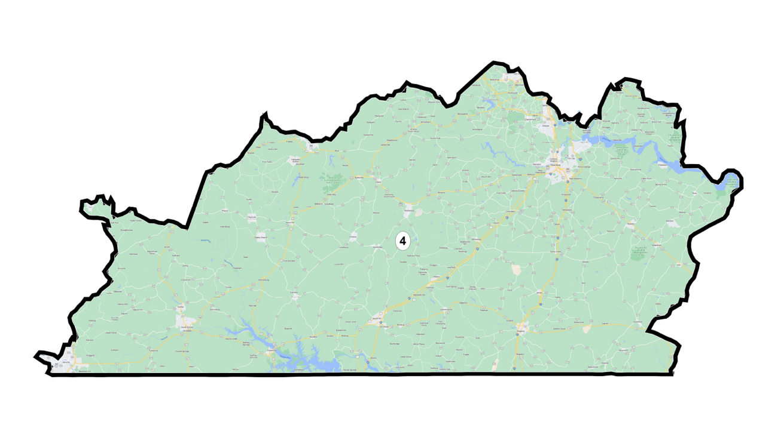The 3rd District once again traces the Hampton Roads Beltway, encompassing Norfolk, Portsmouth, Hampton, and a small segment of Poquoson City. Because there is much cultural contiguity between the 3rd and 2nd District but population necessitates splitting the urban centers of the Tidewater Region, I paid special attention to the Representable communities of interest as there were many small and distinct ones within this area. I drew lines to keep as many as possible intact and looked closely at Google Maps data to avoid splitting neighborhoods and school districts. In so doing, I reached a 47.2% Black VAP, exceeding 2016 levels and those achieved by Grofman and Trende.
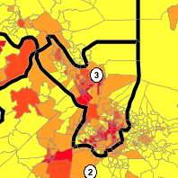
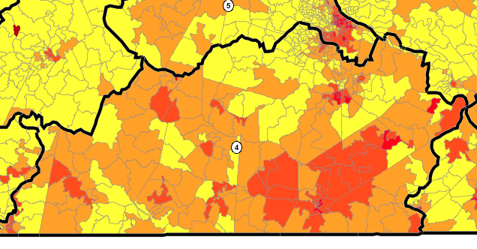
3rd and 4th Districts with VTD colored by % Black VAP (yellow represents 0-25% Black, deepest red represents 75-100% Black VAP)

The 4th District was most problematic from a community of interest standpoint. The 4th District takes on what has historically been the 5th District’s counties in the Southside. Except for Patrick and Henry Counties which are placed in the 9th District and Buckingham, and Cumberland in the 5th, this District mirrors almost exactly the Southside Region. It starts in Danville in the west and stretches to Southampton County in the east. To reach population equality, this District had to include the counties which contain the largely white suburbs south of Richmond: Amelia, Chesterfield, and Dinwiddie. While this combination is not ideal, there are enough Southside Counties and Central Counties that enable consistently intact communities of interest. In other words, this district spans more cultural geography than I was comfortable with, but places two distinct and intact communities of interest within one district together. Furthermore, respecting Richmond’s Black community (largely left intact in the now 5th District) necessitated splitting the broader Richmond metropolitan area and including the white suburbs, especially Chesterfield in the 4th District. However, finding population equality through this strategy necessitated VRA noncompliance. With a 33.6% Black VAP, the 4th District falls well below both benchmarks and would be vulnerable to vote dilution claims.
1st and 2nd Districts: Eastern Virginia and Tidewater
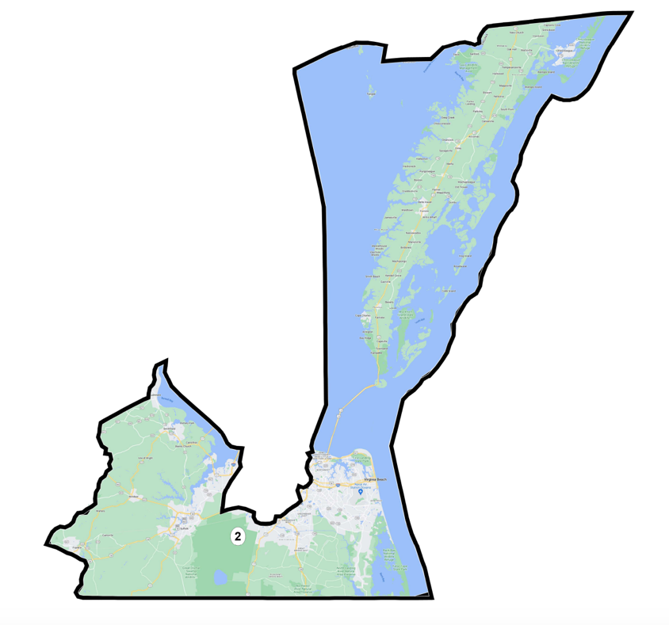
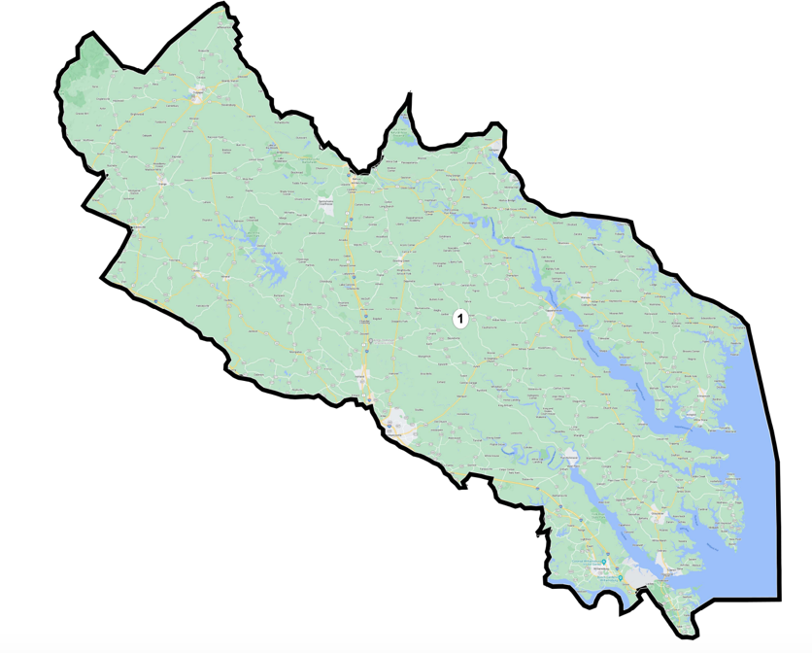
The 2nd District incorporates any Hampton Roads Region counties not included in the 3rd District and combines them with Delmarva Peninsula Districts. By constraining the 3rd District’s southern border to those of Portsmouth and Norfolk, and taking minimal portions of Chesapeake City, the 2nd District can consist of those cities’ suburbs plus the city of Virginia Beach.
The 1st District is also problematic under communities of interest principles. I dislike that it spans the Tidewater and Central Virginia regions, but there were generally fewer communities of interest submitted to the Virginia redistricting commission and Representable for consideration. Additionally, I adopted the same approach I did in District 4, combining two culturally disparate, yet politically strong, areas into one District. Central Virginia counties are included in groups, as are Tidewater ones, so there is no issue of “packing” a single county amongst many culturally disparate ones. Additionally, the 1st District in this plan looks much like that of the 2016 plan, and the new additions to the district would be unlikely to upset the representativeness of this district.
Compactness and Political Subdivision Splits
This plan only contains 11 splits, outperforming the 14 splits in the 2016 map and underperforming the Grofman-Trende Plan, which only has 9 splits. As for compactness, it outperforms the Grofman-Trende plan on Reock scores in a majority of districts: all but the 4th, 5th, 8th, and 11th Districts.
Tradeoffs
I created this map first by grouping large communities of interest: Northern Virginia, Appalachia, Charlottesville-Richmond, and Hampton Roads. I then controlled for population equality and compactness, using smaller communities of interest on Representable to guide my choices about where and how to split subdivisions. As a result of this strategy, districts with fewer small communities of interest and fewer broader statewide ties were less culturally coherent than was ideal. Namely, the cultural coherence of the 1st and 4th Districts suffered for the other nine districts.
Similarly, VRA Compliance in District 4 was not possible. As discussed above, there is something of a catch-22 in this plan. Attempts to keep Black communities intact within one district means a resulting map likely dilutes Black communities, depriving them of the opportunity to have two ability-to-elect districts. This challenge highlights the occasional incompatibility between community of interest principles and federal and state laws that attempt to protect them racial minorities. Ultimately, I decided that a map displaying Virginia divided most closely according to its communities would benefit the redistricting discourse, even if the map could not be used.
- Proportional Representation
Redistricting Principles and Map Summary
This plan prioritizes proportional representation based on Virginia’s 2020 presidential and senate election results. It is important to note that Virginia law prohibits the use of partisan data in redistricting, so this map is noncompliant because it was drawn based on 2020 senate and presidential election data. In 2020, Senator Mark Warner outperformed President Biden, capturing 56% of statewide vote share to Biden’s 54%. This plan reflects that split, creating 5 safe Democratic seats, 4 safe Republican seats, one Republican-leaning seat, and one competitive seat. Currently, Virginia Republicans hold 4 seats in Congress while Democrats hold 7, two of which are highly competitive and held by Democrats. Those two Democrats took former Republican seats in the 2018 midterms. This plan therefore creates at least a one seat gain for Republicans. That aspect of the map was intentional as Republicans most recently outperformed Democrats in the 2021 statewide elections and I aimed to reflect that change in apportioning seats to parties. Plan Score gives this map a Partisan Bias score of 2.9% Republican, significantly lower than the 5.9% Republican bias of the 2016 maps.
It ultimately scores an 85 for proportionality on Dave’s Redistricting App (higher is more proportional), slightly underperforming the Grofman-Trende plan which scored 100. This due in large part to the fact that Dave’s aggregates 2016 and 2020 presidential and Senate data to reach 6 Democratic seats as the most proportional. I opted to use 2020 presidential and senate and 2021 gubernatorial data, which was less generous to Democrats. As a result, I aimed for 5 Democratic seats. Grofman-Trende also used 2016-2020 data in evaluating their plan, explaining in some part why their plan is more representative by the Dave’s measure.
Virginia with VTDs shaded by partisanship (deeper blue is greater 2020 Democratic vote share, deeper red is greater Republican)
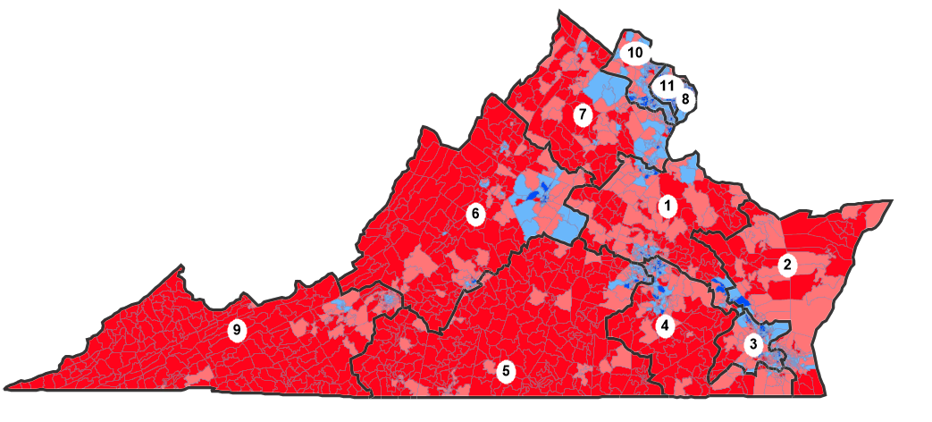

Though close to equally balanced between Republican and Democratic seats, Virginia is highly politically segregated, which presented some issues for this plan. The sparsely populated Southern and Western regions of the state consistently elect Republican representatives, while the Northern, population-dense regions consistently elect Democrats. Balancing efficiency gap minimization and the need to create a certain number of “safe” seats meant joining broader swaths of the state than would usually be acceptable due to compactness and community of interest constraints.
Map Explanation and Partisan Considerations
Safe Democratic Seats in Northern Virginia: 8th, 10th, and 11TH Districts
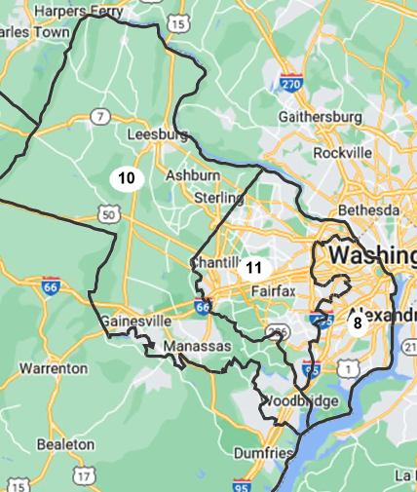
Northern Virginia districts with VTDs shaded by partisanship (deeper blue is greater 2020 Democratic vote share, deeper red is greater Republican)
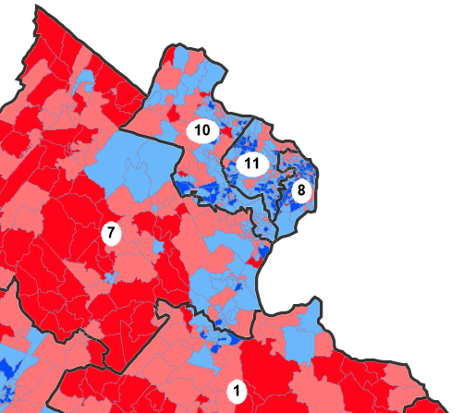

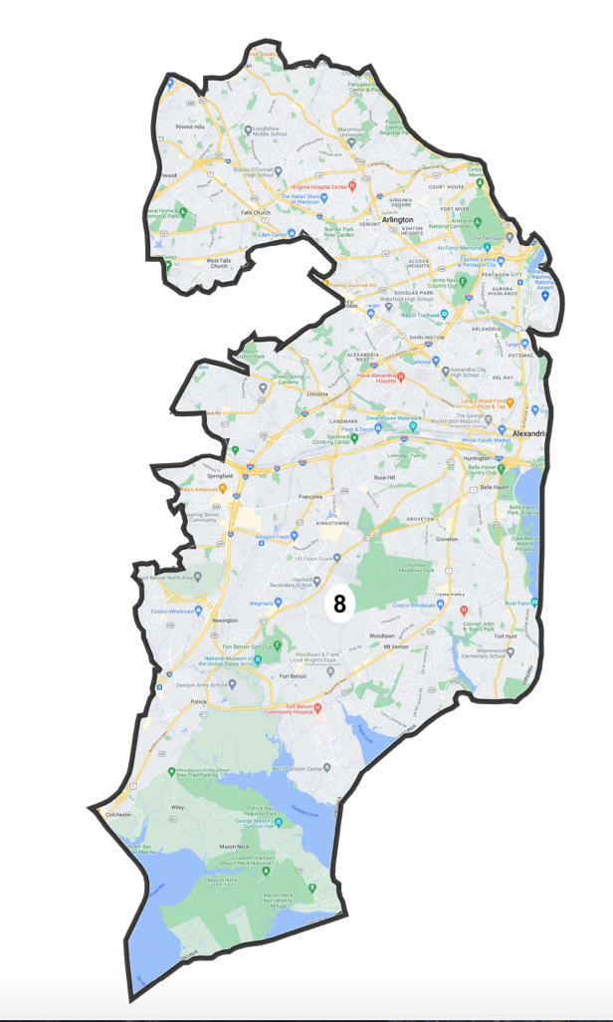
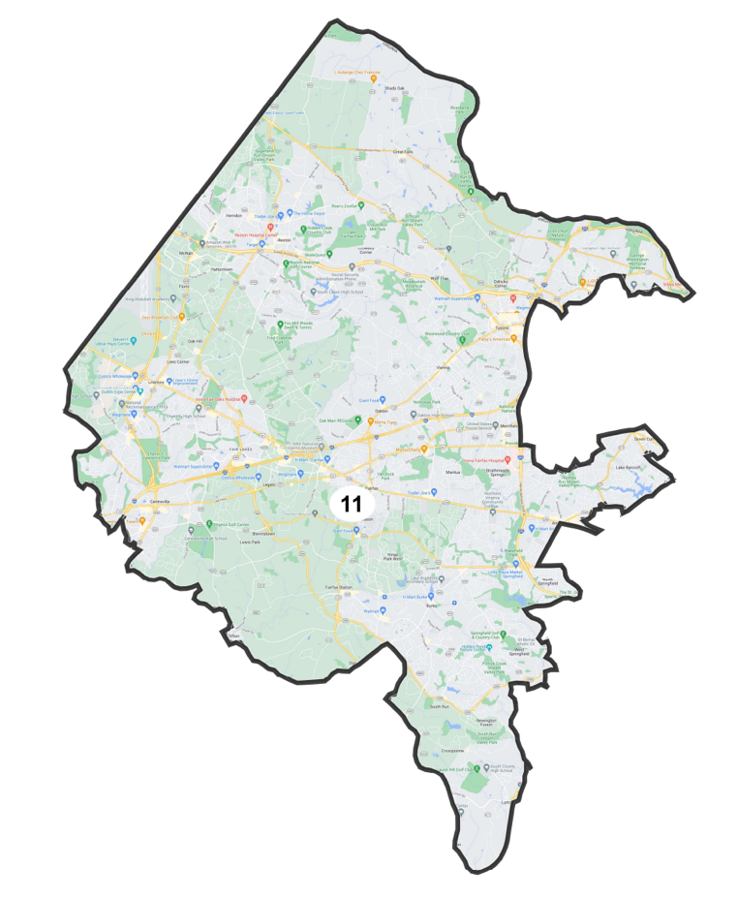

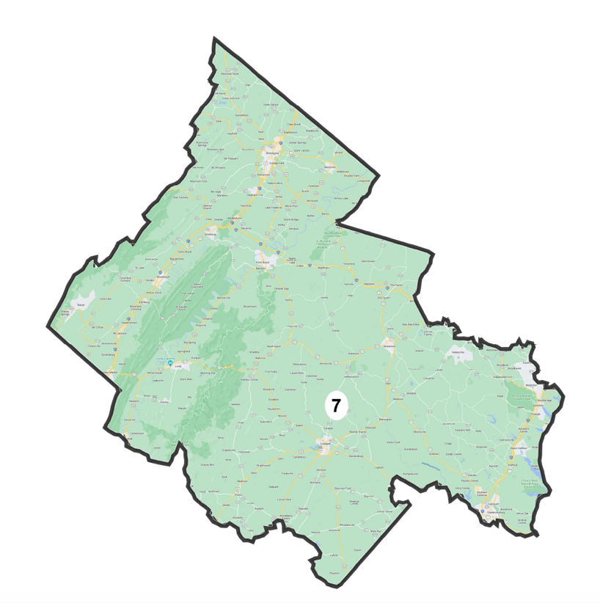
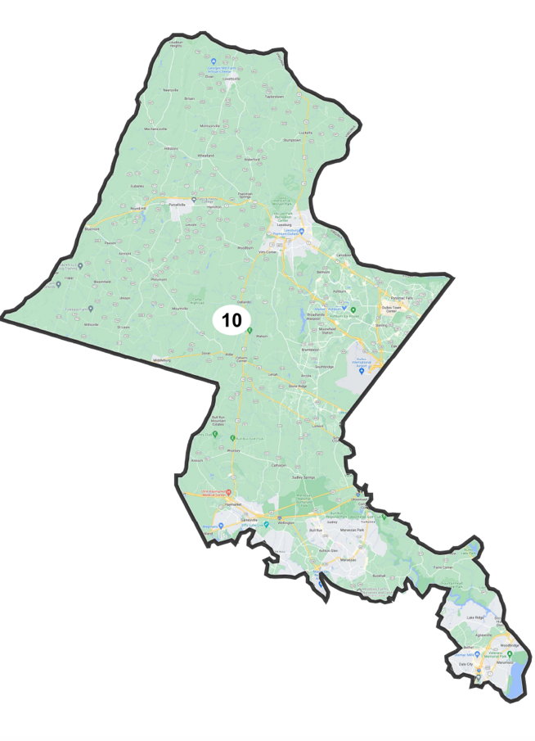

These districts were relatively straightforward to draw as they make up the most populous and most Democratic districts within the state. The 10th District is the state’s median district for Democratic vote share between 2016-2020, but nonetheless went for Democrats in that period by an average of seven points. As such, I was able to draw these districts controlling only for equal population constraints. As they are currently drawn, all three districts would provide well over 55% of vote share to a Democratic candidate in 2020 or 2016. Plan Score deems all safe Democratic seats with a 97+ % likelihood a Democrat would win each seat.

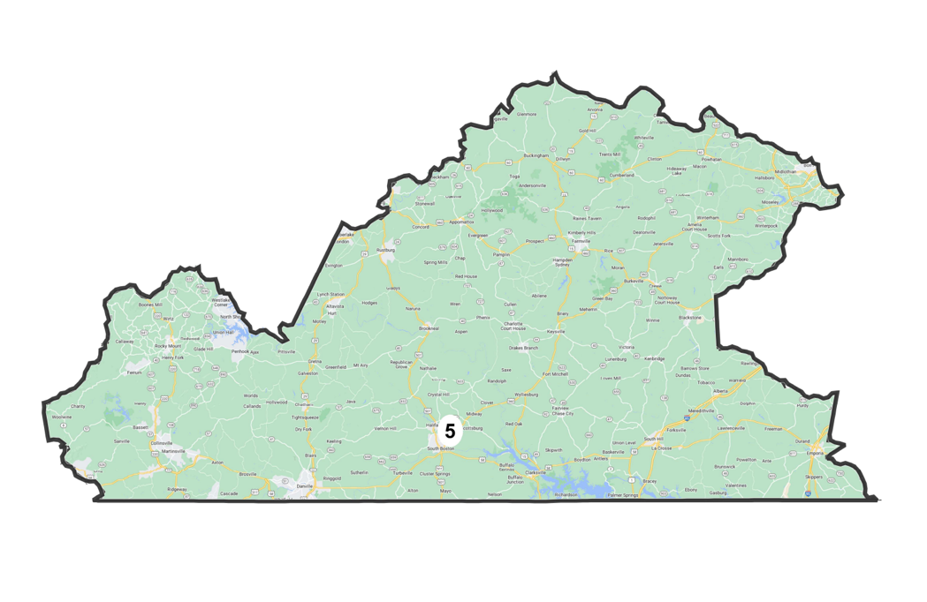
Safe Republican Seats in South and Southwest Virginia: 5th, 6th, and 9th Districts

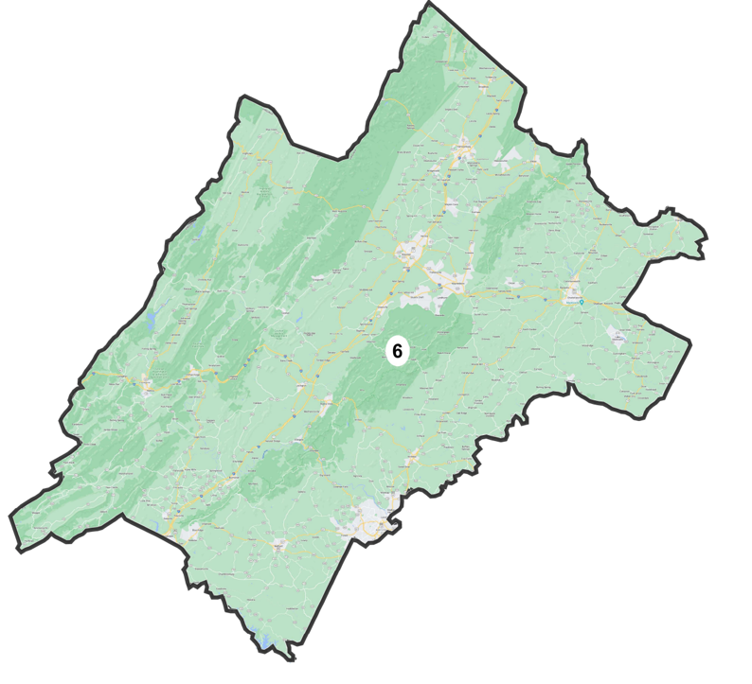
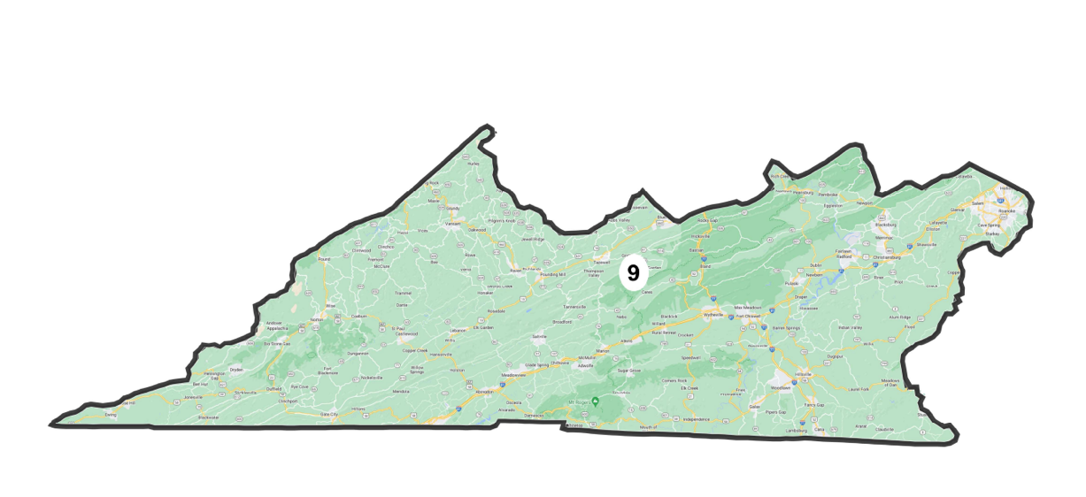
Charlottesville with VTDs shaded by partisanship (deeper blue is greater 2020 Democratic vote share, deeper red is greater Republican)
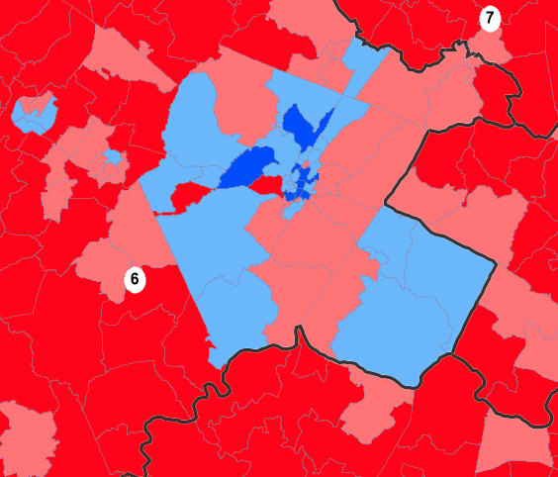
These districts were similarly straightforward to draw as they are comprised of the deeply Republican panhandle and Southside region. Again, I drew these districts with the intention of reaching equal population. A Republican candidate running for president in these districts between 2016 and 2020 would handily receive more than 55% of vote share. However, a 2020 Republican Senate candidate would receive only 53% of the vote share in the 5th District as it is currently drawn, but I believe this aberration may be due to Democratic Senator Mark Warner’s popularity as an incumbent in 2020. In any case, Plan Score rates both as safe Republican, giving Democrats less than 1% chance of winning the 9th District and 3% change of winning the 5th.
Given the spate of Democratic voters in Charlottesville and its deeply Republican surroundings, I wavered between placing it in the 5th or 6th districts. While its historical placement in the 5th weighed in favor of repeating such a placement according to least change principles, I ultimately placed it in the 6th for proportionality reasons. The 6th District was moderately less Republican than the 5th, meaning Charlottesville would be moderately less “stacked” into a Republican district. I also felt Charlottesville and its neighboring Democratic county of Fluvanna were more culturally similar to the Blue Ridge-based communities apportioned to the 6th District rather than the Southside communities of the 5th. The resulting 6th District would have delivered 54% of the vote share to Republicans in the 2020 presidential race, 53% of the vote share Republicans in the 2020 Senate race, and 58% of the vote share to Republicans in the 2016 race. Plan Score confirms it as a safe Republican seat, giving Democrats only a 5% chance of winning it.
Safe Democratic Ability-to-Elect Districts: 3rd and 4th Districts
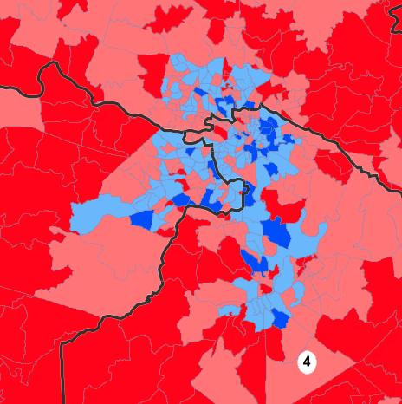
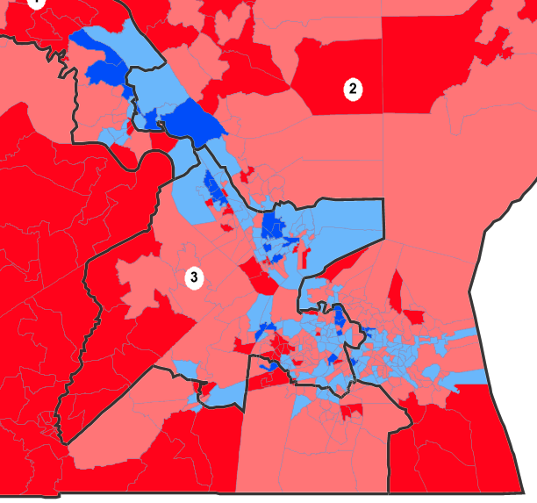
3rd District (left) and Richmond area (right) with VTDs shaded by partisanship (deeper blue is greater 2020 Democratic vote share, deeper red is greater Republican)

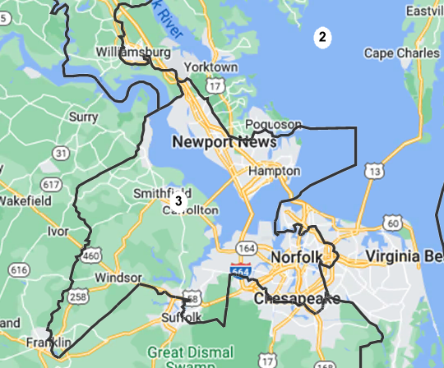
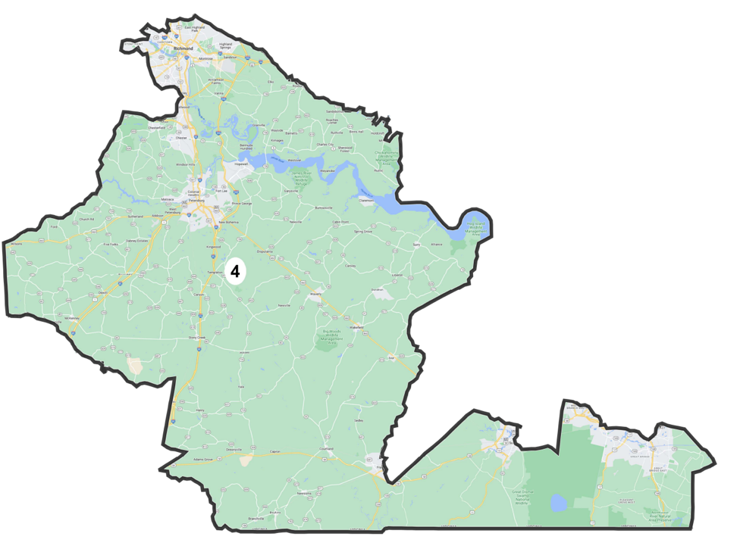

Desiring to maintain the 3rd and 4th Districts as the safe Democratic seats they are, I drew these districts with least change principles from the 2016 maps. I shifted borders only to adjust for equal population, which resulted in two VRA-compliant districts. The 3rd District has a Black VAP of 45.3% and 4th has 41.3%. Under all election scenarios between 2016 and 2020, these districts deliver more than 60% of vote share to Democratic candidates.
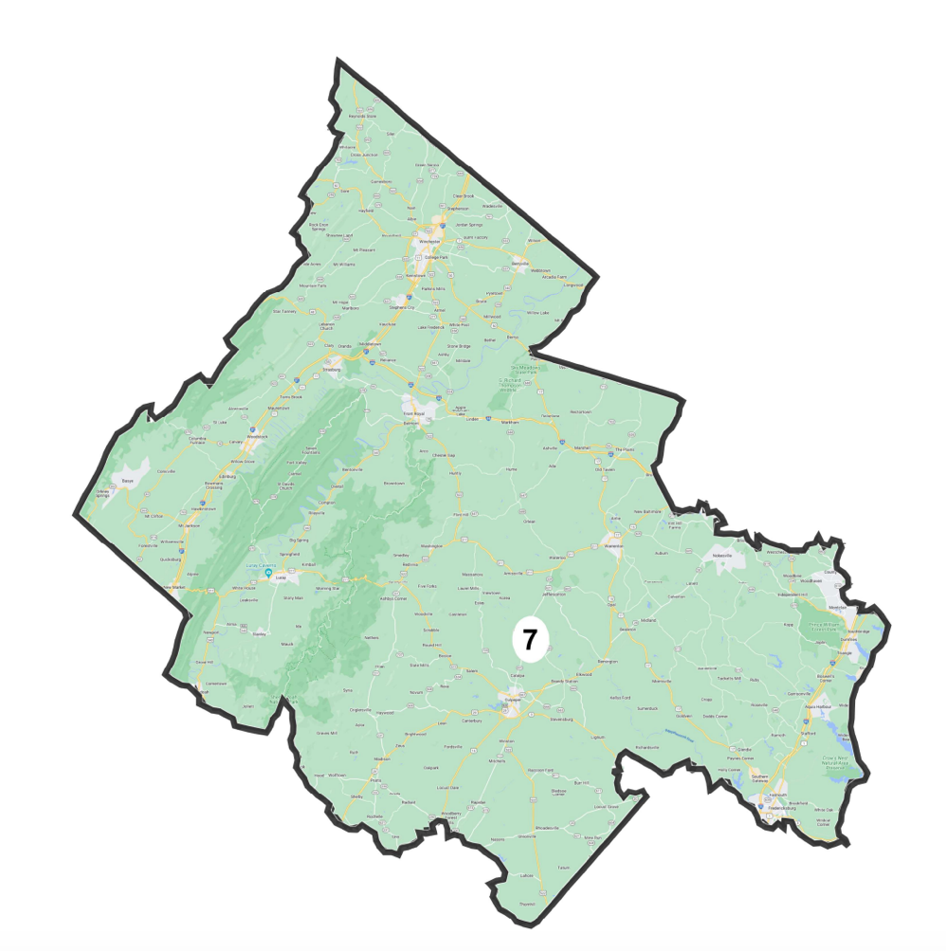
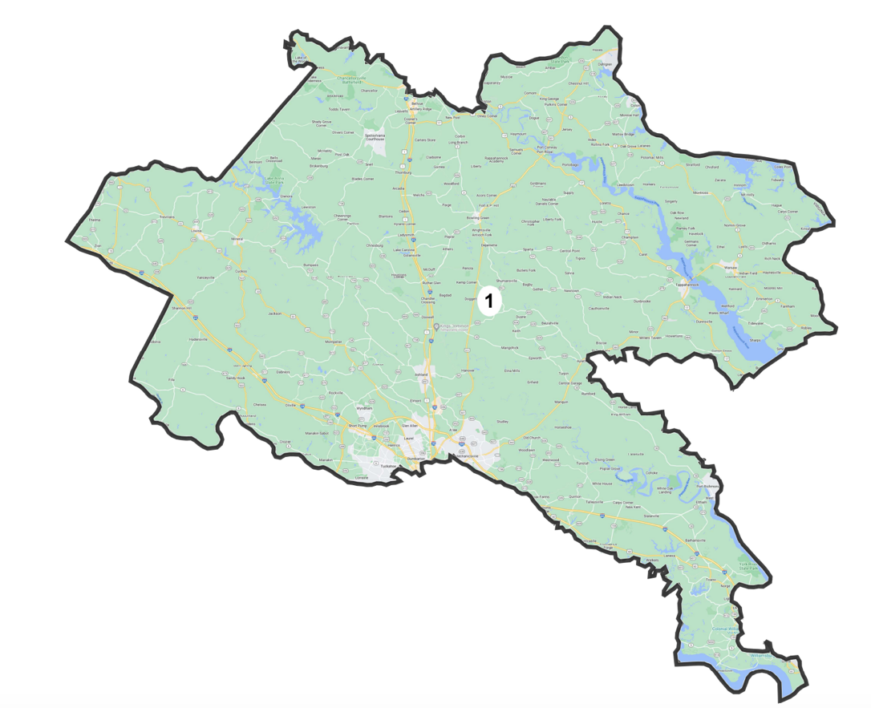
More Competitive Republican Districts: 1st and 7th Districts

District 7 combines the more moderate southeastern Washington, D.C. exurbs with the conservative Northern Virginia counties of Fauquier, Rappahannock, Clark, and Warren. Combined, this District is close to safe Republican by 2020 metrics, with Senate and Presidential Republican candidates receiving 52% of vote share. By 2016 metrics, the District is even safer Republican, at 56%. Plan Score predicts 57% of the vote share for Republicans in this District and an 8% likelihood a Democrat could take the District.
District 1 occupies the northeastern corner of the state below the D.C. area, incorporating Democratic Fredericksburg to the northwest and skirting Democratic Richmond to the south. This District features an unfortunate protrusion into the Williamsburg area, but it was necessary to accommodate population constraints and the 2nd District’s competitiveness. Between 2016 and 2020, a Republican running in the 1st District would have received anywhere from 51% to 55% of the vote share. In this way, it is far from competitive, albeit less safe Republican than its counterparts throughout the state.
Competitive District: 2nd District
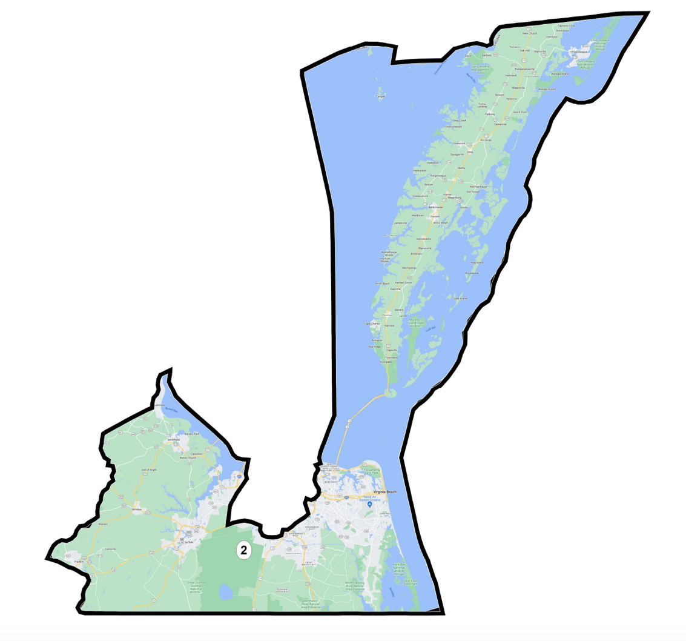
I drew this district to maximize competitiveness. I selected it to be as competitive as possible because of its electoral history. The 2nd District has switched parties four times in the last two decades. Even though the 2nd District currently has a Cook PVI of Republican +1, it is represented by Democrat Elaine Luria. Under 2020 presidential race circumstances, both Democrats and Republicans would receive 48.9% of vote share. However, the competitiveness fares less well under other electoral scenarios. Under 2020 Senate race circumstances, a Democrat would win with 51% of the vote share, while under 2016 presidential race circumstances, a Republican would win with 53%. Dave’s finds a 59.6% Democratic lean, while Plan Score finds a 53% Democratic one for the same district. Given the disparities of these findings, I believe the 2020 vote share metric is most reliable and therefore a marker of a competitive district.
Compactness and Political Subdivision Splits
This plan only contains 11 splits, outperforming the 14 splits in the 2016 maps and underperforming the Grofman-Trende Plan which only has 9 splits. As for compactness, it underperforms the Grofman-Trende plan on Reock scores in the majority of districts. Compactness was generally sacrificed for proportionality because creating safe seats meant joining the liberal urban areas in the north and southeast parts of the state with more distant conservative regions.
Tradeoffs
I am not convinced proportionality is a successful redistricting principle for a state like Virginia that is consistently “purple” on a statewide level but has deep political polarization along geographic lines. Because statewide data determines the number of seats to allocate to each party but is not actually representative of the polarization of an individual place, using this principle to redistrict assigns a certain balance to the state that may not reflect what voters want. This plan illustrates that tension well. Statewide data indicates that voters would want five Republican, five Democratic, and one competitive seats. However, in 2020, they elected seven Democrats and four Republicans. House of Representatives elections occur every two years and are more geographically constrained, so outcomes of those elections are more reflective of voters’ current preferences than those of statewide elections. That the median Democratic district, the 10th District, is only one point more Republican than the entire state overall yet goes on average for Democrats by a seven-point margin indicates how polarized the state is. Using statewide data, then, does not properly capture the depth of partisan leanings in particular places.
It is also worth mentioning that the Grofman-Trende plan reached perfect proportionality by Dave’s measure without consulting political data, except at the end when they ensured their maps did not unduly favor either party. Their ability to reach proportionality without consulting partisan data suggests that redistricting solely on knowledge of residence, participation in communities of interest, and other demographic data may lead to more representative maps than those for which partisan data is the main consideration. Political science research confirms that urban/rural residency, race, socioeconomic status, etc., can be effective proxies for partisan preference. It is possible that using such data (within legal constraints) might then lead to the most representative map and still prevent partisan gerrymanders.
Conclusion
The 2020 redistricting cycle brought many changes for Virginia. The Commonwealth sought a fairer process than it had in cycles’ past. It witnessed larger Hispanic and Asian American populations than it had seen before as well as extensive population growth in northern urban areas. These changes were offset by more modest growth amongst Black Virginians and population declines in southern cities. The plans presented in this paper account for these changes and attempt to improve upon past congressional plans. In all plans presented here, progress was made in reducing county splits and ensuring equal population amongst districts. In the first and third map, progress was made in protecting minority communities’ ability to elect the candidate of their choice. The second map helps document communities of interest that have been previously overlooked in the redistricting process. Even so, no plan is perfect, and each presents its own pitfalls. For Good Government, it was significant departures from previous plans and subdivision splits in the southeast part of Virginia. For Communities of Interest, it was VRA compliance and weaker community ties amongst two districts. For Proportional Representation, it was increasing competitiveness in non-competitive districts to apportion the proper number of seats to each party. Taking a simulation approach like that of the Algorithm-Assisted Redistricting Methodology Project would be worthwhile to determine which of these plans have the most costs or benefits associated with them, to compare these plans to each other, and empirically validate them against other potential plans.
Appendix
Map 1: Good Government
District | Population | Deviation | % Deviation | Reock | % NH_Wht | % 18+_AP_Blk
1 | 784671 | -1 | -0.000001 | 0.43799 | 0.672707 | 0.168223
2 | 784673 | 1 | 0.000001 | 0.25336 | 0.593656 | 0.212225
3 | 784673 | 1 | 0.000001 | 0.46827 | 0.391219 | 0.469808
4 | 784672 | 0 | 0 | 0.54785 | 0.462156 | 0.401501
5 | 784673 | 1 | 0.000001 | 0.39249 | 0.663995 | 0.23232
6 | 784671 | -1 | -0.000001 | 0.27789 | 0.790886 | 0.085796
7 | 784672 | 0 | 0 | 0.33238 | 0.657708 | 0.129826
8 | 784672 | 0 | 0 | 0.51225 | 0.502384 | 0.11597
9 | 784672 | 0 | 0 | 0.21717 | 0.836227 | 0.073328
10 | 784671 | -1 | -0.000001 | 0.36612 | 0.391272 | 0.178007
11 | 784673 | 1 | 0.000001 | 0.39101 | 0.484256 | 0.117923

Map 2: Communities of Interest
District Number | % Deviation | Deviation | % NH18+_Wht | % 18+_AP_Blk | Reock
1 | 0.000001 | 1 | 0.731145 | 0.162181 | 0.33637
2 | 0.000001 | 1 | 0.609488 | 0.241416 | 0.2402
3 | 0 | 0 | 0.427914 | 0.446575 | 0.47878
4 | 0.000001 | 1 | 0.559849 | 0.335672 | 0.35728
5 | -0.000001 | -1 | 0.559721 | 0.291381 | 0.35927
6 | -0.000001 | -1 | 0.78997 | 0.129557 | 0.32034
7 | 0 | 0 | 0.473268 | 0.205727 | 0.57088
8 | 0 | 0 | 0.522763 | 0.119731 | 0.37367
9 | 0.000001 | 1 | 0.86858 | 0.068192 | 0.20843
10 | 0 | 0 | 0.67294 | 0.070641 | 0.38939
11 | -0.000001 | -1 | 0.512695 | 0.114533 | 0.37017

Map 3: Proportional Representation
District | Population |  | Deviation |  | % Deviation |  | % NH Black CVAP 19 |  |  | % NH White CVAP 19
1 | 784672 |  | 0 |  | 0 |  | 17.3% |  |  | 74.6%
2 | 784672 |  | 0 |  | 0 |  | 19.5% |  |  | 68.1%
3 | 784671 |  | -1 |  | -0.000001 |  | 45.3% |  |  | 45.9%
4 | 784671 |  | -1 |  | -0.000001 |  | 41.3% |  |  | 52.1%
5 | 784673 |  | 1 |  | 0.000001 |  | 26.0% |  |  | 69.2%
6 | 784673 |  | 1 |  | 0.000001 |  | 10.5% |  |  | 84.1%
7 | 784673 |  | 1 |  | 0.000001 |  | 14.8% |  |  | 73.8%
8 | 784672 |  | 0 |  | 0 |  | 14.7% |  |  | 62.3%
9 | 784672 |  | 0 |  | 0 |  | 6.9% |  |  | 89.3%
10 | 784671 |  | -1 |  | -0.000001 |  | 13.3% |  |  | 60.0%
11 | 784673 |  | 1 |  | 0.000001 |  | 7.3% |  |  | 63.0%
District |  | % D 20_Pres |  | % R 20_Pres |  | % D 20_Sen |  | % R 20_Sen | % D 16_Pres |  | % R 16_Pres
1 |  | 0.47162 |  | 0.50977 |  | 0.488058 |  | 0.510952 | 44.3% |  | 55.7%
2 |  | 0.489506 |  | 0.489261 |  | 0.512539 |  | 0.486576 | 46.2% |  | 53.8%
3 |  | 0.664218 |  | 0.316177 |  | 0.684909 |  | 0.313922 | 65.9% |  | 34.1%
4 |  | 0.615805 |  | 0.367203 |  | 0.628891 |  | 0.370183 | 61.2% |  | 38.8%
5 |  | 0.429913 |  | 0.55541 |  | 0.459577 |  | 0.539545 | 41.7% |  | 58.3%
6 |  | 0.433861 |  | 0.54571 |  | 0.463666 |  | 0.535475 | 42.0% |  | 58.0%
7 |  | 0.455233 |  | 0.524944 |  | 0.473189 |  | 0.525923 | 43.8% |  | 56.2%
8 |  | 0.769549 |  | 0.209129 |  | 0.764409 |  | 0.234335 | 77.9% |  | 22.1%
9 |  | 0.326191 |  | 0.657638 |  | 0.380107 |  | 0.618848 | 32.0% |  | 68.0%
10 |  | 0.622458 |  | 0.358826 |  | 0.630592 |  | 0.368551 | 59.4% |  | 40.6%
11 |  | 0.690487 |  | 0.288456 |  | 0.690182 |  | 0.308601 | 68.1% |  | 31.9%

Dave’s Redistricting App Proportionality Assessment
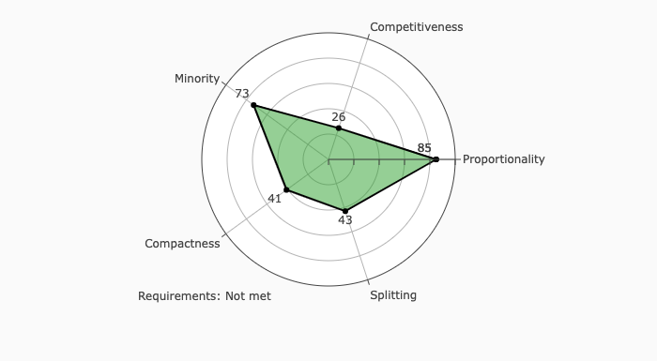

Kumar, Anita. “Bob McDonnell Signs Va. Congressional Redistricting Bill into Law.” Washington Post, 25 Jan. 2012, https://www.washingtonpost.com/blogs/virginia-politics/post/bob-mcdonnell-signs-va-congressional-redistricting-bill-into-law/2012/01/25/gIQADxR0QQ_blog.html. Accessed 1 Apr. 2022.
“Virginia | Princeton Gerrymandering Project.” Princeton University, The Trustees of Princeton University, https://gerrymander.princeton.edu/reforms/VA.
Virginia Redistricting, https://www.virginiaredistricting.org/map.aspx.
155 F. Supp. 3d 552 (E.D. Va. 2016).
“About Us.” OneVirginia2021 Foundation, https://www.onevirginia2021foundation.org/about.
Virginia Redistricting, https://www.virginiaredistricting.org/map.aspx.
Leonor, Mel. “Virginia Is Growing More Diverse; Population Growth Reserved for Urban and Suburban Areas.” Richmond Times-Dispatch, 14 Aug. 2021, https://richmond.com/news/state-and-regional/virginia-is-growing-more-diverse-population-growth-reserved-for-urban-and-suburban-areas/article_5176176f-7d62-54b2-940c-1ecc7dbc4f23.html#:~:text=Virginia's%20population%20grew%207.9%25%20between,from%208%20million%20in%202010. Accessed 3 Apr. 2022.
Id.
U.S. Census Bureau Quickfacts: Virginia. https://www.census.gov/quickfacts/fact/table/VA/PST045221.
Leonor, Mel. “Virginia Is Growing More Diverse; Population Growth Reserved for Urban and Suburban Areas.” Richmond Times-Dispatch, 14 Aug. 2021, https://richmond.com/news/state-and-regional/virginia-is-growing-more-diverse-population-growth-reserved-for-urban-and-suburban-areas/article_5176176f-7d62-54b2-940c-1ecc7dbc4f23.html#:~:text=Virginia's%20population%20grew%207.9%25%20between,from%208%20million%20in%202010. Accessed 3 Apr. 2022
Karcher v. Daggett, 462 U.S. 725 (1983).
Va. Code Ann. § 24.2-304.04.
Miller v. Johnson, 515 U.S. 900, 911 (1995).
Shaw v. Reno, 509 U.S. 630 (1993).
Voting Rights Act, 52 USC § 10301 (2014).
Va. Code Ann. § 24.2-304.04.
Thornburg v. Gingles, 478 U.S. 30, 50–51 (1986).
Id.
Katz, Ellen. "Documenting Discrimination in Voting: Judicial Findings." University of Michigan Journal of Law Reform 39.4 (2005), p. 7.
Brief for the Virginia State Conference of the NAACP, p. 26, December 17, 2021.
Id. at 15.
Id. at 34.
Id. at 40.
Personhuballah v. Alcorn, 155 F. Supp. 3d 552, 565 (E.D. Va. 2016).
Id.
Id. at 552.
Grofman, Bernard and Trende, Sean. “Memorandum Re: VA Redistricting 2021 to the Chief Justice and Justices of the Supreme Court of Virginia” (2021), p. 14.
Va. Code Ann. § 24.2-304.04.
Grofman, Bernard and Trende, Sean. “Memorandum Re: VA Redistricting 2021 to the Chief Justice and Justices of the Supreme Court of Virginia” (2021), p. 7.
Va. Code Ann. § 24.2-304.04.
Id.
Grofman, Bernard and Trende, Sean. “Memorandum Re: VA Redistricting 2021 to the Chief Justice and Justices of the Supreme Court of Virginia” (2021), p. 17.
“Virginia's Demographic Regions.” Weldon Cooper Center for Public Service, https://demographics.coopercenter.org/virginia-regions.
Grofman, Bernard and Trende, Sean. “Memorandum Re: VA Redistricting 2021 to the Chief Justice and Justices of the Supreme Court of Virginia” (2021), p. 15.
“Virginia's Demographic Regions.” Weldon Cooper Center for Public Service, https://demographics.coopercenter.org/virginia-regions.
Grofman, Bernard and Trende, Sean. “Memorandum Re: VA Redistricting 2021 to the Chief Justice and Justices of the Supreme Court of Virginia” (2021), p. 15.
Va. Code Ann. § 24.2-304.04(5).
Bush v. Vera, 517 U.S. 7 952 (1996).
Grofman, Bernard and Trende, Sean. “Memorandum Re: VA Redistricting 2021 to the Chief Justice and Justices of the Supreme Court of Virginia” (2021), p. 6.
Yglesias, Matthew. “The Real Fix for Gerrymandering Is Proportional Representation.” Vox, 6 Nov. 2017.
“Virginia's Demographic Regions.” Weldon Cooper Center for Public Service, https://demographics.coopercenter.org/virginia-regions.
Id.
“Virginia's Demographic Regions.” Weldon Cooper Center for Public Service, https://demographics.coopercenter.org/virginia-regions.
“About the Appalachian Region.” Appalachian Regional Commission, 19 Nov. 2021, https://www.arc.gov/about-the-appalachian-region/.
Grofman, Bernard and Trende, Sean. “Memorandum Re: VA Redistricting 2021 to the Chief Justice and Justices of the Supreme Court of Virginia” (2021) quoting Kenneth C. Martis, The Historical Atlas of United States Congressional Districts:1789-1983 (1982).
“Virginia's Demographic Regions.” Weldon Cooper Center for Public Service, https://demographics.coopercenter.org/virginia-regions.
“PVI Map and District List.” Cook Political Report, https://www.cookpolitical.com/pvi-map-and-district-list.
Grofman, Bernard and Trende, Sean. “Memorandum Re: VA Redistricting 2021 to the Chief Justice and Justices of the Supreme Court of Virginia” (2021), p. 19.
See https://alarm-redist.github.io/about.html.

