Good Government Congressional Plan
New Jersey

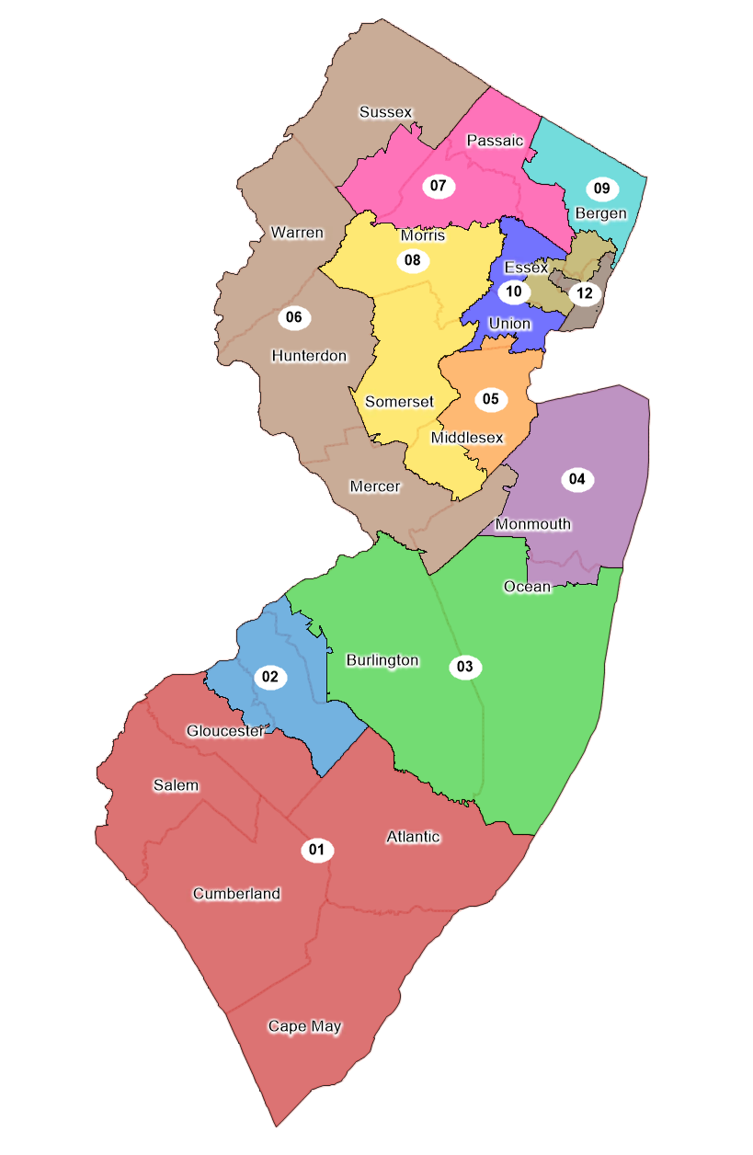

Policy Practicum: Draw Congress, Stanford Redistricting Project
Professor Nathaniel Persily, Fall 2021, Submitted Jan. 15, 2022

Amir Wright
Stanford Law School
J.D. Candidate, 2023
The State of New Jersey – Proposed Plan
  - Overview
New Jersey’s congressional lines are drawn by a 13-member commission, made up of elected officials from across the state. This system was established in 1995 and is based on a statutory model developed in 1991. The system stipulates that the four majority and minority leaders in each legislative chamber and the chairs of the state’s two major political parties each choose two commissioners, none of whom may be a congressional member or employee. Those twelve commissioners then choose a thirteenth who has not held any public or party office in New Jersey within the last five years. The members of the commission are to be appointed with “due consideration to geographic, ethnic and racial diversity.” Should a legal challenge to a plan or to congressional districts arise in state court, the New Jersey Supreme Court has exclusive jurisdiction to review the case. Further, if the commission is unable to draw its lines by its deadline (for this cycle it was January 18th, 2022), it must send two plans to the New Jersey Supreme court, who will then select a winning plan.
As with any state in the union, New Jersey must comply with constitutional equal population requirements. In a 1964 case, Wesberry v. Sanders, the Supreme Court found that Article I, section 2 of the United States Constitution requires strictly equal population in congressional districts as to ensure equal representation. Otherwise, a congressional district in New York might have six million people in it, while one in Montana has six thousand. In Karcher v. Daggett, the Supreme Court rejected a de minimis exception to the equal population requirement. In doing so, they created a strict requirement of perfect population equality for congressional districts unless there is adequate justification for a deviation. This equal population principle, known as “one person, one vote,” ensures that every congressional district in the country has roughly 758,000 people in it (332 million people divided by 435 congressional representatives). For this plan, New Jersey’s ideal population-per-district is 774,083.
Section 2 of the Voting Rights Act plays an important role in the redistricting process. Section 2 prohibits state and local governments from imposing voting laws that disproportionately harm people of color or laws that are motivated by a purpose to discriminate against minority voters. This prohibition on discrimination in voting also extends to redistricting maps that decide where voters live. If a map disadvantages people of color through packing or cracking, it violates section 2. Packing occurs when voters are packed into one or more districts in an effort to decrease the power of their votes. If a community of 1,000 Black voters is packed into one district instead of two districts of 500 (where they would still have a near-majority), that community’s power is reduced. Their voices are only represented in a meaningful way in one district rather than two. On the other hand, cracking is the opposite process. When a community is cracked, voters who could potentially form a majority in one district are split up into many districts. If that same community of 1,000 Black voters is split into ten districts of 100 voters each, their voices are effectively silenced.
  - Guiding Redistricting Principles
This plan begins with a blank map of New Jersey. Because there are no state-mandated laws on how the map must be drawn, redistrictors have relative flexibility in their design philosophies. This plan prioritized taking steps to assure minority representation and maintain the integrity of political subdivisions. It began at the county level in the southern regions of the state and moved north toward Newark, making an effort to keep counties whole and minimize city splits. Some splitting was inevitable in a city as large as Newark. However, county lines form the boundaries of most districts in the more sparsely populated regions of the state to the south.
These principles are used as guidelines, rather than strict rules. Traditional redistricting principles “cannot overshadow the federal redistricting rules of equal population and compliance with the Voting Rights Act.” As such, all elements of this plan must first comply with the Voting Rights Act before any other considerations. After compliance is met, the plan can follow its traditional redistricting principles. For example, while minimizing subdivision splits or protecting incumbents can be traditional redistricting principles, redistrictors must sometimes split precincts or pair incumbents in order to provide minority voters the opportunity to elect their preferred candidate. One such example of a district that was designed with these trade-offs is District 12, infra.
  - Tensions and Trade-Offs
    - Demographic
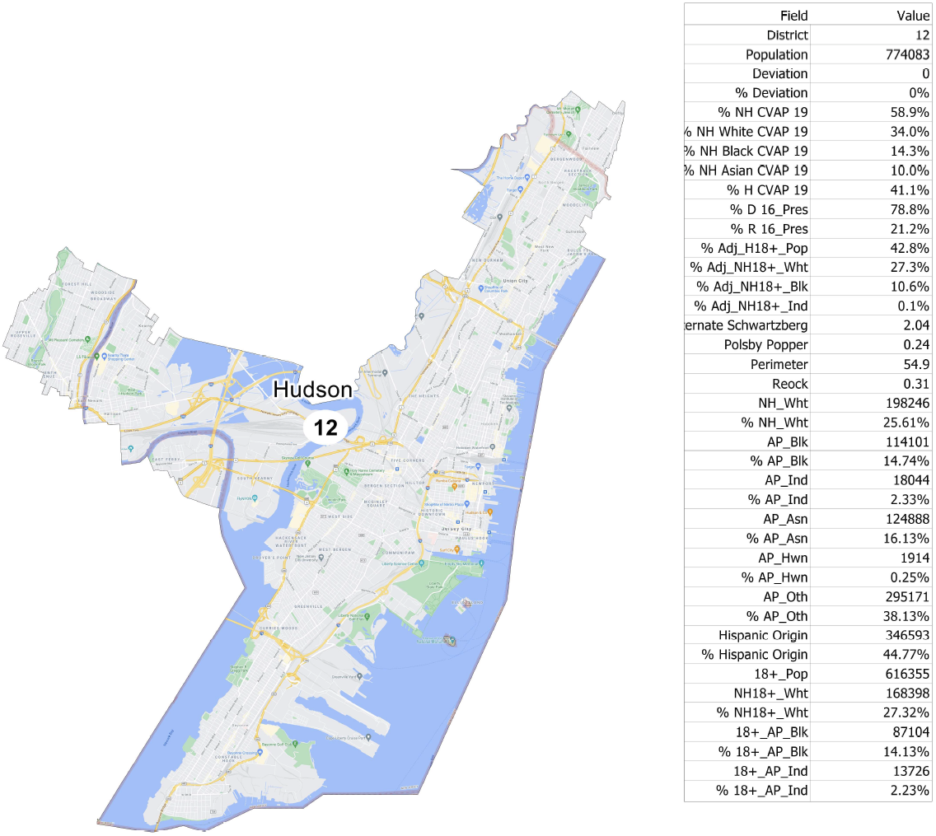
      - District 12

One of the largest considerations in this plan was the balancing of demographic factors. In the current enacted plan from 2012, District 8 (which is District 12 in this proposed plan, seen above) had a narrow Hispanic majority population. This plan unfortunately reduces that population to 41%, though the district remains a minority-majority district. This was done in an attempt to balance the previous Hispanic majority status of the district with factors of contiguity and communities of interest.
Contiguity is the idea that a district be internally contiguous – it should not cross bodies of water or other geographic barriers with no connecting infrastructure (bridges, tunnels, or ferries). Congress considers a district to be contiguous “if it is possible to travel between any two points in a district without crossing into a different district.” A community of interest is a community that shares a common geography and history. This might be a neighborhood, community, or group of people who have common policy concerns and would benefit from being grouped together in a single district. These communities can be determined by data from the Census, including data from the Census Bureau’s American Community Survey, or by community members themselves.
In order to get District 12 up to 50% Hispanic population, it could have extended its southern border and reached across Newark Bay into Elizabeth. However, this would have interfered with the district’s contiguity and with the idea of a community of interest. There is no infrastructure that connects the communities of Bayonne and Constable Hook with Elizabeth without going through Staten Island. Had they been grouped into the same district, little would have bonded them together as a community. Further, it would have violated congressional definitions of contiguity since constituents would have to travel into other districts (Staten Island or District 11) in order to reach Elizabeth. District 12 was allowed to reach across into South Kearny because the New Jersey Turnpike and several rail lines connect the two sides of the Hackensack River, so accessibility, contiguity, and community are kept intact.
      - District 11
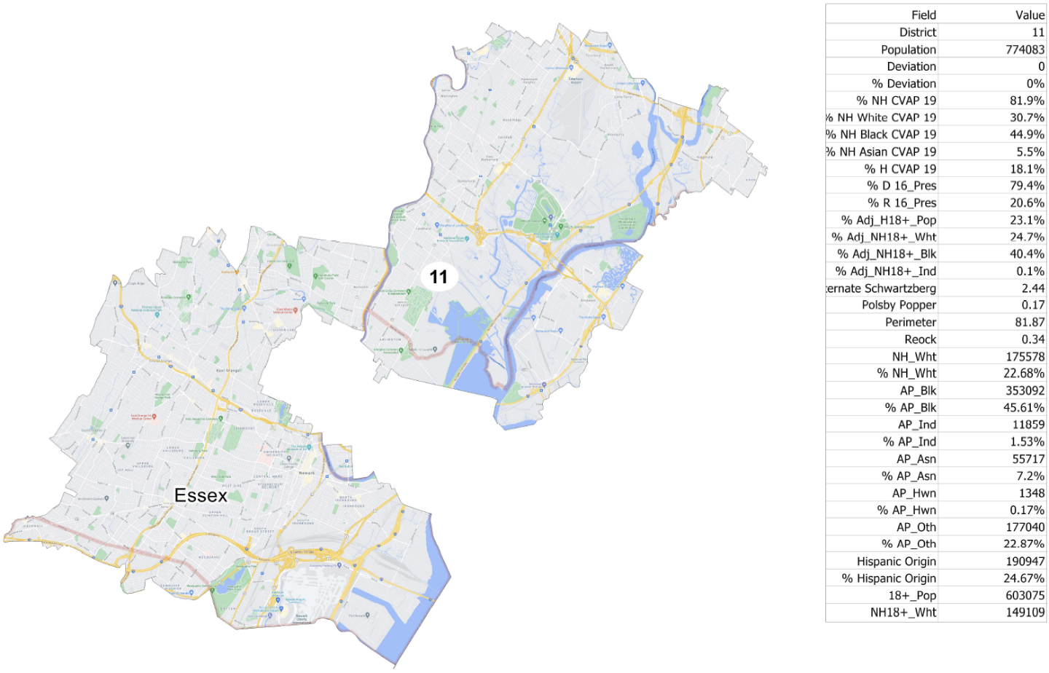

District 11 has a similar story. Much of Newark is captured within District 11, and much of Newark is home to a large Black population. In the 2012 enacted plan, this district is majority Black. However, demographics have shifted since the 2010 census, and it is now incredibly difficult to draw a majority-Black district around Newark that has any hint of compactness (compactness and its definitions are discussed infra), community, or contiguity. Further, much of the core of Newark – where the New Jersey Turnpike crosses the river – had to be ceded to District 12 in order to keep the Hispanic population relatively high.
When drawing districts with racial considerations, redistrictors must bear in mind Shaw v. Reno, which has particular implications for racial gerrymandering. In it, a plaintiff challenged a redistricting plan under the 14th Amendment’s Equal Protection Clause. The Supreme Court accepted their argument that, even though the plan appeared neutral on its face, it could not be understood as anything other than an effort to separate voters into different districts on the basis of race, and that the separation in question had no sufficient justification. Using Shaw as a basis, the Court further developed this doctrine in another case, Miller v. Johnson. There, it held that strict scrutiny is triggered when race served as the “predominant” factor in the drawing of district lines. Miller also held that districts with strange shapes with seemingly no obvious basis can be indicative of discriminatory intent, serving as circumstantial evidence of the predominance of race. At the same time, strictly observing traditional districting principles can be equally indicative of a lack of discriminatory intent. While the strange shape of District 11 here might appear to be indicative of discriminatory intent under Miller (indeed, it purposefully avoids much of the city’s core), the district was created in an effort to preserve as much of the current Black population as possible.
    - Respecting Political Subdivisions
In 42 states, new state legislative districts must consider existing political boundaries such as the borders of cities, counties, boroughs, towns, and wards. 19 states have this requirement for congressional districts as well, though New Jersey does not. Nonetheless, this plan seeks to uphold this principle to the greatest extent possible because it is critical for good governance that communities are not unduly split. Below is a table showing the political subdivision splits in this proposed plan:

Number of City/Town not split | 662
Total Number of City/Town split | 35
Number of City/Town split in two | 33
Number of City/Town split in three | 2
Total number of splits | 72

Respecting political subdivisions was a guiding principle of this plan. The process of drawing the map began by drawing districts around entire counties. Then, the focus shifted to cities and towns to reach the constitutionally required 774,083 people per district. This map keeps 662 cities and towns together, while only splitting 35. Those divisions that are split are often split in minor ways where population requirements did not allow for an entire county fit in one district.
    - Compactness
Compactness measures are one way to visualize and compare the physical appearance of districts. Compactness is difficult to define in standard terms, though there are several ways to measure it. It generally means that the people who reside in a district live near each other. However, it is not always possible to draw perfectly compact districts in which everyone lives near everyone else. Rural districts may cover a large physical area. A district might also follow a mountain range or a river, giving it a strange shape. Oddly shaped or unusually sprawling districts can be signs of gerrymandering, or of racial discrimination as well. To combat this with some degree of consistency, redistrictors use several mathematical tests that consider the shape of a district’s lines (jagged, smooth, or sprawling).
One such measure is Roeck compactness, which is a ratio of a district’s area compared to the area of the smallest circle that will completely encompass the district. As such, a perfectly circular district may have a Roeck compactness score of 1, while a long narrow district (like District 6 in this proposed plan) may have a score closer to 0. Another measure, Schwartzberg, compares the district’s perimeter with the perimeter of a circle containing the same area. On this scale, a score of 1 represents the most compact district possible, while higher numbers represent progressively less compact districts. The final measure that we will examine is Polsby-Popper, which compares the area of a district to the area of a circle with the district’s same perimeter. While similar to Schwartzberg, Polsby-Popper is a ratio, so a score of 1 is the most compact while a score of 0 is the least compact. Below is a table of measures for this proposed plan and for the 2012 enacted plan (Schwartzberg measures were unavailable for the 2012 enacted plan):

 |  | Proposed Plan |  | 2012 Enacted Plan
District | Roeck | Schwartzberg | Polsby-Popper | Roeck | Polsby-Popper
1 | 0.54 | 1.31 | 0.45 | 0.29 |  | 0.25
2 | 0.50 | 1.62 | 0.32 | 0.43 |  | 0.35
3 | 0.57 | 1.44 | 0.41 | 0.33 |  | 0.19
4 | 0.59 | 1.33 | 0.55 | 0.38 |  | 0.22
5 | 0.56 | 1.64 | 0.33 | 0.23 |  | 0.20
6 | 0.25 | 2.25 | 0.17 | 0.27 |  | 0.13
7 | 0.42 | 1.79 | 0.28 | 0.37 |  | 0.20
8 | 0.37 | 2.06 | 0.19 | 0.26 |  | 0.10
9 | 0.38 | 1.54 | 0.40 | 0.40 |  | 0.18
10 | 0.39 | 2.39 | 0.14 | 0.33 |  | 0.12
11 | 0.34 | 2.35 | 0.17 | 0.41 |  | 0.22
12 | 0.31 | 1.91 | 0.24 | 0.31 |  | 0.16
Min | 0.25 | 1.31 | 0.14 | 0.23 |  | 0.10
Max | 0.59 | 2.39 | 0.55 | 0.41 |  | 0.35
Mean | 0.44 | 1.80 | 0.30 | 0.33 |  | 0.19

From the above data, this proposed plan clearly outperforms the 2012 enacted plan in measures of compactness. Looking first to Roeck compactness, the average score for this proposed plan is 0.44, while the average score for the enacted plan is 0.33. Even the minimum and maximum scores for this plan (0.25 and 0.59, respectively) are greater than the minimum and maximum scores for the enacted plan (0.23 and 0.41, respectively). For the Polsby-Popper score, this proposed plan averages at 0.55, while the enacted plan averages at 0.35. This difference is far larger and reflects the principle that plans should generally try to improve on their predecessors where possible. These improvements generally indicate that this proposed plan does a better job at keeping communities together than the 2012 enacted plan.
  - Controversy
On December 22, 2021, the New Jersey Redistricting Commission approved a plan that was put forth by the state Democrats. The New Jersey Monitor summarized the plan below:
The new map will shore up competitive North Jersey districts held by Reps. Mikie Sherrill (D-11) and Josh Gottheimer (D-05) by removing some conservative towns and adding more solidly Democratic ones; give Rep. Andy Kim (D-03) a friendlier district by carving portions of Ocean County out of it and extending it into Mercer County; and remove Republican Rep. Chris Smith’s Hamilton home from the 4th District, forcing him to move to seek re-election to avoid carpetbagger attacks.

New Jersey Republicans (and many in the redistricting community) believe that the plan shows a clear bias towards Democrats. New Jersey Democratic State Committee Chair LeRoy Jones Jr. said the new map will “enhance minority representation and accurately reflect the partisan and demographic composition of our state,” while New Jersey Republican Party Chair Bob Hugin called it a “nakedly partisan gerrymander.” As such, Republicans launched a legal challenge against the plan, alleging that the tiebreaker (former state Supreme Court Justice John Wallace Jr.) should have been conflicted out of serving on the commission. Recall that the thirteenth member of the commission is picked by the first twelve, six of whom come from either party.
Republicans argue that Wallace should not have been allowed to serve because his wife “made personal campaign contributions to Democrats, including one member of the current delegation who was affected by the map, and accepted large donations from Democratic special interests when she ran for mayor of Washington Township.” Democrats meanwhile contend that “[t]he Constitution does not require the independent member to act as a non-partisan tiebreaker, but rather as one member of a thirteen-member group, with each member receiving an equal weighted vote.”
When asked to justify his vote, Wallace simply stated that he voted for the Democratic map because the last map was drawn by Republicans. In response, Chief Justice Stuart Rabner ordered Wallace to provide a more concrete reason for his decision. It is clear that the state Supreme Court is taking the Republican challenge seriously and evaluating this decision carefully. A solution has not yet been reached, and a resolution is unlikely before this paper is submitted.
  - Conclusion
This goal of this plan was to ensure minority representation and keep communities together. While it certainly had to make trade-offs – the shape of District 12, for example – these elements were sacrificed in favor of greater principles of good governance. It aimed to split as few political subdivisions as possible (indeed, only splitting 35) and achieve strictly equal population across all districts.

Justin Levitt, All About Redistricting, New Jersey, Loyola L. School, https://redistricting.lls.edu/state/new-jersey/?cycle=2010&level=Congress&startdate=2011-12-23 (last visited Nov. 16, 2021).
Id.
Id.
N.J. Const. art. II, § II.
N.J. Const. art. II, § II, ¶ 7.
N.J. Const. art. II, § II.
Wesberry v. Sanders, 376 U.S. 1, 7-8 (1964) (“We hold that, construed in its historical context, the command of Art. I, § 2, that Representatives be chosen ‘by the People of the several States’ means that as nearly as is practicable one man's vote in a congressional election is to be worth as much as another’s.”).
Karcher v. Daggett, 462 U.S. 725, 734 (1983). (“We thus reaffirm that there are no de minimis population variations, which could practicably be avoided, but which nonetheless meet the standards of Art. I, §2, without justification.”).
Population Clock, United States Census Bureau, https://www.census.gov/popclock/ (last visited Nov. 17, 2021).
Section 2 of the Voting Rights Act states that “No voting qualification or prerequisite to voting … shall be imposed by any State or political subdivision to deny or abridge the right of any citizen of the United States to vote on account of race or color, or [status as a member of a language minority group].” 52 U.S.C. § 10301(a).
Power on the Line(s), Making Redistricting Work for Us 35, NAACP Legal Defense and Educational Fund, inc. (2021), https://www.maldef.org/wp-content/uploads/2021/05/FINAL-LDF_04142021_RedistrictingGuide-22e.pdf (last visited Jan. 2, 2022).
For example, Arizona laws require that a map begin with a “grid-like pattern” originating from a central point. From there, redistrictors can adjust districts as they see fit. See Ariz. Const. art. IV, pt. 2, § 1(14); see also Ariz. Minority Coal. for Fair Redistricting v. Ariz. Ind. Redistricting Comm’n, 121 P.3d 843 (Ariz. Ct. App. 2005). New Jersey has no such requirement.
Power on the Line(s), Making Redistricting Work for Us 24, NAACP Legal Defense and Educational Fund, inc., https://www.maldef.org/wp-content/uploads/2021/05/FINAL-LDF_04142021_RedistrictingGuide-22e.pdf (2021) (last visited Jan. 2, 2022).
Id.
Congressional Redistricting Criteria and Considerations 2, Congressional Research Service, https://crsreports.congress.gov/product/pdf/IN/IN11618#:~:text=A%20district%20is%20generally%20thought,districts%2C%2034%20states%20require%20contiguity (last updated Nov. 15, 2021).
Rules of Redistricting: Communities of Interest 1, Loyola L. School, https://redistricting.lls.edu/wp-content/uploads/Basics-English6.pdf (last visited Jan. 12, 2022). See also Communities of Interest, Brennan Center for Justice (Nov.2010), www.brennancenter.org/sites/default/files/analysis/6%20Communities%20of%20Interest.pdf.
Power on the Line(s), Making Redistricting Work for Us 24, NAACP Legal Defense and Educational Fund, inc. (2021), https://www.maldef.org/wp-content/uploads/2021/05/FINAL-LDF_04142021_RedistrictingGuide-22e.pdf (last visited Jan. 2, 2022).
Congressional Redistricting Criteria and Considerations 2, Congressional Research Service, https://crsreports.congress.gov/product/pdf/IN/IN11618#:~:text=A%20district%20is%20generally%20thought,districts%2C%2034%20states%20require%20contiguity (last updated Nov. 15, 2021).
Shaw v. Reno, 509 U.S. 630, 642 (1993).
Miller v. Johnson, 515 U.S. 900, 916 (1995) (“The plaintiff's burden is to show, either through circumstantial evidence of a district's shape and demographics or more direct evidence going to legislative purpose, that race was the predominant factor motivating the legislature's decision to place a significant number of voters within or without a particular district.”).
Id.
Id. at 913.
Id. at 916.
Justin Levitt, Professor Justin Levitt’s Guide to Drawing the Electoral Lines, Loyola L. School (2019), http://redistricting.lls.edu/.
Id.
Levitt, supra note 24.
Power on the Line(s), Making Redistricting Work for Us 25, NAACP Legal Defense and Educational Fund, inc. (2021), https://www.maldef.org/wp-content/uploads/2021/05/FINAL-LDF_04142021_RedistrictingGuide-22e.pdf (last visited Jan. 2, 2022).
Id. at 26.
Indeed, District 6 has a Roeck compactness score of 0.25.
Nikita Biryukov, New congressional district map largely a victory for Democrats, New Jersey Monitor (Dec. 22, 2021), https://newjerseymonitor.com/2021/12/22/new-congressional-district-map-largely-a-victory-for-democrats/.
Id.
Id.
David Wildstein, Democrats call GOP challenge to congressional map ‘frivolous,’ says NJ Constitution doesn’t require Wallace to be independent, New Jersey Globe (Jan. 7, 2022), https://newjerseyglobe.com/redistricing/democrats-call-gop-challenge-to-congressional-map-frivolous-says-nj-constitution-doesnt-require-wallace-to-be-independent/.
See supra notes 3-6 and accompanying text.
David Wildstein, Democrats call GOP challenge to congressional map ‘frivolous,’ says NJ Constitution doesn’t require Wallace to be independent, New Jersey Globe (Jan. 7, 2022), https://newjerseyglobe.com/redistricing/democrats-call-gop-challenge-to-congressional-map-frivolous-says-nj-constitution-doesnt-require-wallace-to-be-independent/.
Id.
Id.
Id.

