Maryland Congressional Plans:
Least Change and Good Government

- Introduction
This report presents two congressional redistricting plans for the state of Maryland. The first proposed plan, called the Least Change plan, attempts to change Maryland’s existing congressional districts as little as possible. The plan balances the district populations by moving people from overpopulated districts into underpopulated ones. However, only two of the state’s eight districts were initially underpopulated. The map had to rely on a ripple effect in order to balance district populations—it could rarely transfer directly from an overpopulated to an underpopulated district.
The Least Change plan’s pursuit of compactness is stilted by the existing plan underlying it. The existing plan contains several creatively shaped districts and receives poor compactness scores. The Least Change plan would ideally create more compact districts, but its first priority is to preserve existing lines. Where possible, the plan opts to improve compactness, but this improvement remains unfortunately limited.
The second proposed plan, called the Good Government plan, aims to preserve as many whole counties, cities, and towns as possible. It also prioritizes compactness while respecting natural boundaries, like the Chesapeake Bay, and seeks to preserve communities of interest. The Good Government plan encountered challenges in the state’s demographic data. All plans must comply with the Voting Right Act, establishing minority opportunity districts where certain criteria are met, but preserving communities of interest also means creating appropriately powerful minority influence districts where racial minorities can influence election results. Because Maryland’s racial minorities are packed tightly into certain regions, blind adherence to county lines sometimes impermissibly “packs” or “cracks” minorities communities, leaving them with disproportionately little political power. The Good Government plan had to account for these communities of interest, even if it meant breaking a few more county lines.
- Legal Compliance
- Federal Constitution
At least since 1964, the Constitution has required congressional districts to be as equally populated as possible. All districts in both proposed plans comply with this “one person, one vote” requirement. Maryland’s population (6,175,403 people) does not divide evenly by eight, so some districts deviate by a single person. In both plans, there are five districts with 771,925 people and three districts with 771,926.
The Fourteenth Amendment's Equal Protection clause also imposes requirements on congressional redistricting plans. Shaw v. Reno held that a congressional redistricting plan runs afoul of the Fourteenth Amendment if it is “so irrational on its face that it can be understood only as an effort to segregate voters into separate voting districts because of their race, and that the separation lacks sufficient justification.” Here, neither proposal is so irrational. Both maps adhere to traditional redistricting principles, like compactness, population equality, and the minimization of change and of political subdivision splits. Race is not “the predominant factor” dictating district lines.

- Voting Rights Act
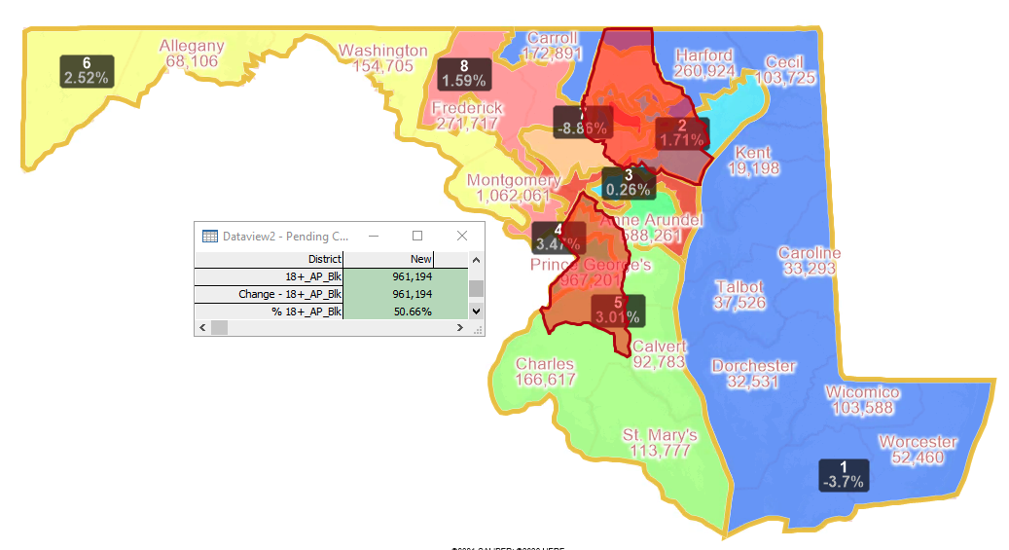
Both plans also comply with the Voting Rights Act (VRA). Section 2 of the VRA protects against intentional race-based vote dilution. In relevant part, section 2 states that the act will be violated if members of a particular race “have less opportunity than other members of the electorate to participate in the political process and to elect representatives of their choice.” As construed in Thornburg v. Gingles, section 2 requires the creation of a minority “opportunity district” where 1) the racial minority is sufficiently large and geographically compact to constitute a majority in a single-member district, 2) the racial minority is politically cohesive, and 3) the white majority votes sufficiently as a bloc to enable it usually to defeat the minority’s preferred candidate. The “opportunity district” need not be majority-minority, but it needs to provide the racial minority with a fair opportunity to elect their candidate of choice.
In Maryland, it is likely that the VRA requires two Black opportunity districts. The state voting age population is 31% percent Black and most of the state’s Black voters— over 64% of them—reside in Baltimore County, Baltimore City County, and Prince George’s County. There are enough Black voters in these counties to constitute two majority-Black districts, meeting the first Gingles criterion. The second and third Gingles criteria demand a racial polarization analysis, which is outside the scope of this paper. However, based on the existence of three current majority-minority districts, it is reasonable to conclude that these criteria would be met as well.
Highlighting Baltimore County, Baltimore City County, and Prince George’s County on the existing plan. Combining these counties, the voting age population is 50.66% Black and there are more than enough people for two congressional districts.
  - Black Opportunity Districts in the Least Change Plan
The Least Change Plan’s Black opportunity districts are District 4 and District 7. District 4 is composed of the eastern side of Prince George’s County and the northern part of Anne Arundel County. It’s voting age population is 55.8% Black (54.9% adjusted Nonhispanic Black). This district remains essentially identical to its current configuration, with the loss of only a few voting districts in Anne Arundel County.
District 7 links the eastern part of Baltimore City County together with northern Baltimore County and northern Howard County. The voting age population is 49% Black (48.6% adjusted Nonhispanic Black). District 7 remains largely the same as its predecessor in the existing plan, aside from gaining a few voting districts in Baltimore and Baltimore City.
  - Black Opportunity Districts in the Good Government Plan
Districts 4 and 7 are Black opportunity districts in the Good Government Plan. District 4 makes up the southeastern portion of the state, picking up the southern portions of Prince George’s County and Anne Arundel County in addition to Charles, St. Mary’s, and Calvert. It has a 52.1% Black (51.4% adjusted Nonhispanic Black) and 36.3% Nonhispanic White voting age population.
District 7 combines the eastern half of Baltimore City County with the eastern side of Baltimore County and the northeastern portion of Howard County. It’s voting age population is 50.1% Black (49.7% adjusted Nonhispanic Black) and 36.6% Nonhispanic White.

- State Law
The Maryland Constitution requires that state legislative districts be contiguous, compact, and substantially equally populated, with due regard for natural boundaries and political subdivisions. However, the state constitution mentions no requirements for Maryland’s congressional districts.
By statute, Maryland adjusts its census data to count incarcerated individuals at their last known address. MD Code, Election Law, §8-701. Both proposed plans were created using this adjusted data, so both comply with the statute.

- Choice Points: How the Plan was Made
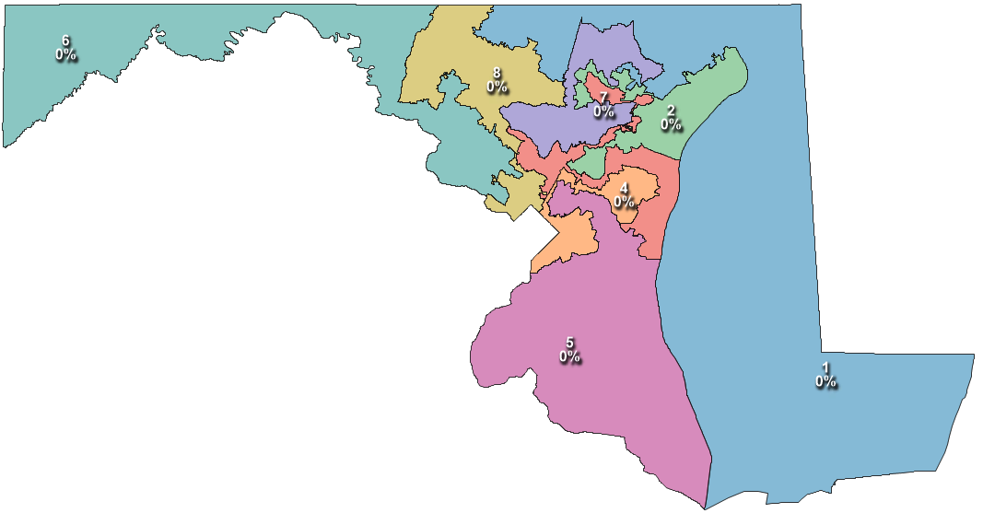
- Least Change Plan
This plan sought only to adjust the current lines to comply with the one person, one vote requirement. Districts 1 and 7 were initially underpopulated, while the other districts were overpopulated. In general, population adjustments were made using voting districts with high population density. This way, moving large numbers of people produced minimal effects on the existing district lines. The discussion below explains the decisions made in order, district by district. Red lines on the images show district lines on the existing plan, for comparison with the Least Change map.

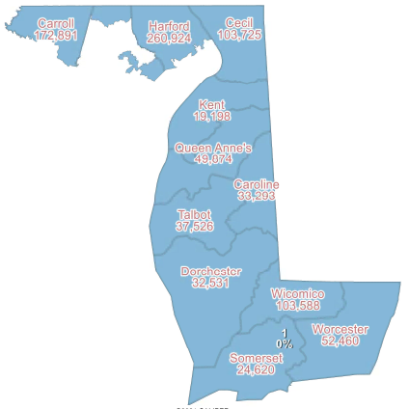
District 1
District 1 was under underpopulated by about thirty thousand people. The Least Change plan takes those people from District 8, in Carroll County, rounding out the formerly more concave northern arm of the district.

District 6
Before the middle districts could be balanced out, District 6 needed to lose about fourteen thousand people. To minimize the change in the district’s perimeter, the plan moves these people from one of the more populous regions of the district, Montgomery County. Only a couple of voting districts were shifted out of District 6 and into District 8.

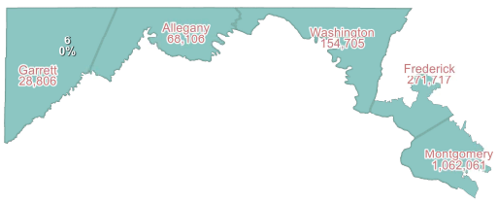

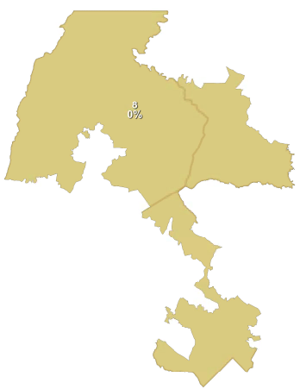
District 8
Though initially overpopulated, District 8 became underpopulated after shifting some of its population to District 1. The plan adds more voters in from the eastern portion of Montgomery County, formerly in District 3. Again, only a couple of voting districts required adjustment.

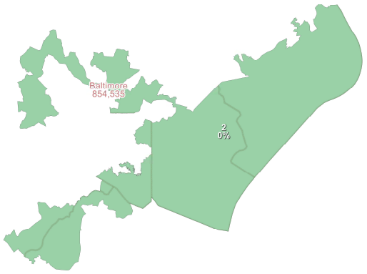

District 2
This district was overpopulated by nearly twelve thousand people. Those people were taken from western Baltimore County and moved to District 7, which was initially underpopulated.

District 7
This was the most underpopulated district in the state. Even after receiving some population from District 2, it still needed over fifty thousand more people. These people came from District 7’s only remaining neighbor, District 3, in northern Baltimore City.

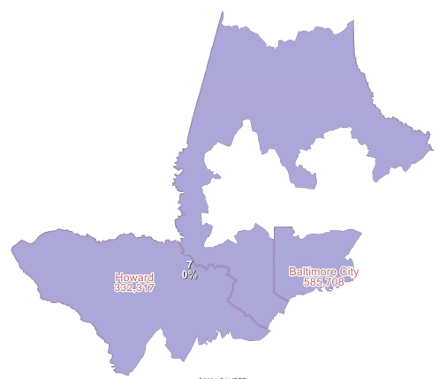

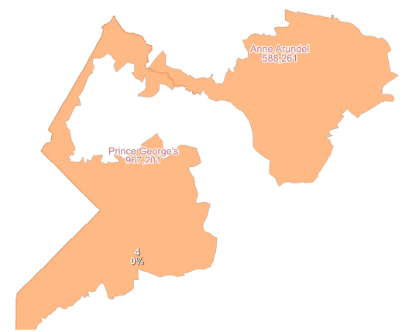
District 4
This district was overpopulated. Its excess population needed to be moved in to District 3 (which had become underpopulated after lending its population to balance District 7). This population was taken from Anne Arundel County, to help smooth out the district’s border.

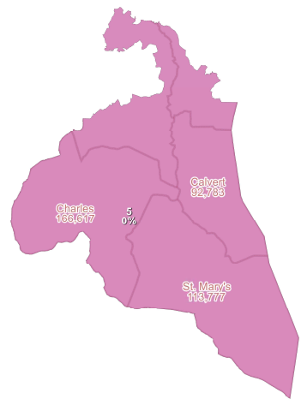

District 5
District 5 likewise needed to contribute its excess population to District 3. Its only border with District 3 is in Anne Arundel County, so that border was pulled south to move the twenty-five thousand people out of the district.

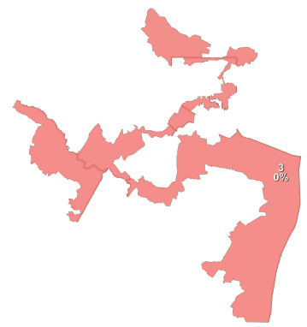

District 3
With these contributions from District 4 and 5, District 3 achieved the ideal population.

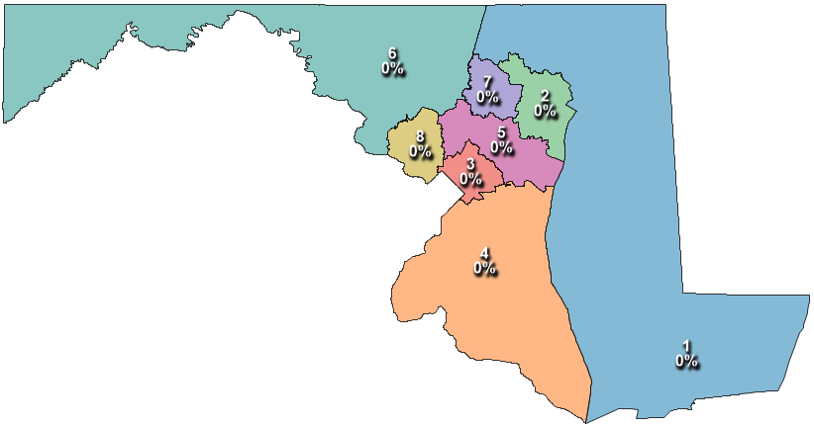
- Good Government Plan
This plan was created from scratch, without the existing plan as a backdrop. It sought to create districts that were compact while splitting as few counties, cities, and towns as possible. The below description explains how each of the plan’s districts came to be.
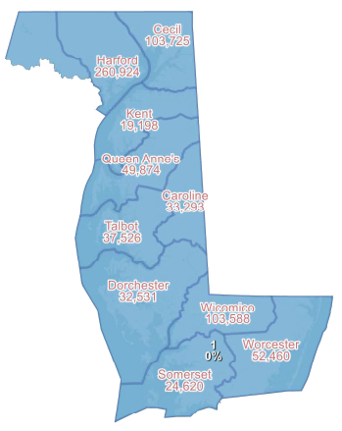

District 1
Respecting the natural boundary of the Chesapeake Bay requires District 1 to extend up the eastern side of the state and around into Baltimore County. The northern portion of Baltimore County joins the eastern shore to fill out the plan’s first district.

District 6
Starting on the western tip of the state, District 6 extends all the way through Carroll County to meet the western edge of District 1 and flows south into Montgomery County fill out its population.
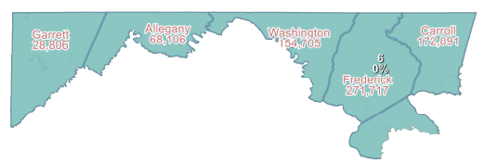

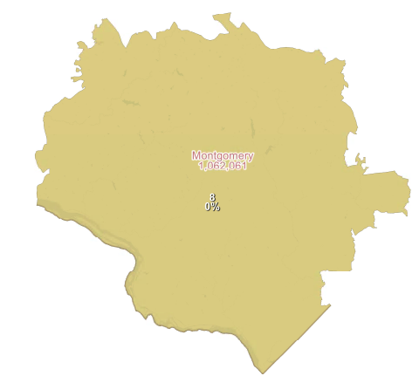
District 8
Beginning from the southern edge of District 6, District 8 fills in the central part of Montgomery County. It is the map’s only district composed of a single county.

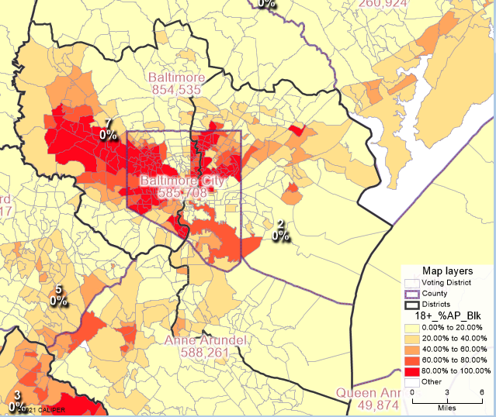
Districts 7 and 2
This was a major choice point in the plan’s creation. Section 2 of the Voting Rights Act very likely requires a Black opportunity district in the Baltimore area. The Black community is heavily concentrated in Baltimore and several cities to the west of it. Baltimore City cannot constitute a congressional district on its own, and the only neighboring counties are Anne Arundel, to the south, and Baltimore County in every other direction.
The plan elects to split Baltimore City County from north to south. Concerns for compactness largely motivated this decision. Splitting the county enabled the creation of two more circular districts, while keeping Baltimore City in one district would require another district to wrap around it, creating a shape more like a crescent.
District 7 takes the western portions of Baltimore County and Baltimore City. It’s voting age population is 50.1% Black (49.7% adjusted Nonhispanic Black), so it complies with the VRA. District 2 takes the eastern side and extends down into Anne Arundel County for extra population. It’s voting age population is close to 30% Black.

Heat map showing the Black voting age populations in Baltimore and Baltimore City

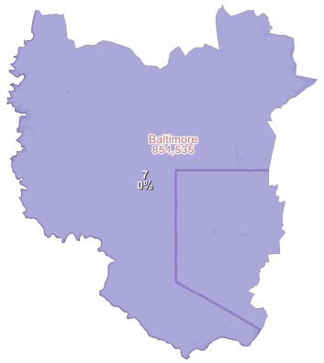

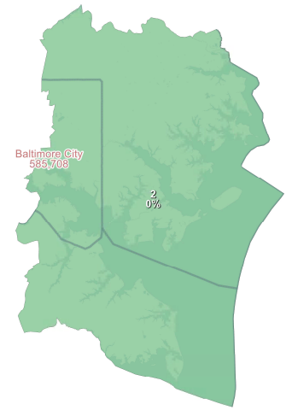

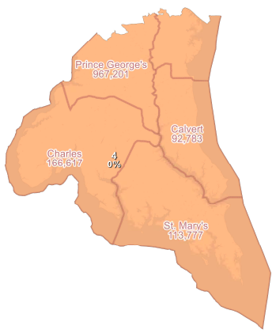
District 4
The Voting Rights Act likewise requires a Black opportunity district in the southeastern portion of the state. Prince George’s County contains nearly one million people and is over sixty percent Black. To the south, Charles County also houses a substantial Black population.
Working up from the bottom of the state, District 4 reaches about halfway up Prince George’s County and across from there into Anne Arundel. It’s voting age population is 52.1% Black (51.4% adjusted Nonhispanic Black).

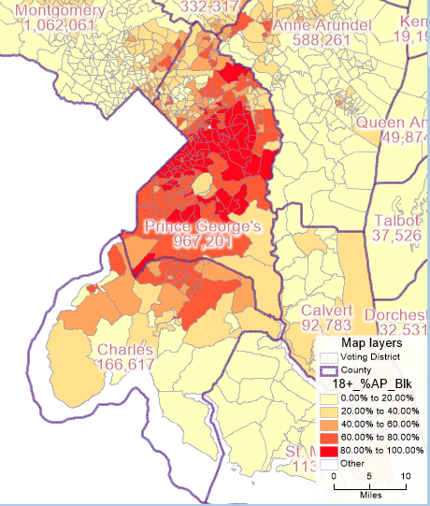

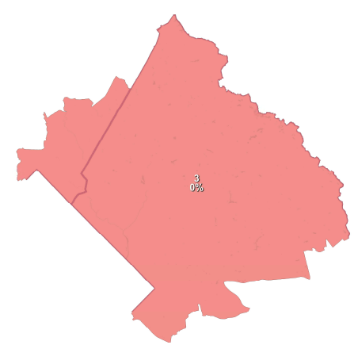

Heat map showing the Black voting age population in Prince George’s County
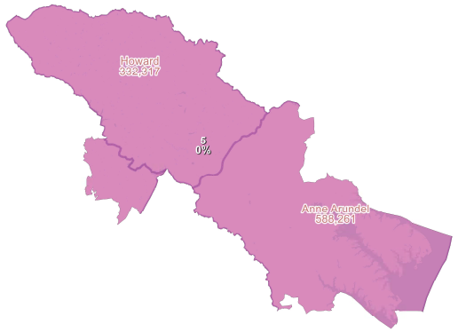

Districts 3 and 5
District 3 absorbs the remainder of Prince George’s County and tacks on a sliver of Montgomery County. The district’s voting age population is 50.7% Black (49.4% adjusted Nonhispanic Black).
This leaves the final district, District 5, to fill in the rest of Howard County, and the final pieces of Montgomery County and Anne Arundel.

- Comparisons with the Existing Plan, Commission Plan, and Adopted Plan
Maryland’s existing plan
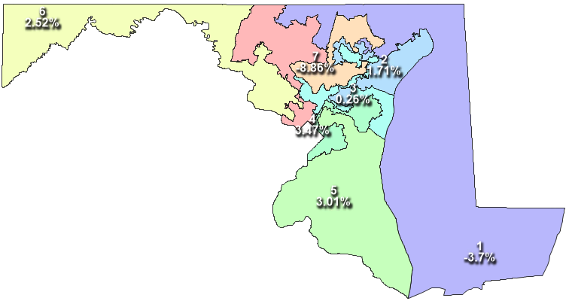

The Commission Plan
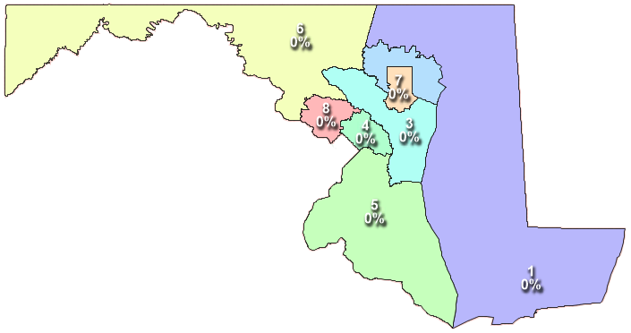

The Adopted Plan

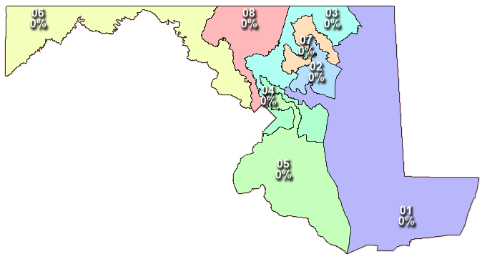

By executive order in January 2021, Maryland’s governor created an independent, nonpartisan redistricting commission, the Citizen’s Redistricting Commission (Commission). The order stated, among other things, that “it is a conflict of interest for politicians to redraw the districts in which they run for re-election” and that “Maryland nonpartisan redistricting reform has been overdue for decades.” It charged the Commission with producing a congressional redistricting plan that complied with state and federal law, respected natural boundaries and political subdivision lines, and was geographically compact. The order also barred the Commission’s plan from accounting for voters’ political affiliations and incumbents’ residences. The Commission created such a plan and presented it to the state legislature for consideration.
While the Commission worked to create a map pursuant to the governor’s executive order, legislative leaders appointed a different redistricting commission. Once both commissions submitted their final proposals, the legislature rejected the Commission plan and voted to adopt their own commission’s plan instead (hereinafter, the Adopted plan). Maryland’s governor vetoed the plan, but the legislature then voted to override his veto, passing the plan into law on December 3, 2021. Within the month, at least two lawsuits were filed challenging the Adopted plan as a partisan gerrymander.
This portion of the report will explore the similarities and differences, across a range of features, between Maryland’s existing plan, Least Change plan, the Good Government plan, the Commission plan, and the Adopted plan.

- Contiguity
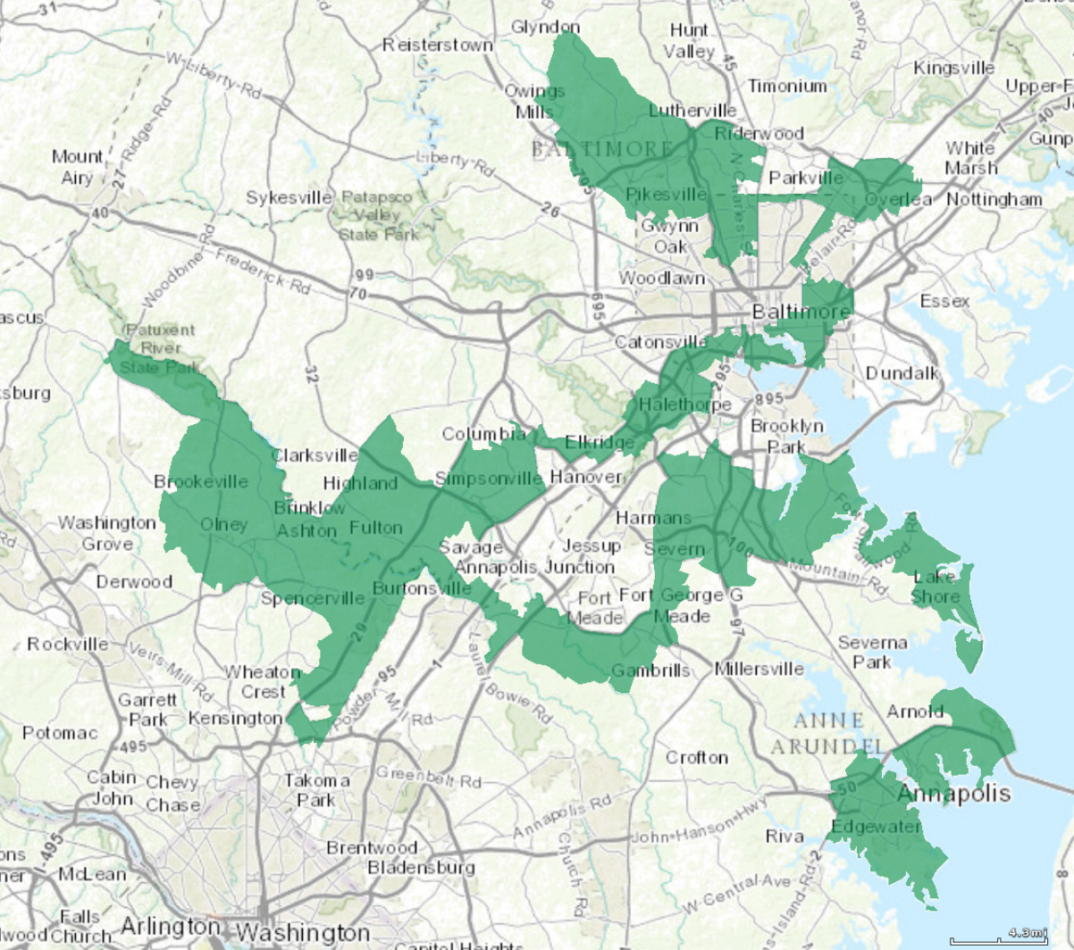
All the districts in the existing plan are contiguous, but not all are fully contiguous by land. Maryland’s geography makes full contiguity by land impossible. Scattered islands run all along the Chesapeake Bay, so any congressional plan will have to include some districts with pieces contiguous only via bridges or by water. Still, the existing plan also creates non-contiguous districts where they are not geographically required. Specifically, District 3 in the existing plan snakes along the eastern side of Anne Arundel County, connecting several of its peninsular edges. Though these land masses connect at their base, their base is in a different congressional district. At least in District 3, the existing plan ignores the traditional preference for contiguity by land. Respecting these existing lines, the Least Change retains them, despite the creation of a district contiguous only by water.
Maryland’s existing District 3
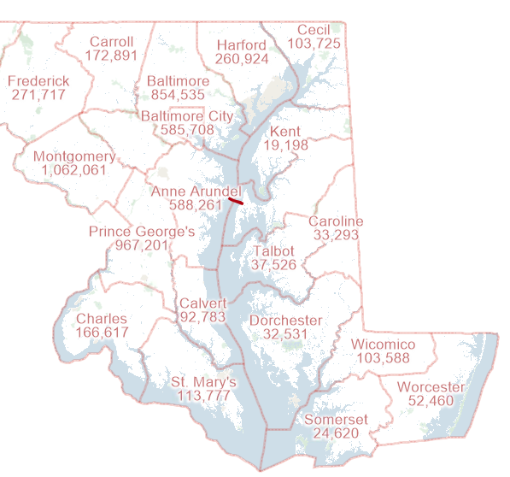
The existing plan does respect the natural boundary created by the Chesapeake Bay. Although the Chesapeake Bay slices Maryland nearly in two, the plan works around the natural boundary by assigning the entire eastern part of the state to a single district (District 1). The Least Change plan does the same.
The Chesapeake Bay Bridge
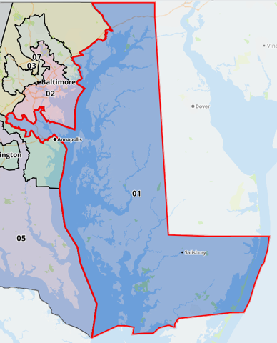
Though there is one bridge across the bay, connecting Anne Arundel County to Queen Anne’s County, this single bridge seems too thin a thread with which to sow a congressional district. In the interest of genuine geographic contiguity, The Good Government also declines to cross the water. Unsurprisingly, given its commitment to respecting natural boundaries, the Commission plan follows suit.
Singularly, the Adopted plan creates one district straddling the Chesapeake Bay. The plan keeps the entire eastern shore unified but then tacks on a piece of Anne Arundel County, using the Chesapeake Bay Bridge to link the land together. It is the only plan which crosses the bay, and it creates a county split in the process.

Adopted Plan District 1, straddling the Chesapeake Bay
- Compactness
Even a cursory glance at Maryland’s existing plan reveals the map’s poor scores on compactness. Almost every district has long arms spiraling in some way around the others. District 3 (pictured above) is one example, but many of the other districts are similarly amoebic. Because the Least Change plan attempts to preserve this existing plan, it receives nearly equivalent compactness scores. Indeed, the Least Change plan exactly matches the existing plan scores on Reock, Population Circle, and Ehrenberg. It comes within 0.01 of the existing plan on Polsby-Popper, Population Polygon, and Area Convex/Hull.
The Good Government plan and Commission plan both improve compactness in every district on area- population- and perimeter-based measures. Only Length-Width compactness puts the existing plan and the Least Change plan at an advantage. Several districts in the existing plan and the Least Change plans rely on their extended arms to balance out their lengths and widths. Because the Good Government and Commission plans lop off some of these arms, they suffer on this compactness measure.
The Good Government plan slightly outperforms the Commission plan on most measures, though their scores differ by less than 0.1 in most categories. The differences between the Good Government plan and the Commission plan stem largely from their differing treatment of Baltimore City County and the surrounding area. While the Good Government plan creates two somewhat circular districts in this region, the Commission plan creates a crescent-shaped district embracing Baltimore City. Of course, the marginal increase in compactness here comes at the expense of other important redistricting values. In particular, the Good Government plan’s emphasis on compactness costs it a county split in Baltimore City.
The Adopted plan also improves on the current compactness scores, but by a significantly smaller margin. Its scores are unimpressive by comparison to either the Adopted plan or the Commission plan. The Adopted plan’s perimeter exceeds the Good Government’s perimeter by over 700. On Reock, Schwartzberg, and Polsby-Popper, the Adopted plan’s most compact districts receive lower scores than the average district in the Good Government plan.
Overall, the Good Government plan receives the best compactness scores. The Commission plan finishes close behind, while the Adopted plan takes a distant third. See compactness reports for each map below.

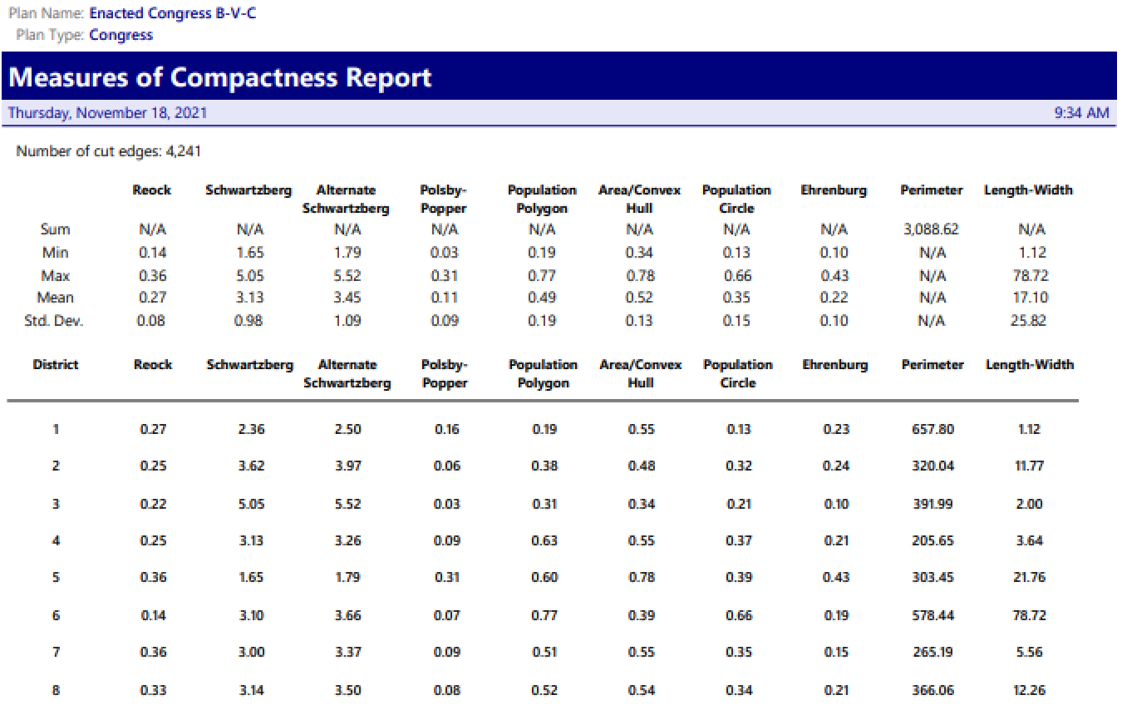
Existing Plan Compactness Scores:

Least Change Plan Compactness Scores:
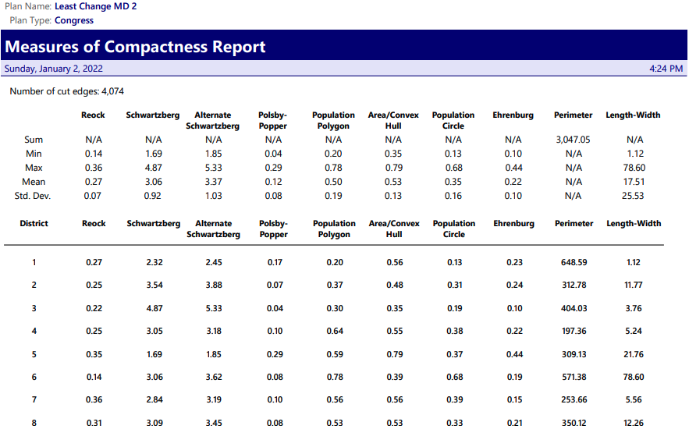

Good Government Plan Compactness Scores:
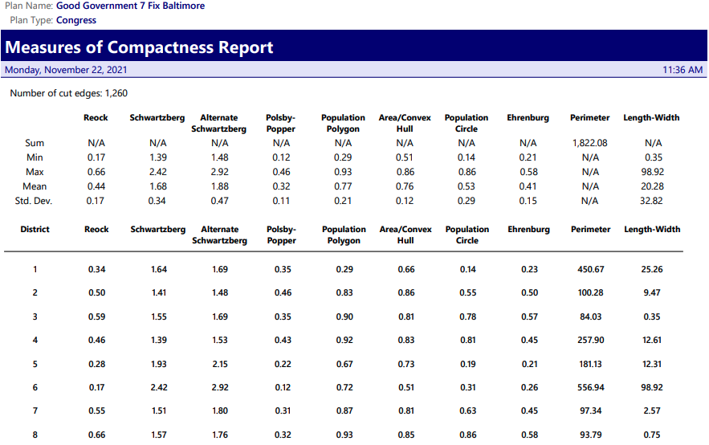

Commission Plan Compactness Scores:
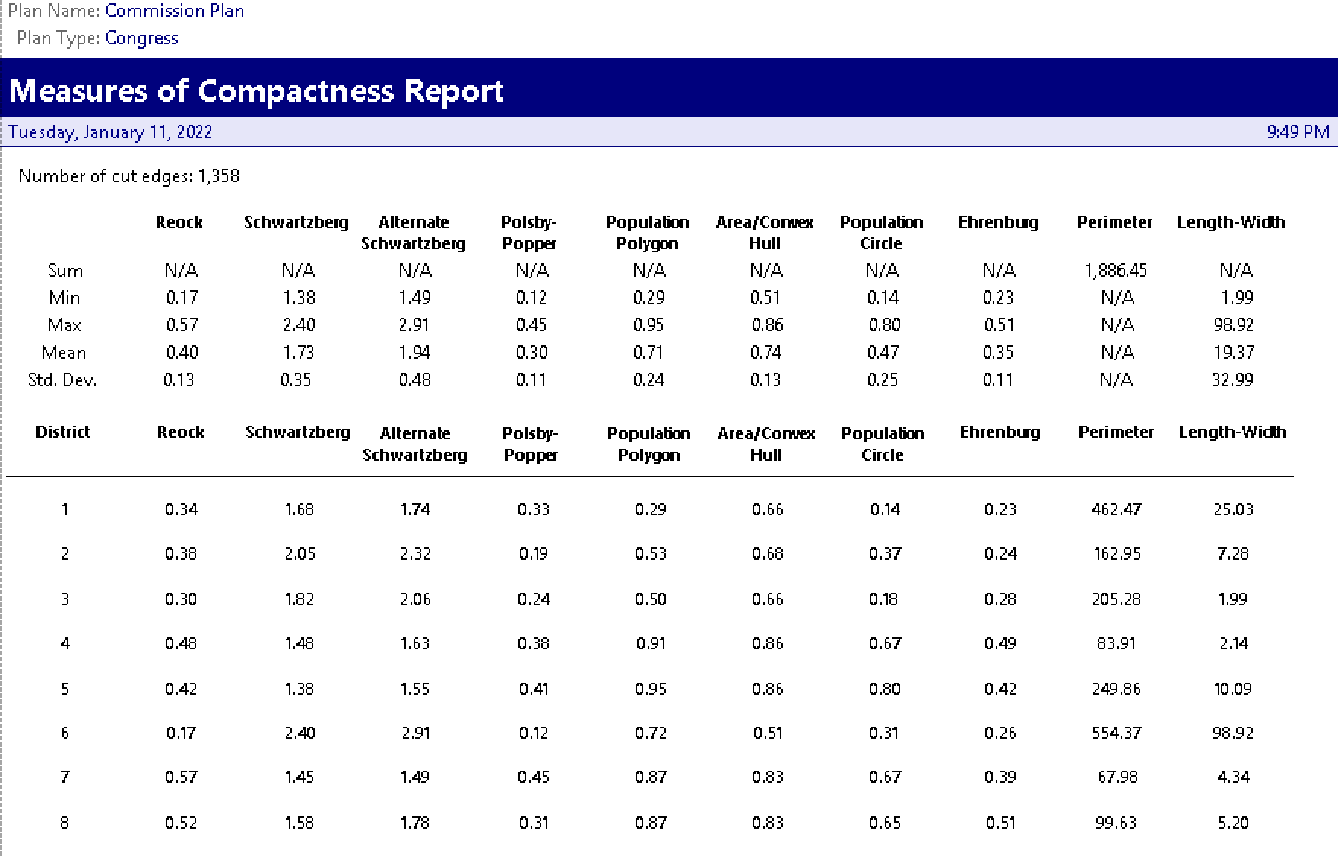
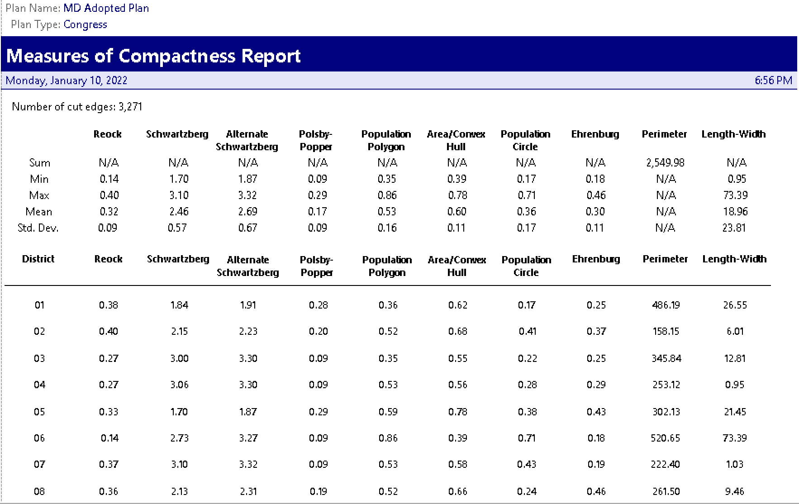
Adopted Plan Compactness Scores:

- Political Subdivision Splits
  - Counties
Due to population alone, three of Maryland’s counties must be split. Baltimore, Montgomery, and Prince George’s County all have populations greater than 771,626, so they are each too populous to fit in any single district.
Maryland’s existing plan splits nine of the state’s twenty-four counties. Predictably, the Least Change plan follows suit, splitting the same nine. More surprisingly though, the Adopted plan also splits these same nine counties. It does have four fewer splits than the existing plan, since it only splits one county—Montgomery—into more than three parts. Still, the Adopted plan does not substantially improve on the existing plan’s treatment of county lines.
The Good Government plan, unsurprisingly, makes fewer county splits. It splits five counties in total and splits them fewer times. As in the Adopted plan, only Montgomery County is split into more than three districts. As discussed above, the Good Government elects to split Baltimore City. Here, the map places over three hundred thousand residents in District 7 and the other quarter million in District 2.
The Commission plan does even better than the Good Government plan. It also splits five counties, but splits none of them into more than three pieces. Four of these five counties are the same ones split in the Good Government plan: Anne Arundel, Baltimore, Montgomery, and Prince George’s. The Commission’s fifth county split happens in Calvert County. There, a little over seven thousand of Calvert’s ninety-three thousand residents were moved to District 5, while the rest remained in District 3.
  - Voting Districts
The existing plan splits fifty-four voting districts. The Least Change plan marginally improves on this measure, reducing split voting districts to fifty.
The Good Government plan also splits fifty voting districts. The plan prioritizes keeping cities and towns whole. Because voting district lines seldom match city/town boundaries, keeping more cities whole requires splitting more voting districts.
The Commission plan only splits twenty-three voting districts—by far the fewest of any plan considered here. The Adopted plan, by contrast, splits a whopping 118 voting districts—more than double the splits of any other plan.

- Communities of Interest - Cities and Towns
The existing plan splits eighty-five cities, and splits fourteen of them into more than two districts. The Least Change plan splits eighty-nine cities, thirteen of them more than once.
The Good Government plan prioritizes keeping cities whole, and it manages to split only a fraction of the municipalities that the other two plans do. In all, the Good Government plan divides only thirteen cities, and no city is split into more than two districts.
The Commission plan also improves on the existing plan, though it splits twice as many cities as the Good Government plan, at twenty-eight. The Adopted performs even more poorly, splitting seventy-eight cities/towns, five of them into three different districts.

- Demographics and Minority Representation
The Least Change, Good Government, Commission, and Adopted plans each create three districts with plurality-Black voting age populations. In each plan, Black voters have considerable sway, if not complete control, of election outcomes in those districts. Of course, the plans do not allocate voters in exactly the same ways. They each confront tradeoffs between placing more minority voters together, where they will be more powerful and more accurately represented, and spreading minority voters out where they can have more influence across a broader range of districts.
The Least Change plan does create three plurality Black districts, but one of them just barely qualifies. District 5 is 41.5% Black and 41.3% white. By cutting it so close here, the Least Change plan is able to create another district with a large Black influence: District 2, with a 35.1% adjusted black voting population. In addition to its three plurality Black districts, this district gives Black voters a substantial influence on elections. Especially since district is less than 50% white, Black voters and other racial minority voters may coalesce to elect their candidate of choice.
Black votes easily outweigh white voters in the Good Government plan’s three plurality Black districts (Districts 3, 4, and 7). Like District 2 in the Least Change plan, District 2 in the Good Government plan also provides for substantial Black influence. The voting age population is over 31% Black—approximately the same as the statewide proportion of Black voters. Although District 2 is majority white, Black voters constitute a large enough interest group that they will be able to exert a meaningful influence on elections there.
Among the Commission’s three plurality Black districts, two are majority Black (Districts 5 and 7). The third, District 4, is only 45% Black—a smaller percentage than any of the Good Government plan’s plurality Black districts. However, the Good Government plan only contained one majority Black district. Further, District 4’s voting population is still only 21% white—less than half of its Black voting population. Like the other plans, the Commission plan’s District 2 provides for Black influence, even in a white majority district. Black voters compose 32% of the voting population there.
The Adopted plan also creates two majority Black districts. It’s third black plurality district is weaker than both the Commission’s and the Good Government plan’s, at only 43% Black and 38% white. District 2 also comes out weaker for Black voters. Its voting population is only 26% Black, and with a 56% white voting population, white voters outnumber Black voters more than two to one.
Least Change Demographics:
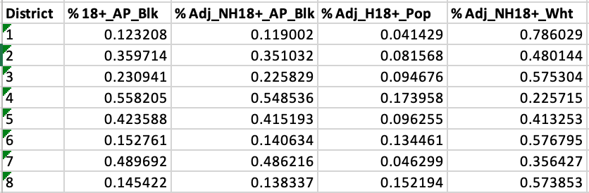

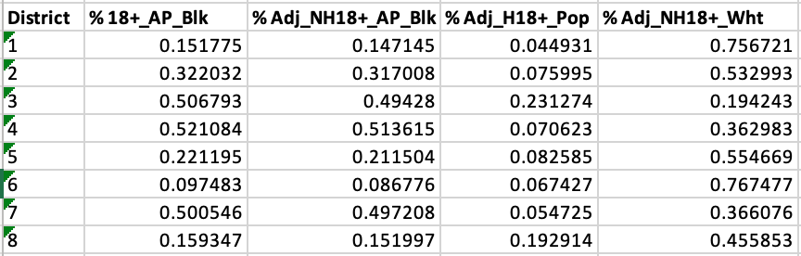
Good Government Demographics:

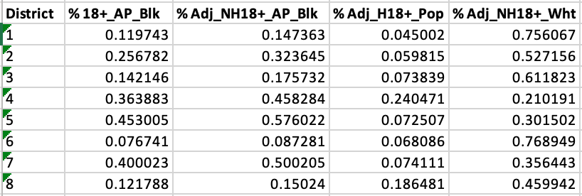
Commission Plan Demographics:

Adopted Plan Demographics:
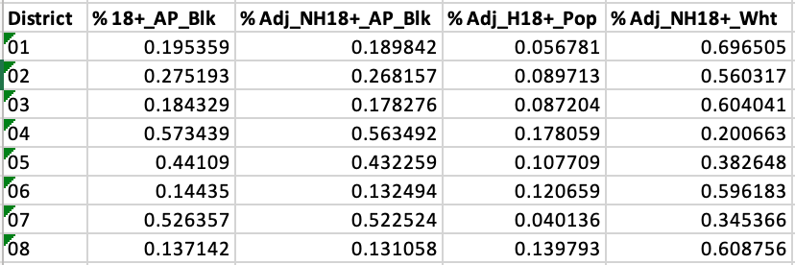
- Partisan Fairness and Competition
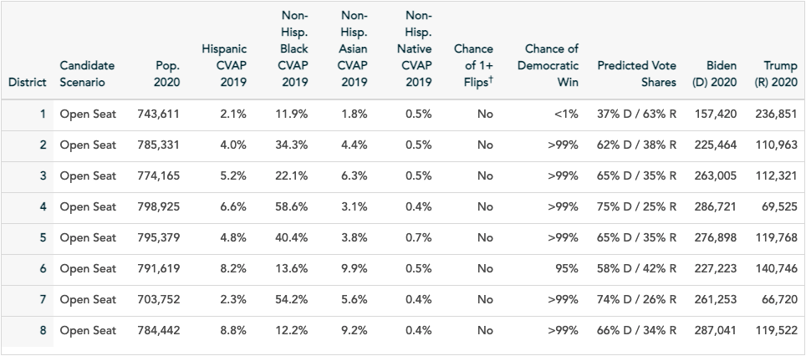
Maryland’s existing plan is a well-known Democratic gerrymander. According to PlanScore, the parties’ statewide vote shares are 63% Democratic and 37% Republican. However, the redistricting population data set shows the state is 67% Democratic and only 33% Republican. In either case, the existing plan gives Democrats more than their fair share of districts, creating only one solidly red district, District 1, along the state’s eastern side. The existing plan results in seven solidly Democratic districts. In six of these, the chance of a Republican win is less than one percent. In District 6, the most “competitive” of the state’s districts, the odds are still over nine in ten for a Democratic victory.
Existing Plan partisan data

The Least Change plan, predictably, creates nearly identical partisan imbalances, achieving the same political goals as the existing plan. It creates one solidly Republican and seven solidly Democratic districts. Again, the most competitive district is District 6, where Republicans have a mere six percent chance of an election win.
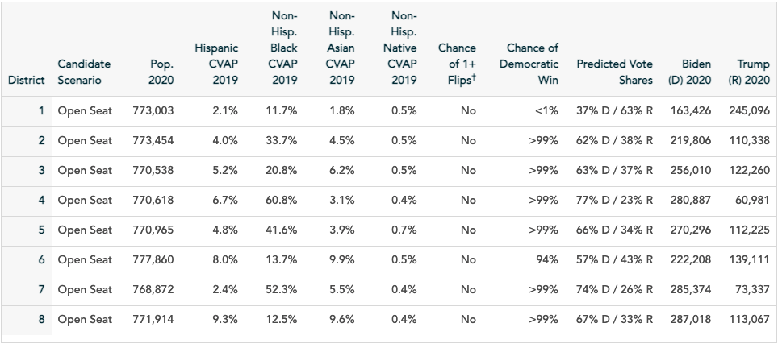
Least Change partisan data
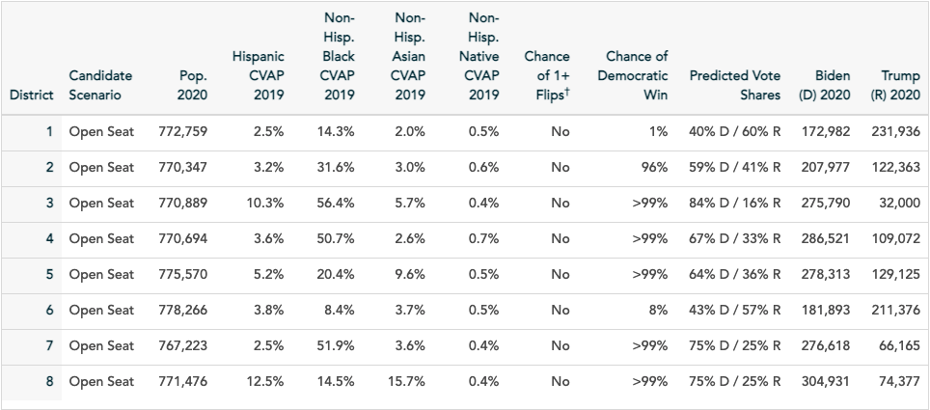
The Good Government plan evens out the state’s political arena, though it still slightly favors Democratic votes. It creates two solidly Republican districts: District 1 on the eastern shore, and District 6, the state’s northwestern arm. The other six districts remain solidly blue, with Democratic odds greater than ninety-five percent.
Good Government partisan data
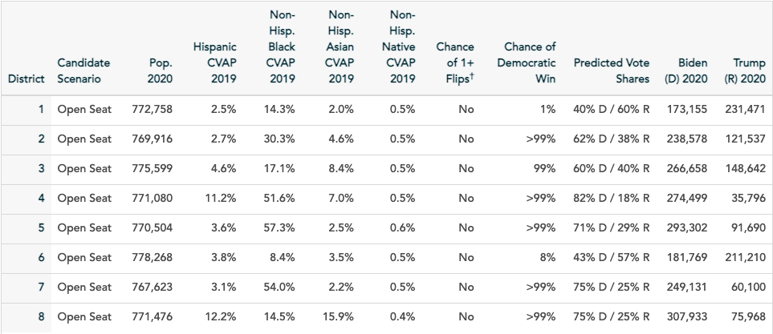
The Commission plan likewise creates a more even political playing field. However, it creates two solidly Republican districts: again, the eastern and northwestern portions of the state. In fact, the competitiveness of the Commission plan is nearly identical to the Good Government plan. Between the two, only District 2 differs by more than a percentage point.
Commission Plan partisan data
The adopted plan is easily the most competitive of the maps considered here (though the degree of competition remains severely limited). Indeed, it is the only plan containing a district that is not “solidly” held by either party. The adopted plan’s District 1, on the eastern shore, is only “leaning” Republican. The district is 47% Democratic, giving Democrats a 25% chance of prevailing in an election. Predictably, the other seven districts remain solidly blue. The creation of this one competitive district adroitly serves the interests of the Democratic legislature that adopted it. Where once lay a single Republican stronghold, now lies the potential for an eighth Democratic victory.
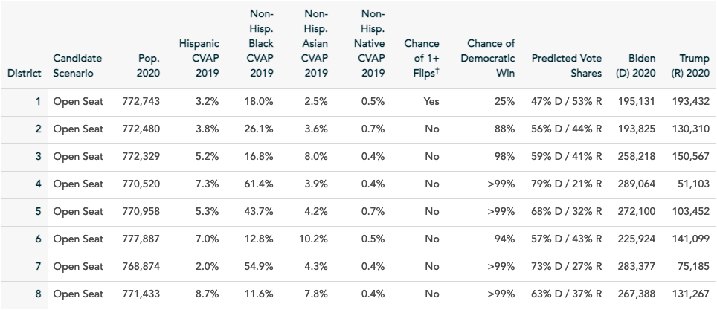
Adopted Plan partisan data

- Conclusion
Without explicit directives from the state constitution, redistricting in Maryland remains dominated by party interests. The Adopted plan underperforms the Good Government plan and the Commission plan on contiguity, compactness, political subdivision splits, communities of interest, minority representation, and partisan fairness. The Maryland legislature actively rejected the Commission plan, despite its superiority across all these parameters. The Adopted plan does not pretend to be anything other than a political power-grab, hardly more disguised than Maryland’s existing infamous gerrymander. Maryland citizens deserve a “good government”—one that strive for genuine representation, respecting political subdivisions and communities of interest and uplifting all voices as equitably as possible. The Adopted plan does not do this, and our democracy will suffer for it.

Both plans can be found at https://drawcongress.org/state/maryland/. The plan referred to here as the Least Change plan is titled “Least Change.” The plan referred to as the Good Government plan is titled “Compact, Cities Intact.”
See Wesberry v. Sanders, 376 U.S. 1 (1964).
Shaw v. Reno, 509 U.S. 630, 658 (1993).
See Miller v. Johnson, 515 U.S. 900, 916 (1995) (stating that a plaintiff must show that race was the predominant factor motivating the redistricting plan to trigger strict scrutiny under the 14th Amendment).
Thornburg v. Gingles, 478 U.S. 30, 50-51 (1986).
There are enough Black voters in these counties to comprise three majority-Black districts. However, the VRA does not require overrepresentation for any minority group. Black voters comprise only 31% of the voting age population, so they are entitled to no more than two opportunity districts out of the eight total congressional districts in the state.
Unfortunately, the adjusted data set is incomplete. The adjusted data only includes the Nonhispanic Black voting age population. It does not include Hispanic Black voters. For this reason, this report will provide both the adjusted Nonhispanic Black voting age population and the unadjusted, any-part Black voting age population when discussing the districts’ Black voting population.
Maryland Executive Order 01.01.2021.02.
Id.
Id.
Neil Parrott v. Linda Lamone, C-02-CV-21-001773; Katherine Szeliga v. Linda Lamone, C-02-CV-21-001816.
These nine counties are Anne Arundel, Baltimore City, Baltimore, Carroll, Frederick, Harford, Howard, Montgomery, and Prince George’s.
This section uses only the Adjusted Nonhispanic Black voting age population to refer to Black populations in these districts. Because it excludes Hispanic Black voters, these numbers slightly underestimate the true Black coting age population.

