Colorado Congressional Plans
Least Change and Good Government
- Introduction
This report presents two congressional redistricting plans for the state of Colorado. The first proposed plan, called the Least Change plan, attempts to change Colorado’s existing congressional districts as little as possible. Though conceptually straightforward, creating a Least Change plan for Colorado this redistricting cycle proved especially challenging. The state has experienced substantial population growth since the last redistricting cycle, and it gained a new congressional district. Moving from a seven-district plan to an eight-district plan required making sizeable changes to the existing district lines. To keep these changes to a minimum, the Least Change plan locates Colorado’s new district entirely within El Paso County, where it can be created most compactly and with the shortest new perimeter.
The Least Change plan also faced challenges under article V of the Colorado Constitution. The constitution enumerates certain values that any congressional redistricting plan must incorporate. In the effort to change as little as possible, the plan had to simultaneously account for existing district lines while also maximizing compactness and preserving whole communities of interest and whole political subdivisions. The plan ultimately strikes a delicate (and hopefully constitutional) balance between promoting these prescribed values and minimizing change.
The second plan proposed in this report is called the Good Government plan. The Good Government plan’s central goal is to minimize county splits while maximizing compactness. Of course, it too must follow the constitutional command to preserve communities of interest. In some instances, Colorado’s cultural and economic communities of interest do not align with its county lines, forcing the Good Government plan to choose between preserving communities of interest and preserving political subdivisions. In these instances, the plan consistently chooses to preserve political subdivisions. This strategy allows it to achieve its goal of minimizing county splits without jeopardizing its constitutionality. The court (likely) allows for these tradeoffs between preserving communities of interest and preserving county lines.
The Good Government plan also faced the logistical difficulty of keeping Colorado counties whole while achieving geographic contiguity. Several counties in the state have non-contiguous pieces—islands of one county embedded in another. The Good Government plan had to bite the bullet and split these non-contiguous counties. However, in cases where the embedded islands had no residential population, the plan still made an effort to avoid further splits to the county, to keep the residential population unified in a single district.

- Legal Compliance
- Federal Constitution
At least since 1964, the Constitution has required congressional districts to be as equally populated as possible. All districts in both of the proposed plans comply with this “one person, one vote” requirement. Colorado’s population (5,773,714 people) does not divide evenly by eight, so some districts deviate by a single person. In both plans, there are six districts with 721,714 people and two districts with 721,715.
The Fourteenth Amendment's Equal Protection clause also imposes requirements on congressional redistricting plans. Shaw v. Reno held that a congressional redistricting plan runs afoul of the Fourteenth Amendment if it is “so irrational on its face that it can be understood only as an effort to segregate voters into separate voting districts because of their race, and that the separation lacks sufficient justification.” Here, neither proposal is so irrational. Both maps adhere to traditional redistricting principles, like compactness, population equality, and the minimization of change and of political subdivision splits. Race is not “the predominant factor” dictating district lines.
- Voting Rights Act
Both plans also comply with the Voting Rights Act (VRA). Section 2 of the VRA protects against racialized vote dilution. In relevant part, section 2 states that the act will be violated if members of a particular racial class “have less opportunity than other members of the electorate to participate in the political process and to elect representatives of their choice.” As construed in Thornburg v. Gingles, section 2 requires the creation of a minority “opportunity district” where 1) the racial minority is sufficiently large and geographically compact to constitute a majority in a single-member district, 2) the racial minority is politically cohesive, and 3) the white majority votes sufficiently as a bloc to enable it usually to defeat the minority’s preferred candidate. The “opportunity district” need not be majority-minority, but it needs to provide the racial minority with a fair opportunity to elect their candidate of choice.
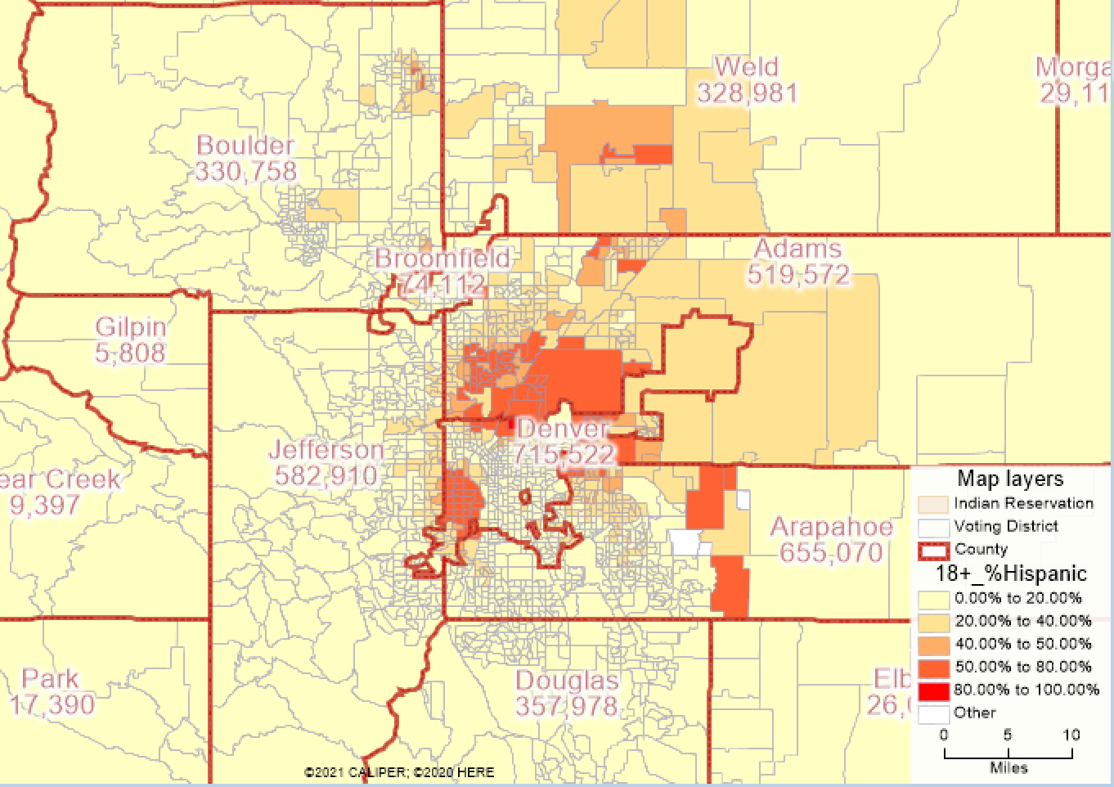
Section 2 does not compel the creation of any minority opportunity districts in Colorado. The first Gingles criterion is not met: there is no racial minority large and geographically compact enough to constitute a majority in a single district. Hispanics make up the state’s largest racial minority group, at 19.16% of the voting age population. Denver, Arapahoe, and Adams County house most of the state’s Hispanic population. Despite the proximity of these counties, there are still not enough Hispanic voters to meet the Gingles requirement.
Left: Heat map showing Hispanic voting age population in Denver, Arapahoe, and Adams County

Below: An experimental district superimposed on the same heat map, drawn to maximize the Hispanic voting age population
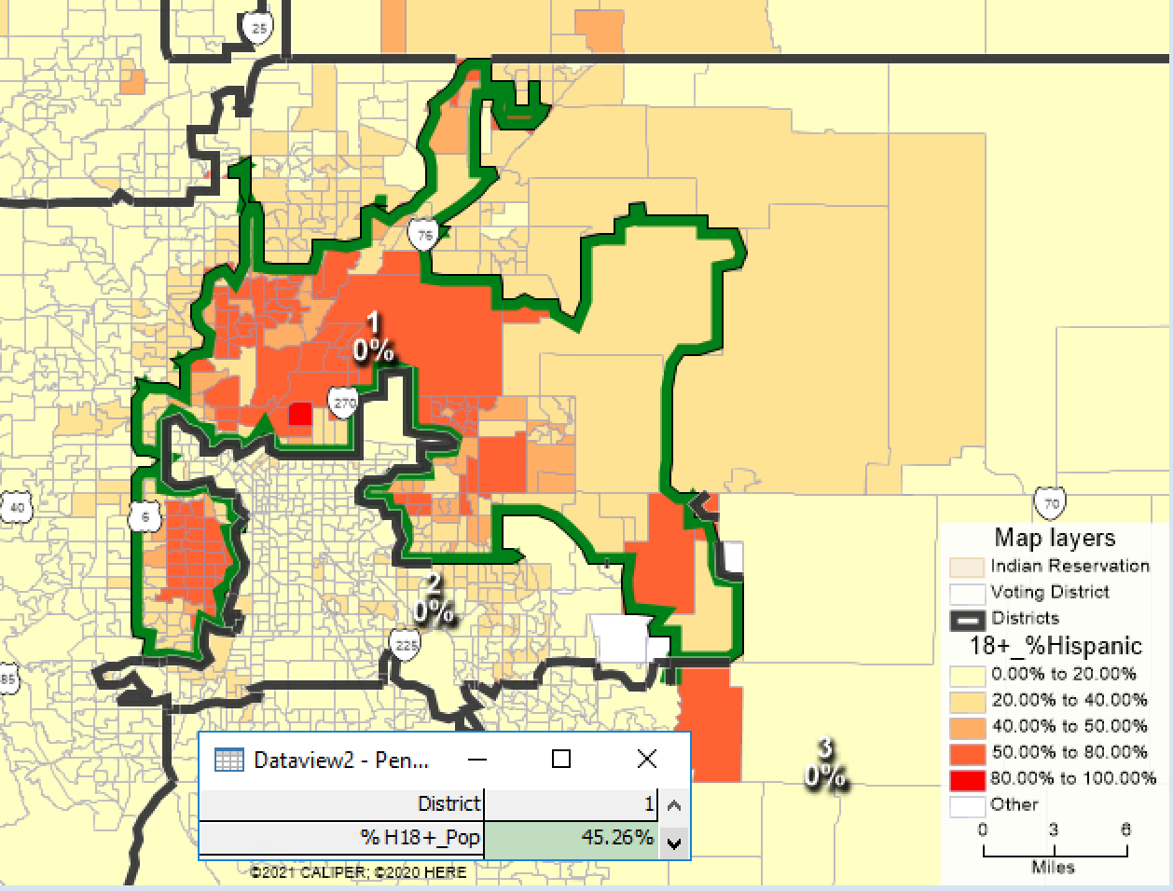
This experimental map combines the most heavily Hispanic voting districts in the state to create a single congressional district. Despite cherry-picking voting districts exclusively based on race, this district’s voting age population is still only 45.26% Hispanic. Using the citizen voting age population, the percentage drops to 29%.
Even if there was a way to draw a Hispanic-majority district in this area, it would still not necessarily trigger section 2 of the VRA. In fact, such a district may itself violate the constitution. The district at issue in Shaw was a majority-Black district meandering down the I-85 corridor in North Carolina, connecting Black communities along the way. The Supreme Court held that the district had to be examined with strict scrutiny because it attempted to segregate voters based on race. The Court then held that the district did not meet this constitutional test, so it had to be struck down.
The same fate would likely befall a Hispanic-majority district in Colorado. As in Shaw, the district could only be explained as a racial gerrymander—traditional redistricting principles would not produce such a delicate composite. Because Shaw, later elaborated by Miller, prohibits the use of race as the predominant factor in drawing district lines, the district would be found unconstitutional.
The second and third Gingles criteria demand a racial polarization analysis. Such an analysis is outside of the scope of this paper. It is also unnecessary, since the first Gingles criterion is not met.
- State Law
In 2018, Colorado amended its state constitution to create an independent redistricting commission. The commission is composed of twelve appointees: four from the largest political party, four from the second largest, and four who are not affiliated with any political party. The commission must make a good faith effort to achieve mathematical population equality in their plan—justifying each variance—and the districts must be geographically contiguous. As much as reasonably possible, the districts must preserve whole communities of interest and whole political subdivisions. The districts must also be as compact as reasonably possible. Once these requirements are met, the commission must, to the extent possible, maximize the number of politically competitive districts.
Given these constitutional directives, it is not immediately clear whether the Least Change plan would be upheld by the Colorado Supreme Court. As much as the Least Chang plan tries to honor traditional redistricting principles like the preservation of political subdivisions and compactness, these concerns come second to the preservation of existing district lines—a value not mentioned in the Colorado constitution. Other plans, like the Good Government plan, do a much better job of preserving communities of interest and political subdivisions. The Least Change plan’s efforts seemingly fall short of the constitution’s command to pursue these values “as much as is reasonably possible.”
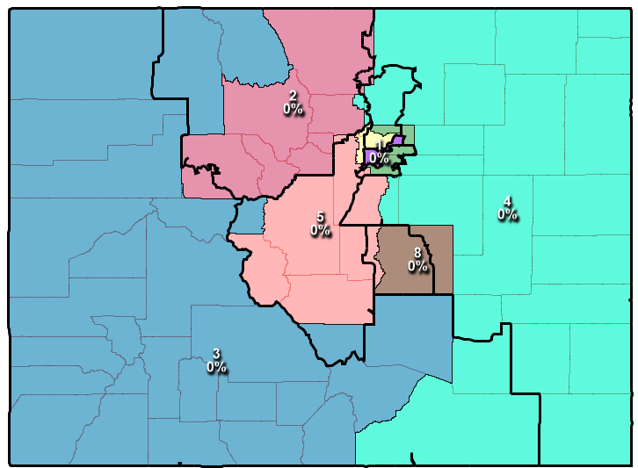
However, the map created by the independent redistricting commission (Adopted plan) splits more counties than the Least Change plan. It also receives worse scores on nearly every compactness measure. Despite these red flags, the Colorado Supreme Court upheld the Adopted plan, finding that it complied with the constitutional criteria. In fact, the court must approve any plan submitted by the commission “unless it finds that the commission…abused its discretion in applying or failing to apply the criteria.” Under this standard, the court will only reject a plan which “can only be explained as an arbitrary and capricious exercise of authority.” In approving the Adopted plan, the court discussed the communities of interest it preserves, many of which related to the state’s geography. The Least Change plan preserves many of these same communities (as discussed in further detail below). Since it also improves on county splits and compactness, it is likely the Least Change map would also be upheld by the court.
Least Change plan with Adopted plan overlayed in black.
The Good Government plan already prioritizes preserving political subdivisions and creating compact districts. Though it does not preserve as many cultural communities of interest as the Adopted plan (as discussed below), it makes far fewer county splits and outperforms the Adopted plan on most compactness measures as well. The court would likely find that the Good Government plan, like the Adopted plan, is a “reasonable choice among multiple alternatives.”
State law also pertains to the population data used to create congressional districts. In 2020, Colorado’s state legislature passed a law requiring the redistricting commission to count incarcerated people as residing at their last residential address, not their place of incarceration. However, the Colorado Supreme Court then ruled that the legislature had no authority to direct the decisions of the independent redistricting commission, so the commission itself had the final say. It opted to maintain the status quo, counting incarcerated people as residing at their places of incarceration. All the maps considered in this report were created using this unadjusted population data.
- Choice Points: How the Plan was Made
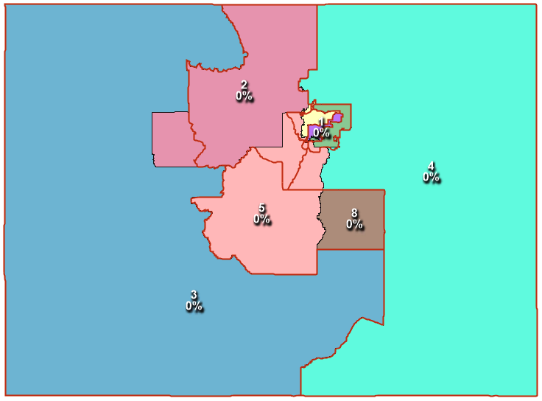
- Least Change Plan
Note: Existing plan is shown in red
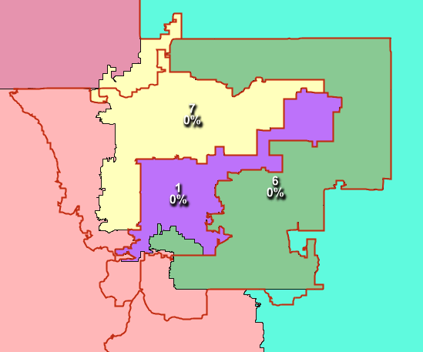
The Least Change plan sought to preserve existing district lines as much as possible while adjusting to meet population requirements. It does a decent job of preserving the existing lines with regards to Districts 3 and 4, and maintains similar shapes for Districts 1, 6, and 7. The biggest changes occurred in District 5, which made way for the new District 8 and had to expand northwards as a result. Below, each district is described in greater detail, in the order they were conceived for this plan.
Closeup of Denver, Arapahoe, and Adams County, showing the existing plan in red
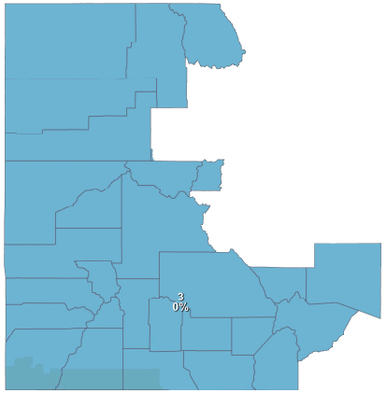
District 3
District 3 required very little adjustment to the population: it contained a little over thirty thousand surplus people. Every county in the existing district was whole, except for Eagle County, towards the center of the state, which was already split with District 2. The plan leveraged this existing county split and gave most of the rest of Eagle County to District 2, thereby balancing out the population.

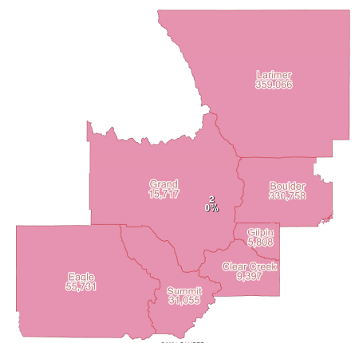
District 2
With the added population from District 3, District 2 was overpopulated by nearly 150,000 people. The plan removed Broomfield County from the district, adding it to District 7. It also removed the existing pieces of Jefferson County and Park County, adding them to District 5. Final population adjustments were made in Boulder, leveraging its exiting county split with District 4.

District 8
Colorado needed to gain a district. On the theory that creation of a new district from a single county would be the least disruptive to the current boundaries, the Least Change plan generates District 8 entirely from El Paso County, where Colorado Springs is located. Happily, the county was already exceptionally compact, and the new district could fit neatly within the former boundary of District 5.

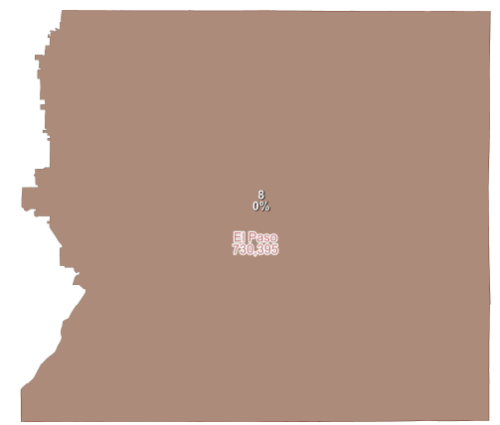

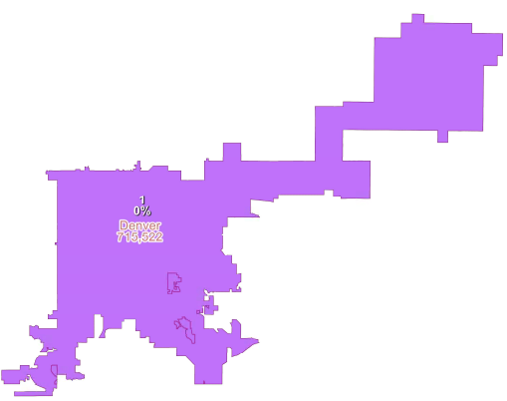
District 1
This district was composed of three different counties and needed to lose nearly 120,000 people. Denver County by itself contains almost the perfect population for a single district. However, some pieces of Arapahoe County and Jefferson County are fully embedded within Denver County. Because congressional districts must be geographically contiguous, these islands had to be included in District 1. The district still had slightly too many people after these adjustments, so Denver had to cede some residents to neighboring District 6.

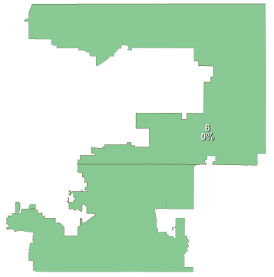

District 6
At this point, District 6 was overpopulated by nearly 200,000 people. The plan first removed the pieces of Douglas County hanging onto the district’s southern edge. It then ceded the western tip of Arapahoe County to District 5 to achieve the ideal district population.

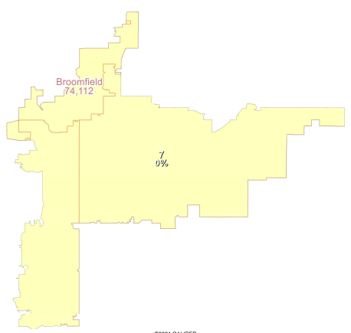

District 7
This district needed to lose about 150,000 people after having Broomfield County added in from District 2’s adjustments. The plan found these people in Jefferson County, reuniting much of the county’s northern area with its southern portions in District 5.

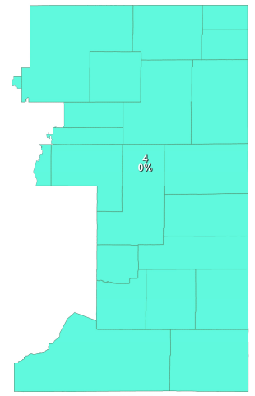
Districts 4 and 5
District 4 was able to sustain almost the same perimeter. At this point in the adjustment process, its only border with District 5 was in Douglas County. By allocating part of Douglas to District 5, both districts were able to achieve the ideal population.

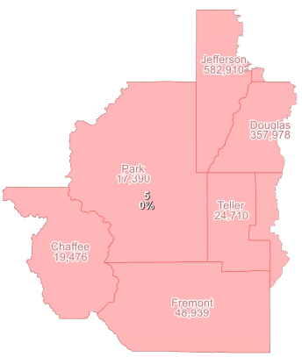

- Good Government Plan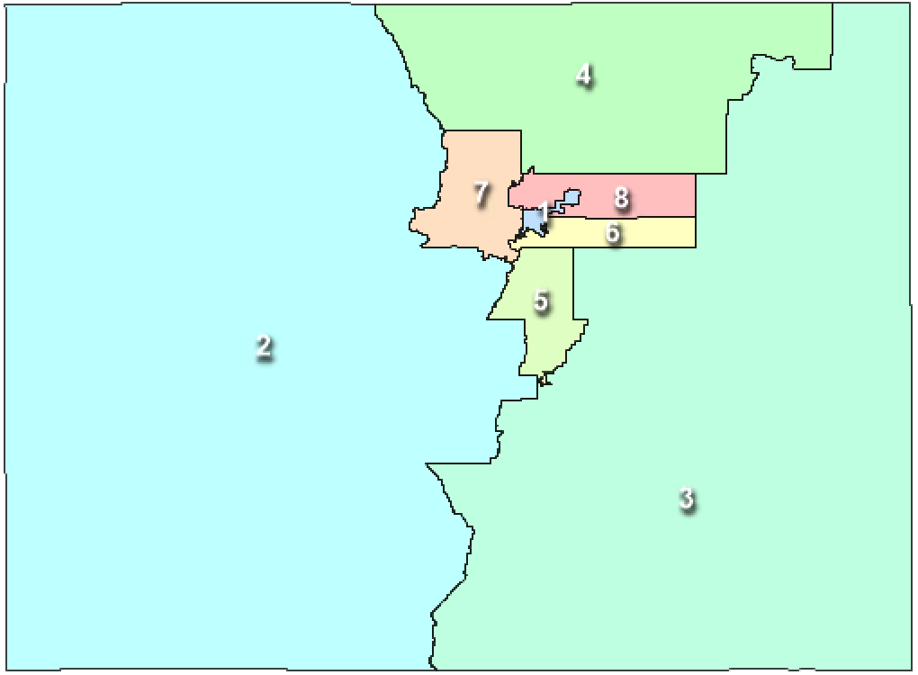
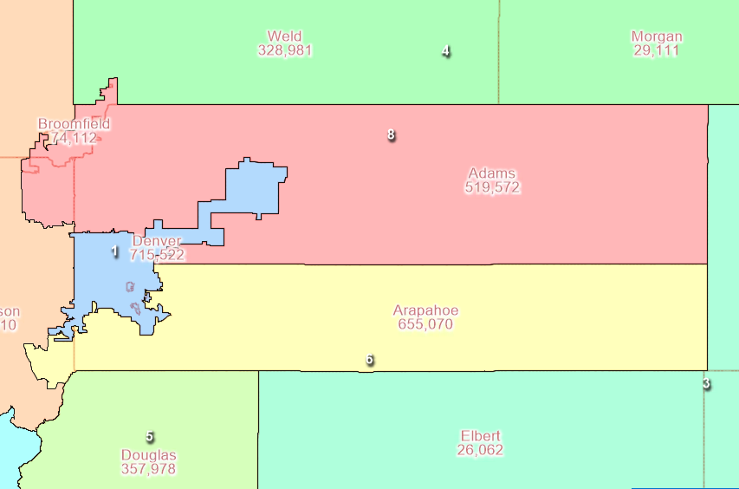
The Good Government plan prioritizes keeping counties whole. In particular, the map avoids splitting Denver, Arapahoe, Adams, and Boulder County. It also aims for compactness and tries to preserve communities of interest by pairing high-density counties with other high-density counties, keeping less populous counties together.

Closeup of Denver, Arapahoe, and Adams County
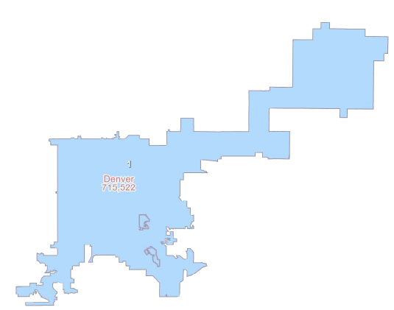

District 1
Denver County has 715,522 residents— nearly the ideal population for a congressional district. Adding in the embedded pieces of Arapahoe and Jefferson to ensure contiguity, the Denver district is slightly overpopulated. The plan subtracts just over 1,200 people from southern Denver to reach population equality.

District 6
Arapahoe’s population is concentrated just south of Denver, though the county stretches out to the west from there. The county needed about 70,000 more people to reach the ideal district population. The plan pulls residents from neighboring Jefferson County to fill out the district’s population.

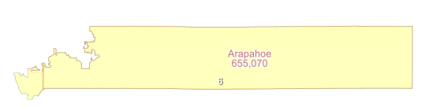

District 8
Adams County has the same long, rectangular shape as Arapahoe to its south. It likewise needed additional population to bring it to the ideal value. The plan adds on Broomfield County in the northwest and fills out the remaining population with the northeastern tip of Jefferson County. This keeps Adams and Broomfield consolidated without splitting another county (since Jefferson was already split to create Districts 1 and 6).

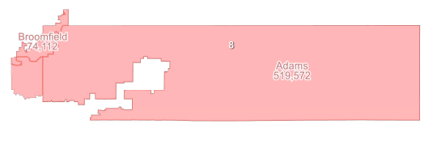

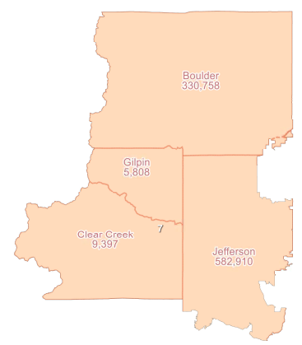
District 7
Ensuring Boulder County remains whole, the plan combines Boulder with Gilpin and Clear Creek to the south. Again, to avoid splitting another county, the plan takes residents from Jefferson to fill out the district’s population.

District 4
With the goal of preserving communities of interest, the plan tries to keep more densely populated counties together and put sparsely populated counties in their own districts. Larimer and Weld both have over 300,000 residents, so the plan puts them together. Adding Morgan County helps make the district more compact, and a final few thousand people from Logan County brings the population to the ideal.

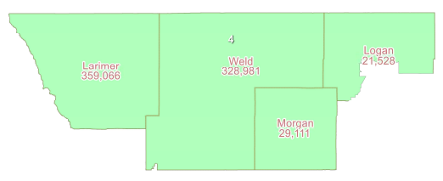

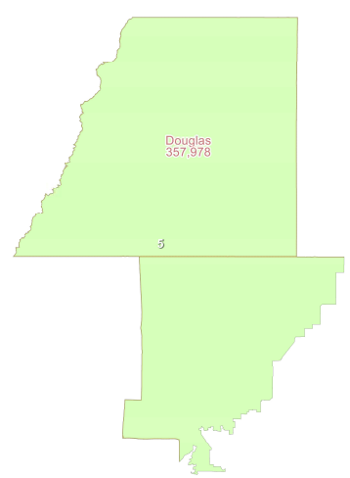

District 5
Again keeping higher density, more metropolitan counties together, the plan combines Douglas County with the northwestern tip of El Paso. El Paso County had to be split regardless, since its population exceeds the ideal district population. This district remains relatively compact and keeps Douglas County whole.

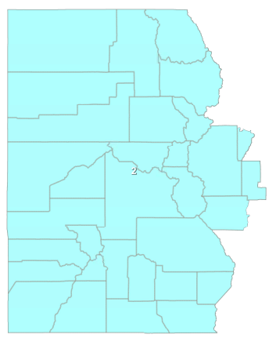
Districts 2 and 3
These two final districts extend from the edges of the state to meet in the middle, embracing the other districts in between. In the interest of compactness, the plan attempts to draw the straightest possible line from north to south. Doing this without splitting any more counties yielded an imbalance of about 30,000 people. To preserve the line as much as possible, the plan splits Fremont County, where those 30,000 people could be taken from a relatively dense population, and thereby minimally disrupt the district boundary.

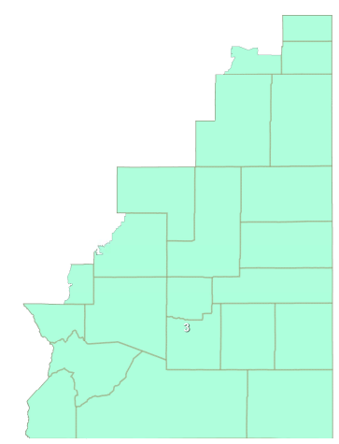

- Comparisons with the Existing Plan and Adopted Plan
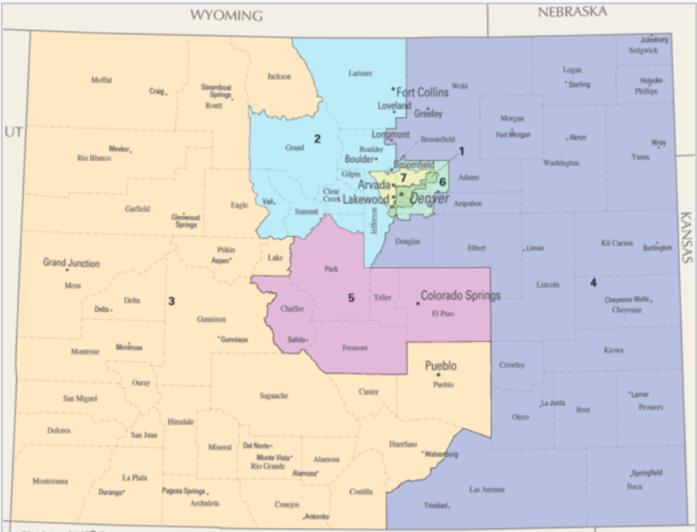
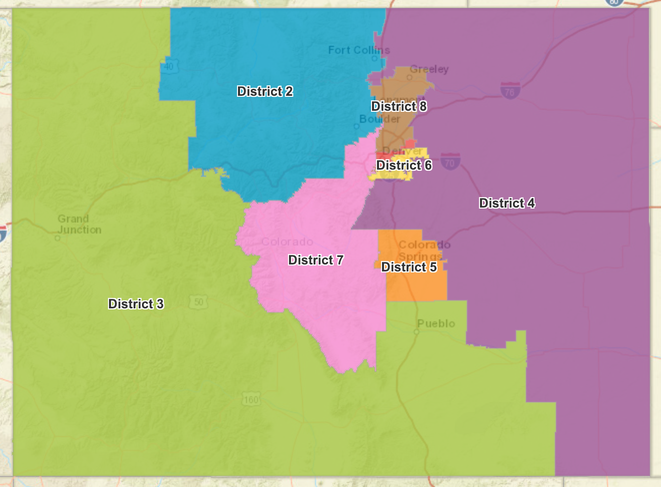
The Colorado Independent Congressional Redistricting Commission produced Colorado’s new congressional map. The commission voted eleven to one to adopt the map (satisfying the supermajority requirement in the state constitution), and the Supreme Court later found that it satisfied the constitutional requirements. This portion of the report will compare the Least Change and Good Government plans with the existing (2010) Colorado congressional map and the new Adopted plan.
Colorado’s existing congressional districts
The Adopted plan

- Compactness
The Colorado constitution requires districts to be “as compact as is reasonably possible.” The Least Change, Good Government, and Adopted plans all improve on the existing plan, though to different degrees. The Least Change plan bests the existing plan on every compactness measure. Although the existing plan has a shorter gross perimeter, it also contains one fewer district. The average perimeter per district is still shorter in the Least Change plan. The improvements are small—only a few hundredths on most measures—but the Least Change plan is more compact than the existing plan.
The Good Government goes a step further in outperforming the existing plan. In minimizing county splits, the Good Government plan better preserves the shape of Colorado’s counties, many of which are rectangular. The plan thus receives particularly high scores in the population polygon measure and the area/convex hull measure, both of which use polygons to create compactness ratios. It also outperformers all three other maps on Schwartzberg, Polsby-Popper, and perimeter. However, the Good Government plan receives worse scores than the other plans in both its Reock score and its length-width ratio. For the same reason that it scores so well on the polygon-based measures, the plan performs more poorly on these—long, skinny rectangles, like Adams and Arapahoe County, score badly on both Reock and length-width measures.
The Adopted plan also bests the existing plan on nearly every compactness measure, but not by much. It only marginally improves on Reock, Polsby-Popper, and Area Convex/Hull and remains less compact than the Least Change plan on each of those measures. The Adopted plan also does the worst of any of the plans on the Schwartzberg measure. Though it may be considered more compact on average than the existing plan, it is less compact than both the Least Change and Good Government plans on most of the compactness measures. See compactness reports for each plan below.

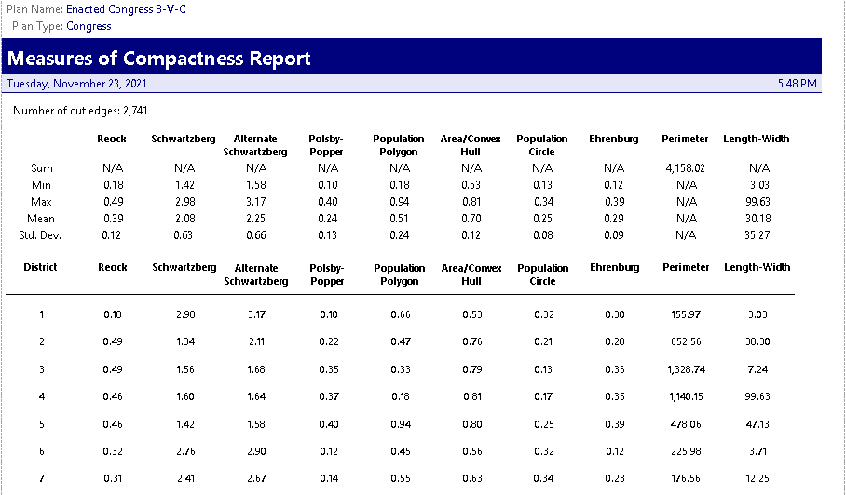
Existing Plan Compactness Scores:

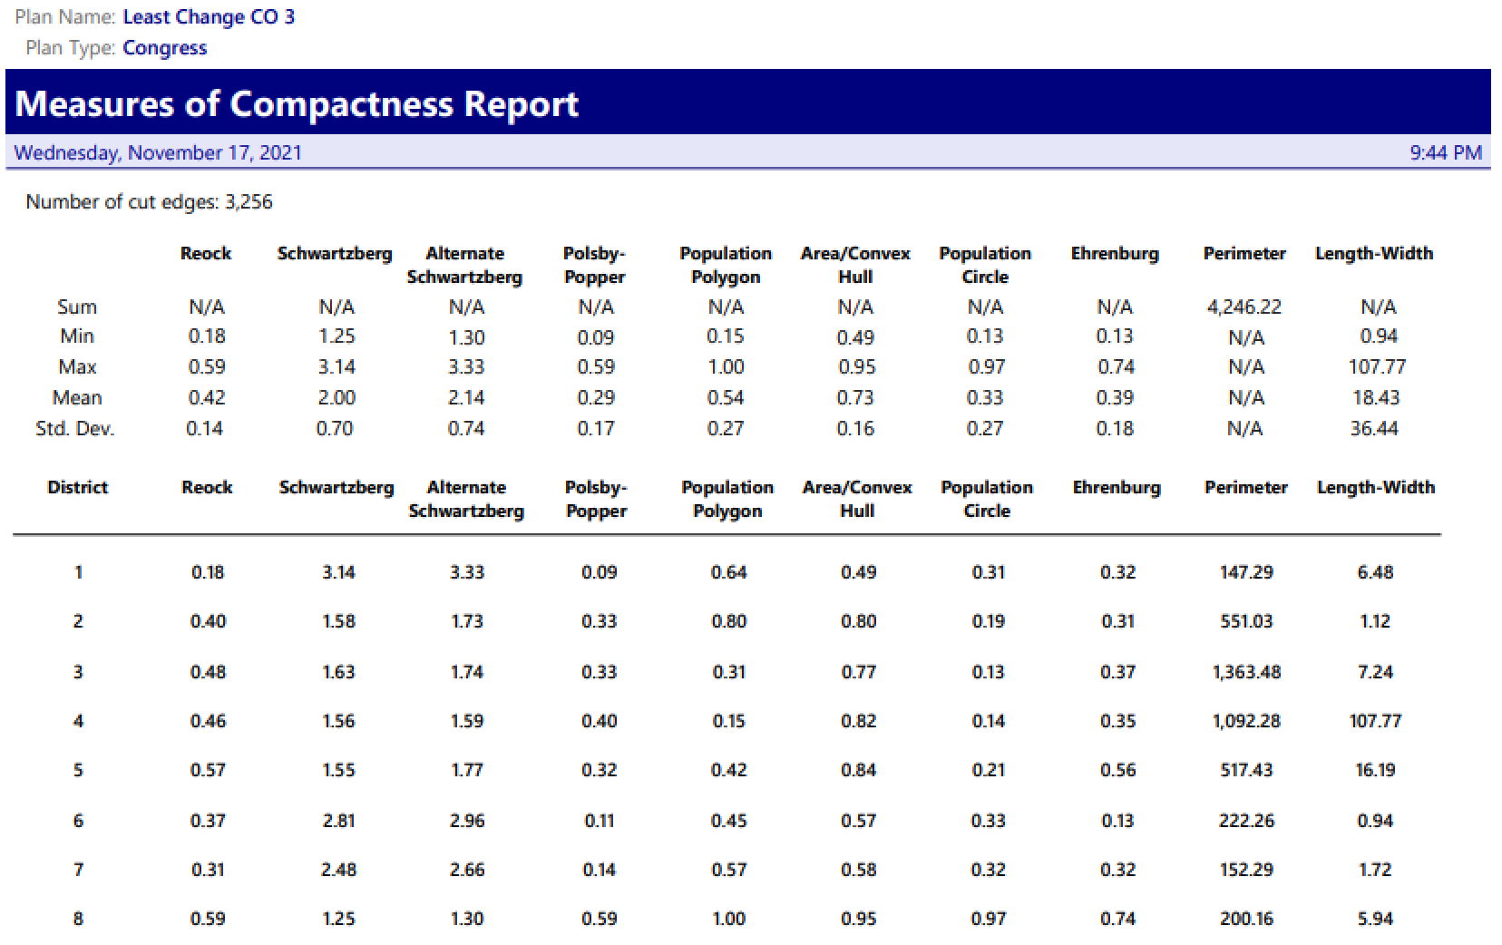
Least Change Compactness Scores:
Good Government Compactness Scores:
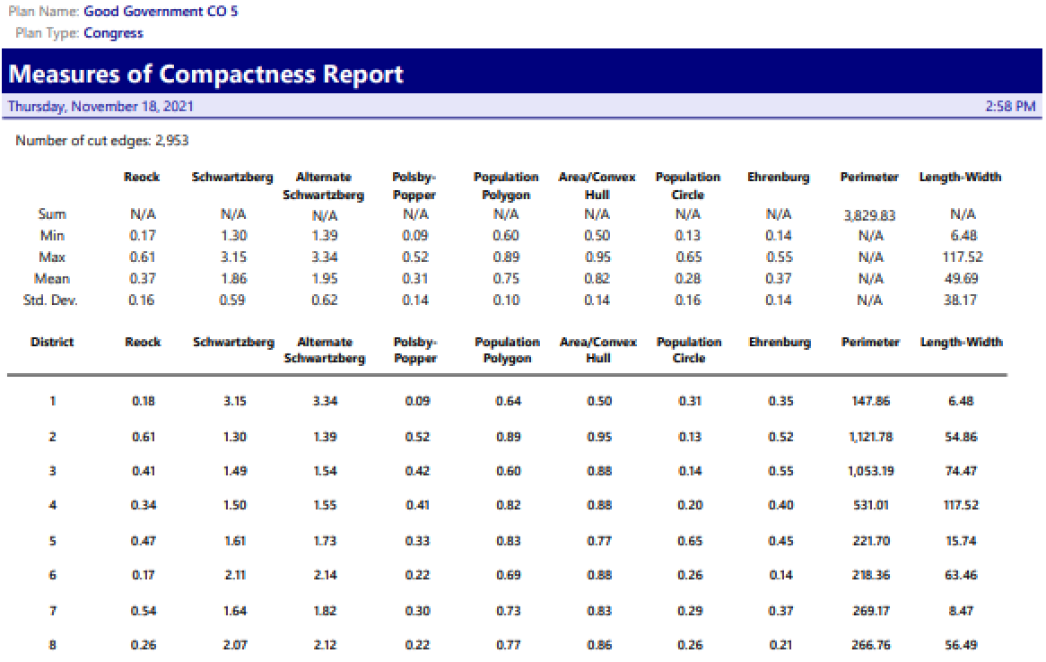
Adopted Plan Compactness Scores:
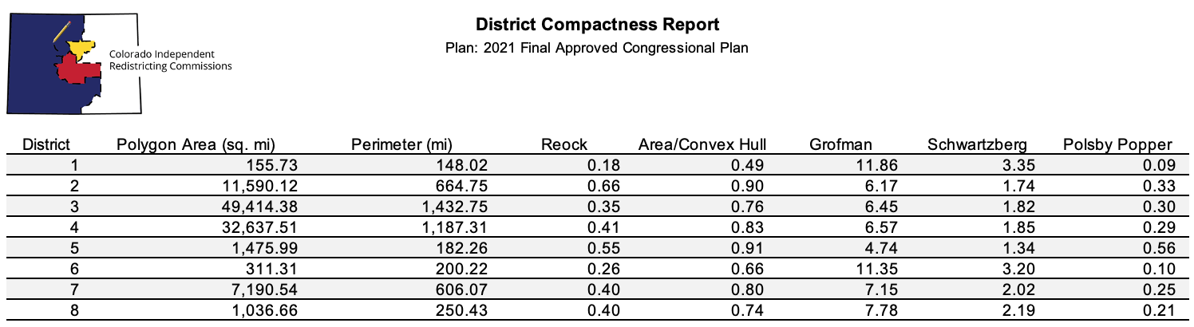

- Political Subdivision Splits
Some county splits in Colorado are inevitable. El Paso County must be split since it is too populous to fit in a single district. Arapahoe and Jefferson both have islands within Denver County, so they have to be split as well. An unpopulated sliver of Weld County is enclosed in the northern tip of Broomfield. There is also a tiny strip of Broomfield—a highway with no population—embedded in Boulder County. Colorado’s county splits should be assessed in light of these noncontiguous county lines.
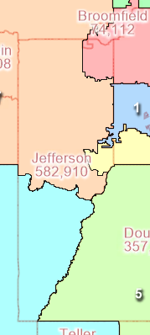
The state’s existing map, from 2010, splits nine of the state’s sixty-four counties. The Least Change plan splits ten, but two of these splits contain no population. The highway in Broomfield and the sliver of Weld are both excluded from their parent county, but neither has any residential population. So while the map does draw district lines across ten different county borders, it only splits eight county populations.
The Good Government plan does better. It splits eight total counties and, like the Least Change plan, only splits Broomfield and Weld geographically, leaving their residential populations intact. Only six counties have their populations split between districts. However, in limiting the total number of counties split, the Good Government plan splits one county several times. Jefferson County, west of Denver, gets split into five different pieces. One of these, the portion of Jefferson embedded in Denver, contains no population, but the other four pieces all move Jefferson residents into different districts. Splitting Jefferson multiple times allowed other counties to remain whole and meant that no other county in the state is split more than once. The state constitution calls for preserving “whole political subdivisions.” The Good Government map interprets this language to prioritize keeping more counties whole, even at the cost of splitting one county multiple times.
Jefferson County, split five ways in the Good Government plan
Still, the state constitution may not impose such harsh a standard in the realm of county splits. The Adopted plan passed constitutional muster despite splitting more counties than any of the other plans. In all, the Adopted plan splits eleven counties, and six of these are split more than once. Three counties—Adams, Jefferson, and Weld—are split into four different districts. Curiously, the Colorado Supreme Court did not directly comment on the county splits when considering the plan’s legal compliance. The court largely focused on communities of interest rather than political subdivisions, and it recognized the difficulty of preserving both. In fact, the court treated political subdivisions as themselves a type of community of interest, acknowledging the tradeoffs between preserving cultural and economic communities and preserving county lines. Though the Adopted plan shows less respect for county lines than the other plans, the court held that its prioritization of other communities of interest rendered it “a reasonable choice among multiple alternatives.”

- Communities of Interest
  - Geographic, Economic, and Cultural Communities
Under the state constitution, a community of interest is “any group in Colorado that shares one or more substantial interests that may be the subject of federal legislative action, is composed of a reasonably proximate population, and thus should be considered for inclusion within a single district for purposes of ensuring its fair and effective representation.” These shared interests include public policy concerns relating to urban and rural areas, agriculture, industry, environmental resources, public health, education, employment, and transportation. Racial, ethnic, and language minority groups may also comprise communities of interest.
The independent redistricting commission identified various communities of interest in each of the Adopted plan’s districts. Many of these same communities are preserved in the Least Change and Good Government plans as well.
The Least Change, Good Government, and Adopted plans all preserve as much of Denver as possible in a single district, keeping this economic and cultural hub intact.
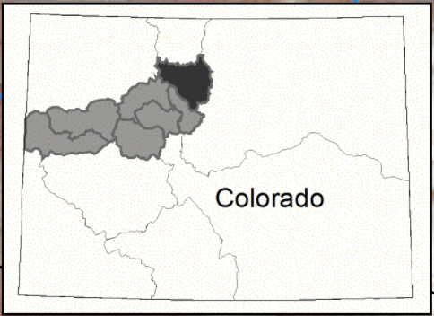
The north-central part of the state (Adopted plan’s District 2) houses many of Colorado’s ski resorts. These areas share an interest in the protection and use of public lands. Several of these counties also share a water system: the upper Colorado headwaters. Each plan treats this area slightly differently, but all reasonably accommodate the community of interest. The Least Change and Adopted plans join the north-central counties with parts of Larimer and Boulder, both of which have an interest in higher education, as the sites of large public universities. The Good Government plan instead joins these north-central counties with the western side of the state, leaving out Larimer and Boulder. This more accurately tracks the water system and joins more rural areas together rather than attaching them to higher-density counties.
The Colorado headwaters span from Grand County to the state’s western edge.
All three maps keep most of the western side of the state together, preserving its shared interests in land and water conservation, agriculture, outdoor recreation, and the use of other natural resources and mining. All three also preserve the two Native American reservations in Colorado’s southwestern corner.
All three maps likewise combine most of eastern Colorado, where rural counties share common interests in agriculture, oil, and gas.
Colorado’s mountainous central counties—Lake, Park, Teller, Chaffee, Fremont—share an interest in outdoor recreation and public land use. The Good Government plan places these with the rest of the western counties, which share interests in outdoor recreation and preservation. The Least Change and Adopted plans instead pair these counties with more densely populated areas to their northeast (Jefferson and Douglas County). This pairing still preserves a community of interest however, by acknowledging the relationship between the more rural areas and the day-trip tourists who visit them. People frequently travel between these nearby metropolitan areas and the mountains, giving these areas a shared interest in transportation.
The Least Change and Adopted plans especially preserve the communities of interest in the regions outside of Denver. The substantial Hispanic population in western Adams and Arapahoe County differs from the more rural, more white population on the eastern sides of those counties. The Least Change and Adopted plans break county lines to preserve the common cultural and economic interests of this population. The Good Government plan, in prioritizing keeping counties whole, does not.
The southern-central portion of Colorado is home to the San Luis Valley. This area houses a substantial Spanish-speaking population with a common heritage predating the land’s acquisition by the United States. Six different counties compose it—Saguache Mineral, Rio Grande, Alamosa, Conejos, and Costilla—and the Adopted plan and Least Change plan keep all six together. The Good Government plan accounts for five of the six, only leaving Costilla County out of the mix.
The Least Change and Adopted Plan also do a better job of preserving El Paso as its own community of interest. El Paso has a large urban hub in Colorado Springs, with interests in transportation, education, public health, and employment. These plans make El Paso into its own district, where it can best promote its own interests. The Good Government plan instead pairs a large part of El Paso with the more rural eastern side of the state, again prioritizing political subdivision splits.
Finally, the Adopted plan’s District 8, north of Denver, joins the Hispanic community in Adams County with the Hispanic communities to the north in Weld and Larimer. Because this breaks several county lines and greatly diverges from the existing plan, neither the Least Change nor the Good Government plan have a comparable district.
On this analysis, the Adopted plan best represents communities of interest across the state. The Least Change plan and Good Government plan perform similarly in many ways, but the Good Government plan’s divergent treatment of the San Luis Valley, El Paso County, and the Hispanic communities surrounding Denver give the other plans the upper hand. To preserve county lines, the Good Government plan has to divide these more amorphous cultural and economic communities.

  - Cities and Towns
The existing plans splits twenty-eight cities. The Least Change plan unfortunately splits more, upping the total to thirty-six. In part, the Least Change plan splits more cities because it prioritizes shifting entire voting districts rather than census blocks. Since voting districts often do not align perfectly with cities and towns, more cities and towns end up split. Additionally, to shift the existing district lines as little as possible, the Least Change plan tends to pull bits of population from higher-density areas. Higher-density areas are usually in cities or towns, so these areas are more split more frequently.
The Good Government plan slightly improves on the existing plan. It was also built largely by voting district, rather than census block. It prioritized keeping voting districts whole rather than cities. However, it still improves on the existing plan, only splitting twenty-six cities in all.
The Adopted plan fairs the best here. Its prioritization of economic and cultural communities of interest lends itself to the preservation of cities and towns too. The Adopted plan only splits fifteen cities total.

- Partisan Fairness and Competition
Colorado is one of the more politically balanced states in the country. Its voting population is 56.9% Democratic to 43.1% Republican according to the redistricting population data. The existing plan, from 2010, created four Democratic and 3 Republican districts. The most competitive of these seven was leaning-Republican District 3, Colorado’s western side.

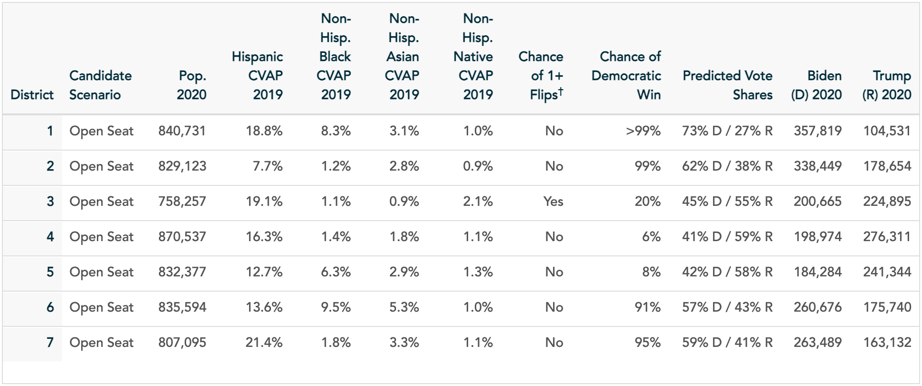
Existing Plan - 4D, 3R (1 leaning)
With the addition of a new district this cycle, the state may less accurately reflect its partisan balance. The existing plan gives Democrats 57% of seats and Republicans the remaining 43%—almost perfectly matching the state-wide political demographics. Now, with eight districts, no allocation of seats can come as close to perfect representation. Democrats will either be underrepresented (with four or fewer seats) or overrepresented (with five or more).
The Least Change plan results in slight underrepresentation for Democrats, creating only four Democratic districts. However, of the four Republican districts, only two are “solidly” held. The other two—District 3, the western flank, and District 5, in the state’s center—both only “lean” Republican. Both have a chance of flipping and electing Democratic representatives. District 5 is particularly competitive, at 49% Democrat, 51% Republican.

Least Change Plan - 4D, 4R (2 leaning)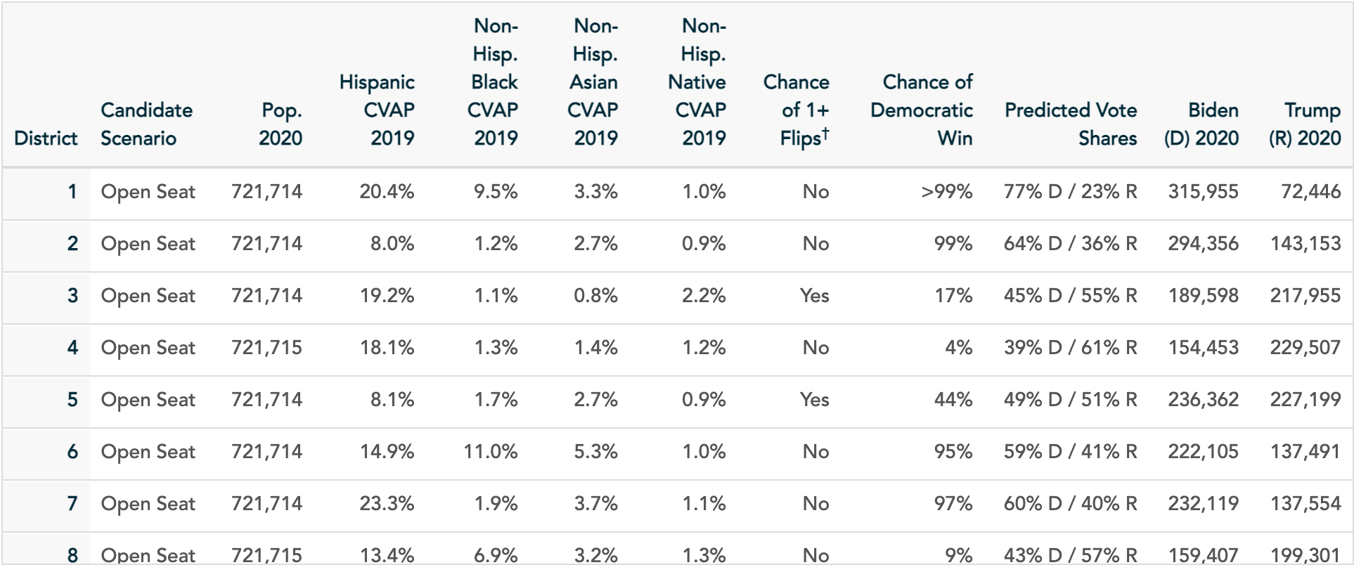

The Good Government plan also creates 4 Democratic and 4 Republican seats, though with slightly different partisan balances. Only one of the four Republican districts is solidly red—the other three all leave open the possibility of a Democratic flip. District 2, in the west, and District 5, south of Denver, both give Democrats odds over 15%, and District 4 puts Democratic chances at one in three. The Good Government plan creates three competitive districts, rather than two, though none of the districts in the Good Government plan are as competitive as the Least Change plan’s fifth district.
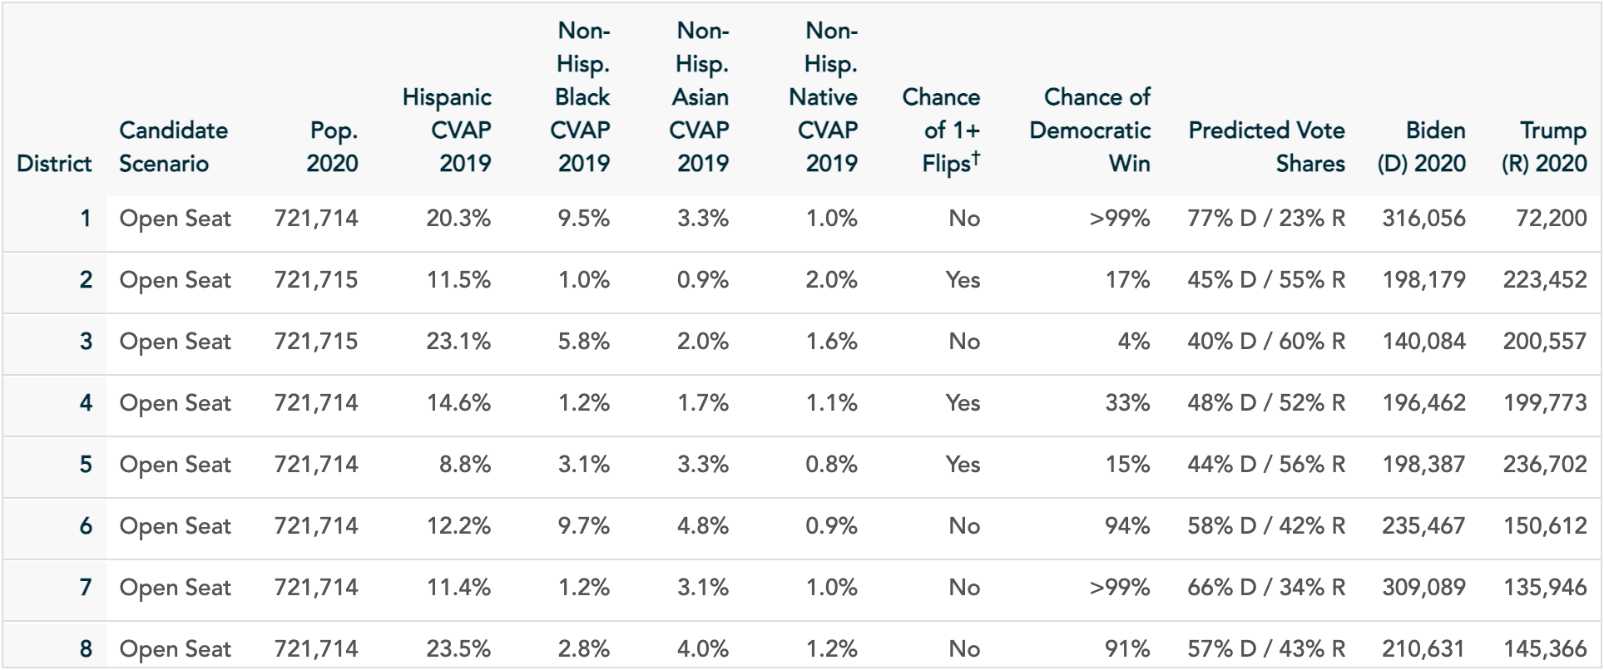
Good Government Plan - 4D, 4R (3 leaning)

Like the Good Government plan, the Adopted plan creates three competitive districts. However, rather than splitting districts evenly between parties, it creates five Democratic districts and three Republican ones. Unlike the other plans, the Adopted plan also creates competitive districts on both sides of the political divide—of the three non-solid districts, one leans Republican and two lean Democratic. As in the Least Change and Good Government plans, the state’s western side (here District 3) leans Republican but leaves Democrats with better than 10% odds. The Adopted plan’s District 7, in the center of the state, leans Democratic but gives Republicans a 17% chance of victory. District 8, the Adopted plan’s second Democratic-leaning district, is the most competitive district in any of the plans. Allotting each party 50% of the vote share gives them each essentially equal chances. (The slight Democratic tilt can be seen in the vote shares from the 2020 presidential election. See the table below.) District 8 joins communities north of Denver, in Adams, Larimer, and Weld County, to create this competitive composite. This District has no functional equivalent in either the Least Change or Good Government plans.

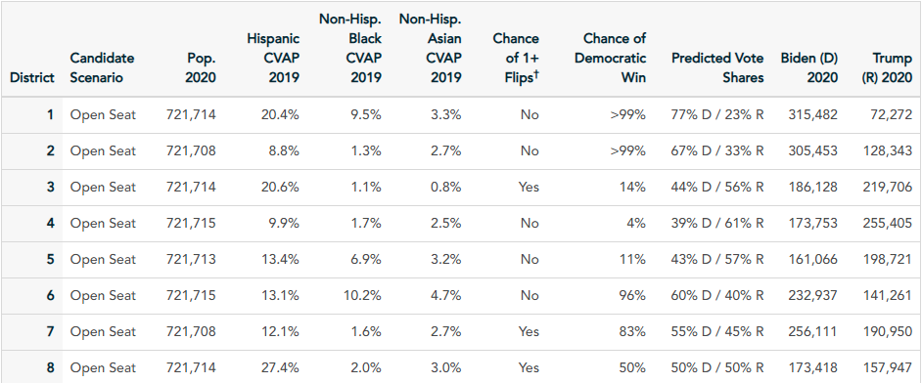
Adopted Plan – 5D (2 leaning), 3R (1 leaning)
- Demographics
Colorado’s total population is 21.88% Hispanic, though its voting age population is only 19.16%, and its citizen voting age population only 15.6%. The state is 65.13% white, with a 68.65% white voting age population and a 75.7% white citizen voting age population.
The Least Change plan creates 5 districts with Hispanic populations greater than the statewide proportion. These five districts may be considered “influence districts,” where the Hispanic minority will be able to influence, though probably not determine, election outcomes.

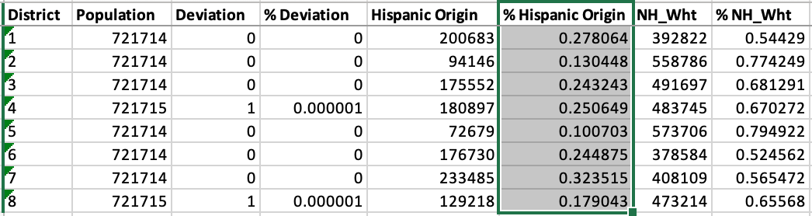
Least Change Demographics:

The Good Government plan only creates three districts with Hispanic populations greater than 21.88%. (A fourth district, District 4, comes close, at 21.35%.) Of these, District 8 has the biggest Hispanic influence, as Hispanics compose over 34% of the district population.

Good Government Demographics:
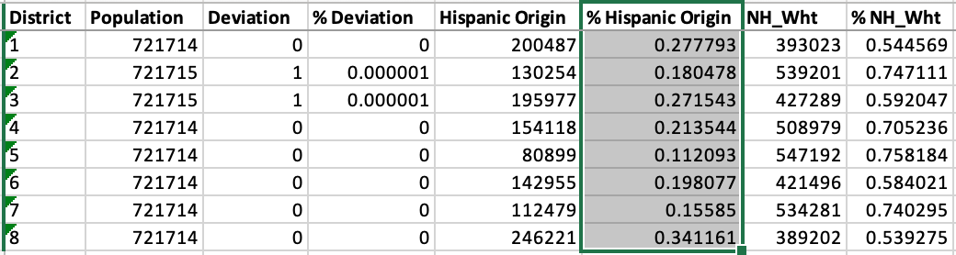
The Adopted plan creates four districts with Hispanic populations above the statewide proportion. Three of these also have white populations under 60%. Though the Adopted plan creates one fewer “influence” district than the Least Change plan, it consolidates Hispanic voters in District 8. At over 38% of the district population, Hispanic residents in District 8 will be more influential here than in any of the districts in the Least Change of Good Government plans.

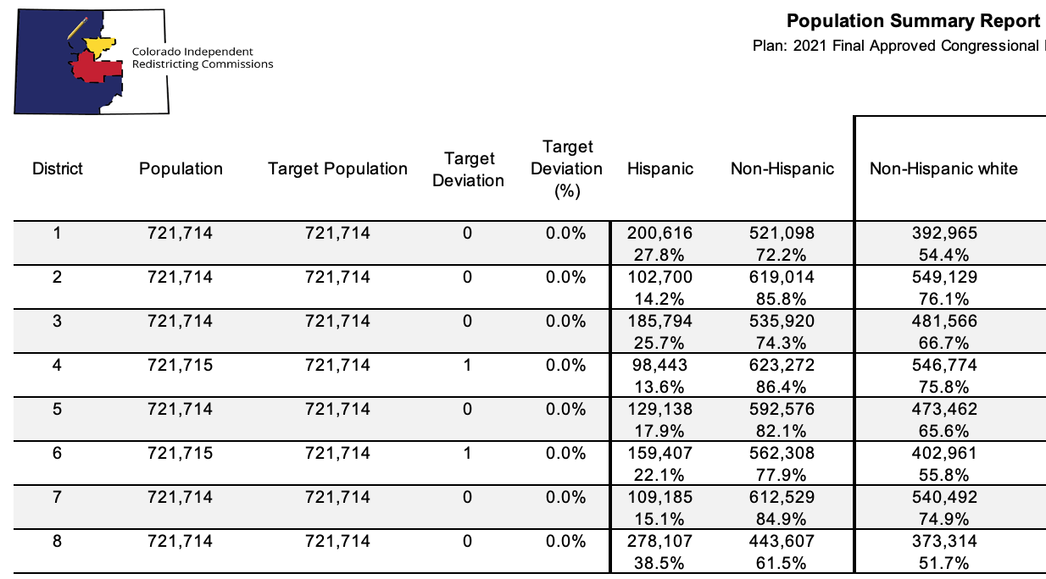
Adopted Plan Demographics:

- Conclusion
Redistricting in Colorado is not for the faint of heart. The constitution imposes many requirements, and the independent redistricting commission must also navigate its own diverse political values and party affiliations. The commission’s first exercise of its constitutional mandate has yielded a map that adequately, and perhaps even elegantly, accommodates the various redistricting principles the constitution imposes. While other maps, like both the Least Change and Good Government plans, may be more compact or split few counties, the Adopted plan attempts to better represent the cultural, geographic, and economic interests of the people. In a representative democracy, it is hard to ask for much more.

Both of these plans can be viewed at https://drawcongress.org/state/colorado/. The plan referred to in this report as the Least Change plan is titled “Least Change.” The plan referred to as the Good Government plan is titled “Keeping Counties Whole (Boulder and Denver too).”
See Reynolds v. Sims, 377 U.S. 533 (1964).
Shaw v. Reno, 509 U.S. 630, 658 (1993).
See Miller v. Johnson, 515 U.S. 900, 916 (1995) (stating that a plaintiff must show that race was the predominant factor motivating the redistricting plan to trigger strict scrutiny under the 14th Amendment).
Thornburg v. Gingles, 478 U.S. 30, 50-51 (1986).
See also In re Colo. Indep. Redistricting Comm’n, 479 P.3d 493, 508 (Colo. 2021 (concluding that the Voting Rights Act does not require a minority opportunity district in Colorado).
Colo. Const. art. V, § 44
Id. § 44.3
Id.
Id.
In re Colo. Indep. Redistricting Comm’n, 479 P.3d 493 (Colo. 2021).
Colo. Const. art. V, § 44.5
479 P.3d at 503 (quoting Langer v. Bd. of Comm’rs, 462 P.3d 59, 62 (Colo. 2020)).
See id. at 512-14.
Id. at 513.
Colo. Rev. Stat. § 2-2-901-902.
In re Interrogatories on Senate Bill 21-247 Submitted by Colorado General Assembly, 488 P.3d 1008, 1011 (Colo. 2021) (“the General Assembly does not have the power to compel the independent commissions or their nonpartisan staff to consider a particular source of population data or take any action beyond what Amendments Y and Z already require. The Amendments were expressly intended to remove the General Assembly from the redistricting process, instead vesting all authority to draw district maps with independent commissions”).
Colo. Const. art. V, § 44.2(2).
In re Colo. Indep. Redistricting Comm’n, 479 P.3d 493 (Colo. 2021).
Colo. Const. art. V, § 44.3.
Colo. Const. art. V. § 44.3.
In re Colo. Indep. Redistricting Comm’n, 479 P.3d 493, 513-14 (Colo. 2021).
Id. at 513 (“efforts to preserve communities of interest will often conflict. Indeed, ‘[i]f the Commission satisfies the desires of one county, city or community of interest to remain whole and undivided, it often must necessarily split another county, city, or community of interest’”) (citation omitted).
Id.
Colo. Const. art V., § 44(3)(b)(I).
Id. § 44(3)(b)(II).
Id. at § 44(3)(b)(III).
See In re Colo. Indep. Redistricting Comm’n, 479 P.3d 493, 499-500 (Colo. 2021).
This feature could, and should, be changed by adding Costilla County to Good Government’s District 2 and pushing the district line in Fremont County slightly west to account for the population shift. This is an easy fix that was unfortunately overlooked in creating this plan but could be implemented without major change to the plan’s other components or values.
According to PlanScore, the site used to produce these data tables, the state is even more evenly split, at 54% Democratic to 46% Republican. See Colorado Final Approved Congressional Plan, PlanScore (Sep. 29, 2021), https://planscore.campaignlegal.org/plan.html?20210929T191852.242083208Z.
See In re Colo. Indep. Redistricting Comm’n, 479 P.3d 493, 510 (Colo. 2021) (reporting that Fair Lines Colorado, a redistricting advocacy group, treats Colorado districts with greater than 22% Hispanic populations as Hispanic influence districts).

