Good Government Congressional Plan
Arizona

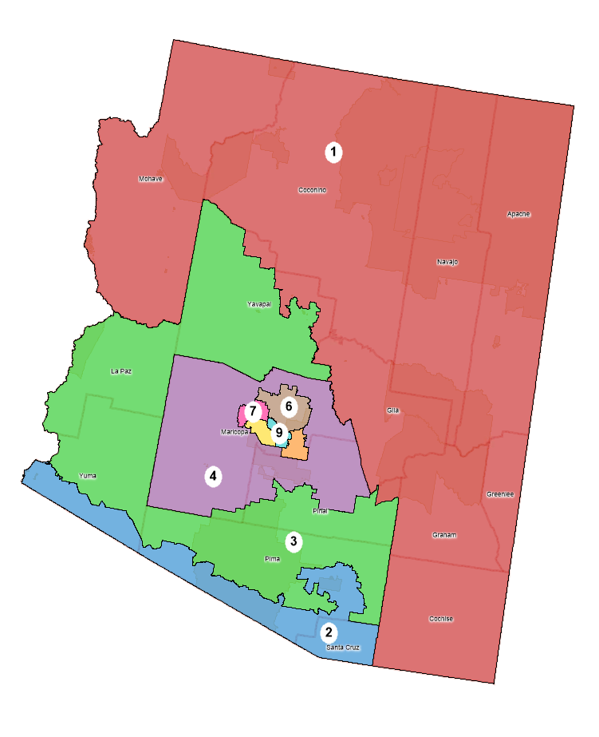

Policy Practicum: Draw Congress, Stanford Redistricting Project
Professor Nathaniel Persily, Fall 2021, Submitted Jan. 15, 2022

Amir Wright
Stanford Law School
J.D. Candidate, 2023
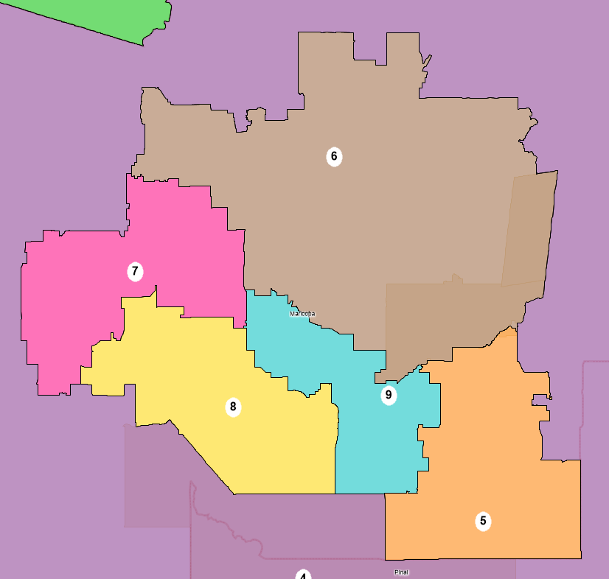
The State of Arizona – Proposed Plan

  - Overview
Congressional districts in Arizona are drawn by a five-member independent commission that was created by a ballot initiative in 2000. In adopting the initiative, Arizona voters shifted the responsibility away from the state legislature. In 2012, the Arizona Legislature filed suit against the Arizona Independent Redistricting Commission (AIRC), claiming that giving the AIRC, instead of the state legislature, responsibility to draw the state’s redistricting maps violated the Elections Clause of the United States Constitution. In 2015, the Supreme Court considered Arizona State Legislature v. Arizona Independent Redistricting Commission. The Supreme Court held that giving the responsibility for congressional redistricting to an independent redistricting commission, such as the AIRC, did not violate the Constitution. Today, this case allows independent redistricting commissions, rather than state legislators, to conduct redistricting.
Arizona’s commission on appellate court appointments nominates ten Republicans, ten Democrats, and five people that belong to neither party to be on the AIRC. Then, the majority and minority leaders in each state legislative house choose one commissioner from this pool of 25 nominees. Those four commissioners then select a fifth tiebreaker who is not registered in the same party as any other commissioner. Each commissioner must be an Arizona voter registered with the same political party (or unaffiliated) for at least three years, and at most two of the first four commissioners may live in the same county. Once this commission is assembled, it may begin drawing a plan.
As with any state in the union, Arizona must comply with constitutional equal population requirements. In a 1964 case, Wesberry v. Sanders, the Supreme Court found that Article I, section 2 of the United States Constitution requires strictly equal population in congressional districts as to ensure equal representation. Otherwise, a congressional district in New York might have six million people in it, while one in Montana has six thousand. In Karcher v. Daggett, the Supreme Court rejected a de minimis exception to the equal population requirement. In doing so, they created a strict requirement of perfect population equality for congressional districts unless there is adequate justification for a deviation. This equal population principle, known as “one person, one vote,” ensures that every congressional district in the country has roughly 758,000 people in it (332 million people divided by 435 congressional representatives). For this plan, Arizona’s ideal population-per-district is 794,611. State laws also require that districts have equal population to the extent practicable. Because the Supreme Court has interpreted the Constitution as having an equal population requirement already, this state law was not a factor in this plan.
What is unique, however, is that the Arizona constitution requires that the district map begin with a “grid-like pattern.” This asks redistrictors to begin with a grid originating from a geographically central point, then to adjust districts to be contiguous, geographically compact, and respect communities of interest to the extent practicable. In practice, though, the final maps rarely resemble the underlying grid that they began with because so much adjustment takes place to create populous, consistent, and representative districts. The state constitution also requires, to the extent practicable, that district lines use visible geographic features; city, town, and county boundaries; and undivided census tracts. This plan follows each of these principles where possible, deferring first to political subdivision lines and then to natural geographic boundaries. The last element that the state constitution asks is that, to the extent practicable, competitive districts be favored where doing so would not significantly detract from the goals above. This is perhaps the area where this plan is least compliant. This point (and the trade-offs that were made at its expense) are discussed infra.
Section 2 of the Voting Rights Act plays an important role in the redistricting process. Section 2 prohibits state and local governments from imposing voting laws that disproportionately harm people of color or laws that are motivated by a purpose to discriminate against minority voters. This prohibition on discrimination in voting also extends to redistricting maps that decide where voters live. If a map disadvantages people of color through packing or cracking, it violates section 2. Packing occurs when voters are packed into one or more districts in an effort to decrease the power of their votes. If a community of 1,000 Black voters is packed into one district instead of two districts of 500 (where they would still have a near-majority), that community’s power is reduced. Their voices are only represented in a meaningful way in one district rather than two. On the other hand, cracking is the opposite process. When a community is cracked, voters who could potentially form a majority in one district are split up into many districts. If that same community of 1,000 Black voters is split into ten districts of 100 voters each, their voices are effectively silenced.
Another seminal case, Thornburg v. Gingles, held that a plaintiff challenging a redistricting plan under section 2 must first satisfy a three-pronged threshold test. This test asks first, that the plaintiff must show that a minority group is sufficiently large and geographically compact to constitute a majority in a district. If and only if this is satisfied, the test proceeds. The second prong is that the minority group must be politically cohesive. Third, the plaintiff must prove that the white majority in the district votes as a bloc, and that they vote in a sufficient manner to enable them to defeat the minority-preferred candidates. These Gingles factors will be important when considering minority districts infra.
  - Guiding Redistricting Principles
This plan begins with the required starting grid and prioritizes keeping communities together. For example, in the current 2011 congressional plan, the city of Tucson is split. This proposed plan makes every effort to keep Tucson together. It further attempts to avoid splitting counties where possible. Lastly, in almost all districts it strives to keep Native American Reservations whole. In yet another court case, Tennant v. Jefferson County Commission, the Supreme Court held that districts need not have perfect population equality so long as they consistently respect political subdivision lines. In other words, so long as cities and counties are not split, the Court will allow some deviation. However, in the case of Arizona (and indeed in most states), it is nigh-impossible to consistently achieve this. For example, a Tennant approach would not split the city of Phoenix, which has a population in excess of 1.6 million people. The Court would certainly not allow a deviation of such magnitude when the city of Phoenix has enough people to compose more than two districts.
  - Tensions and Trade-Offs
    - Demographic
The first tension that this plan had to address was that of demographics. Below is the demographic data for Arizona’s proposed 2021 congressional map, based on the 2020 population. In the demographic context, it is important to look at the proposed 2021 plan in order to ensure that population comparisons are accurate when assessing whether the plan being put forward in this paper is more effective than the plan currently being considered by the state.
Looking to the bottom row, we see that Hispanics are the largest minority group on average in the state. Because of their large population, the Hispanic population in Arizona will satisfy the numerosity requirement of Gingles’s first prong. However, compactness is more difficult to prove. While there is certainly a compact Hispanic population in District 8 (in the areas surrounding the Salt River in Phoenix, seen infra), drawing a compact district around the other Hispanic communities required some creativity. Below is a heatmap of the Hispanic population in Arizona by voting district. Darker blue areas represent those that have higher concentrations of Hispanic-identifying individuals:
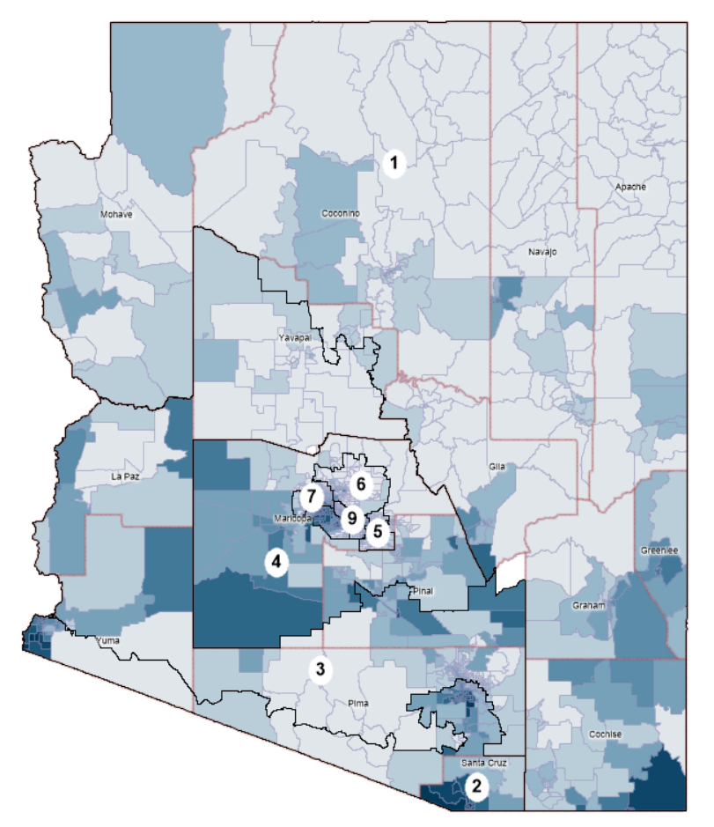
Large concentrations of Hispanic populations can be found in southeastern Cochise county, southern Santa Cruz county, and western Yuma county. Such populations required a Hispanic-majority district to comply with section 2 of the Voting Rights Act and with the second prong of Gingles. Section 2 requires that districts be drawn that provide the state’s minority populations with the opportunity to elect representatives of their choice. In order to do this, District 2 takes an unusual shape, stretching across almost the entirety of the southern border to reach the Hispanic population in Yuma. While this shape appears strange, it is important to note that the enacted 2011 plan (and indeed, most proposed Arizona plans) have this same feature; a single district covers a majority of the southern border, stopping west of Cochise county, near Sierra Vista. The main difference with this proposed plan is that District 2 does not extend north towards Phoenix. See District 3, in the enacted 2011 plan below:

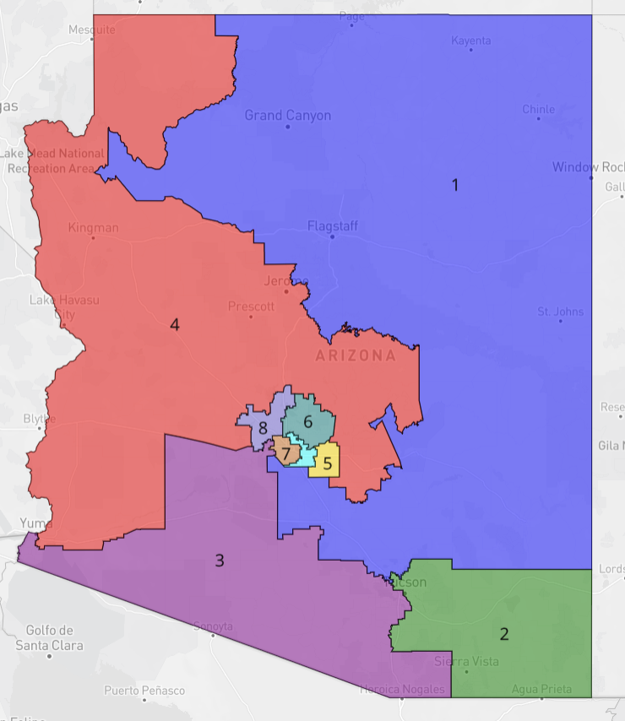

Why not simply start in Santa Cruz and move east to Cochise? The second prong of Gingles requires that the minority community in question vote sufficiently as a bloc. The Hispanic populations in Yuma are more liberal than those in Cochise, and therefore keep the voting bloc consistent. If the district moved east to Cochise, it would spoil the otherwise cohesive bloc. The state’s 2021 proposed plan has two majority Hispanic districts – 3 and 7. With this map, it was important not to differ in the number of Hispanic districts and to perform at least as well as the state’s plan. Districts 2 and 8 on this plan accomplish that same Hispanic-majority district floor as the state’s proposed plan.
When drawing districts with racial considerations, redistrictors must bear in mind Shaw v. Reno, which has particular implications for racial gerrymandering. In it, a plaintiff challenged a redistricting plan under the 14th Amendment’s Equal Protection Clause. The Supreme Court accepted their argument that, even though the plan appeared neutral on its face, it could not be understood as anything other than an effort to separate voters into different districts on the basis of race, and that the separation in question had no sufficient justification. Using Shaw as a basis, the Court further developed this doctrine in another case, Miller v. Johnson. There, it held that strict scrutiny is triggered when race served as the “predominant” factor in the drawing of district lines. Miller also held that districts with strange shapes with seemingly no obvious basis can be indicative of discriminatory intent, serving as circumstantial evidence of the predominance of race. At the same time, strictly observing traditional districting principles can be equally indicative of a lack of discriminatory intent. Miller is important to consider in District 2, which indeed has a strange shape, but its basis in Hispanic representation is fairly obvious and easily defended.
    - Geographic
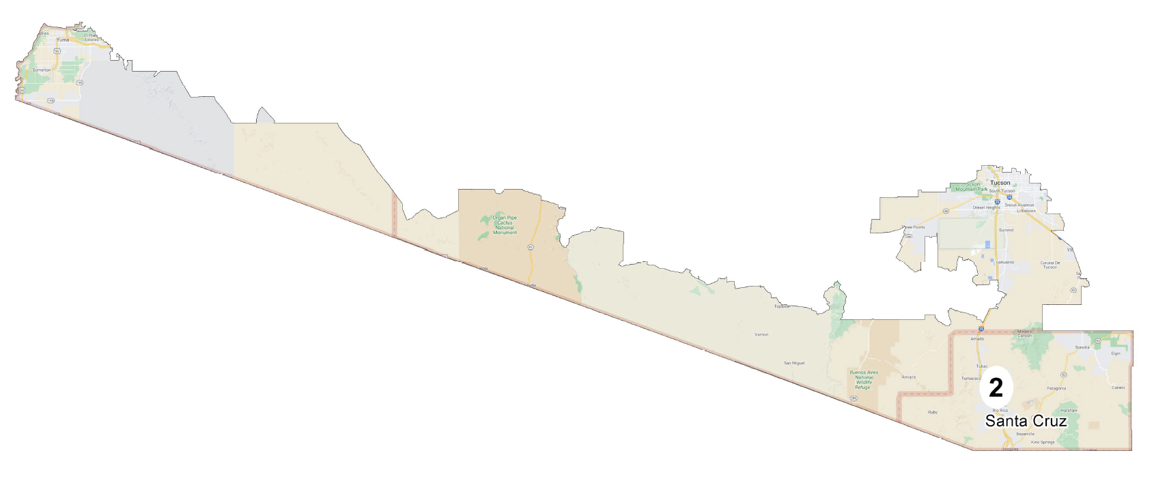
Focusing on District 2 for just a bit longer, this map makes a substantial geographic change to the southern regions when compared to the current congressional map from 2011. In the current enacted map, the city of Tucson is split in two. This map attempts to remedy that split by placing almost all of Tucson into one district (District 2) rather than cracking it. This decision was made in an effort to keep Tucson communities together. District 2 also takes a shape that would appear unusual, running along most of the southern border. Again, this feature is a relative staple of Arizona congressional plans. The only unusual part about District 2 is that it does not extend north. An unfortunate byproduct of the way that District 2 was designed is that it cracks the Tohono O'Odham Nation Reservation. This was not ideal, as keeping Reservations together was of the utmost importance when drawing this map. However, District 2 was drawn this way, again, to connect Tucson and Yuma in order to comply with the Voting Rights Act to keep the Hispanic majority that currently resides in District 3. It was impossible, with the current demographics from 2021, to draw a Hispanic-majority district without connecting Tucson and Yuma.
Finally, we must consider the Voting Rights Act. Section 2 of the Voting Rights Act is violated if minority communities “have less opportunity than other members of the electorate to participate in the political process and to elect representatives of their choice.” In Arizona, the Hispanic population is certainly sufficiently large enough to constitute a majority in District 2. To do anything other than create a Hispanic majority would be to deprive the community of the opportunity to participate in the political process and to elect representatives of their choice. This plan attempts to remedy that, though the solution is imperfect.
    - Respecting Political Subdivisions
In 42 states, new state legislative districts must consider existing political boundaries such as the borders of cities, counties, boroughs, towns, and wards. 19 states (including Arizona) have this requirement for congressional districts as well. This plan seeks to follow these requirements to the greatest extent possible. Fortunately, these laws tend to be relatively flexible, particularly if redistrictors have to split cities or counties to comply with the Voting Rights Act or the requirement of equal population. Below is a table showing the political subdivision splits in this proposed plan:

Number of City/Town not split | 431
Total Number of City/Town split | 33
Number of City/Town split in two | 28
Number of City/Town split in three | 2
Number of City/Town split in four | 1
Number of City/Town split in five | 2
Total number of splits | 76

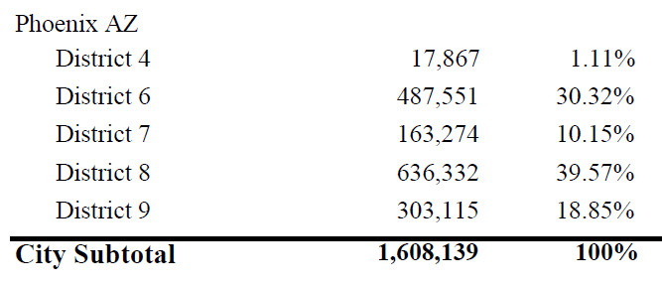
Respecting political subdivisions was a guiding principle of this map. The process of drawing the map began by drawing districts around entire counties. Then, the focus shifted to cities and towns to reach the constitutionally required 794,611 people per district. This map keeps 431 cities and towns together, while only splitting 33. Those divisions that are split are often split in minor ways. The few substantial splits in this plane were done out of necessity. For example, Phoenix is split five ways, seen below:

It was impossible to fit the entire city into one district because of its population, which exceeds 1.6 million. Even using just two districts would fail to accurately capture the greater metropolitan area, demographic trends, and geographic boundaries. As a result, five districts were used to accurately represent Phoenix voters. For example, District 8, infra, creates a Hispanic majority. This would be impossible to create if Phoenix were only composed of two districts.
    - Compactness
Compactness measures are one way to visualize and compare the physical appearance of districts. Compactness is difficult to define in standard terms, though there are several ways to measure it. It generally means that the people who reside in a district live near each other. However, it is not always possible to draw perfectly compact districts in which everyone lives near everyone else. Rural districts may cover a large physical area. For example, District 1 in this proposed plan covers nearly half of Arizona in geographical terms, yet its population is the same as any other district:
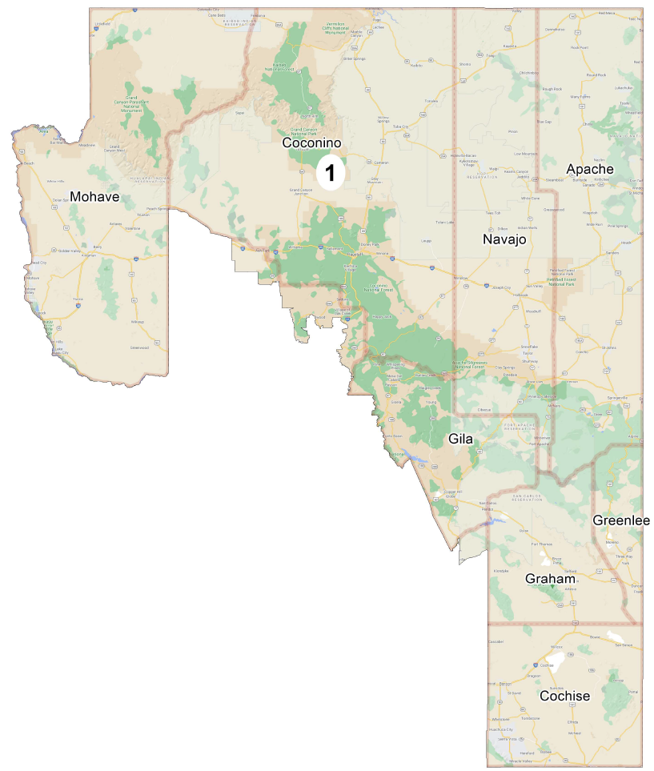

A district might also follow a mountain range or a river, giving it a strange shape. Oddly shaped or unusually sprawling districts can be signs of gerrymandering, or of racial discrimination as well. To combat this with some degree of consistency, redistrictors use several mathematical tests that consider the shape of a district’s lines (jagged, smooth, or sprawling).
One such measure is Roeck compactness, which is a ratio of a district’s area compared to the area of the smallest circle that will completely encompass the district. As such, a perfectly circular district may have a Roeck compactness score of 1, while a long narrow district (like District 2 in this proposed plan) may have a score closer to 0. Another measure, Schwartzberg, compares the district’s perimeter with the perimeter of a circle containing the same area. On this scale, a score of 1 represents the most compact district possible, while higher numbers represent progressively less compact districts. The final measure that we will examine is Polsby-Popper, which compares the area of a district to the area of a circle with the district’s same perimeter. While similar to Schwartzberg, Polsby-Popper is a ratio, so a score of 1 is the most compact while a score of 0 is the least compact. Below is a table of these measures for this proposed plan and for the 2011 enacted plan (Schwartzberg measures were unavailable for the 2011 enacted plan):

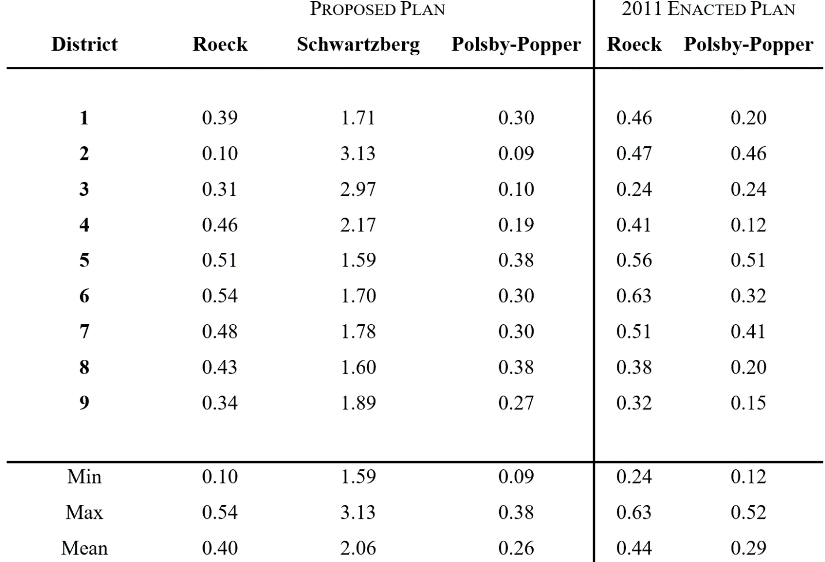
From the above data, this proposed plan does not clearly outperform the 2011 enacted plan in measures of compactness. Looking first to Roeck compactness, the average score for this proposed plan is 0.40, while the average score for the enacted plan is 0.44. This difference is not hugely significant, but a loss of 0.04 nonetheless. For the Polsby-Popper score, this proposed plan averages at 0.26, while the enacted plan averages at 0.29. Again, the difference is small, but plans should generally try to improve on their predecessors where possible. Despite this apparent loss in compactness, this proposed plan is still viable. One reason for the loss in averages in both Roeck and Polsby-Popper was the reduced geographic size of District 2. Recall that in the 2011 plan, District 2 (previously District 3) extended from the southern border all the way to Phoenix. In this plan, much of that northern region has been removed from District 2, and the district now takes a much narrower shape, reducing its compactness score. However, this approach was taken for reasons discussed supra. Broadly speaking, compactness is not a priority measure. While it may be satisfying to draw districts that are visually appealing, it is much more important to draw districts that adequately represent the communities of interest that reside within their borders.
    - Political Competitiveness
The Arizona constitution asks that, to the extent practicable, competitive districts be favored where doing so would not significantly detract from other goals. These goals ask that districts are contiguous, are geographically compact, respect communities of interest, use visible geographic features, respect city, town, and county boundaries, and respect undivided census tracts to the extent practicable. This plan does not strictly comply with this competitiveness metric for two reasons: first, when the plan was originally created, partisan data was not yet available. This meant that only a rough idea of partisanship based on the 2016 and 2018 elections was available. Second, and more substantially, the other goals of the plan took priority over competitiveness. It is important to note that the state constitution asks to favor competitive districts to the extent possible when it would not significantly detract from other goals. Not only would redrawing the map at this point be impracticable – doing so would significantly detract from this plan’s other goals. This plan focuses on keeping communities together and reducing subdivision splits. Perhaps this plan’s best example of this trade-off can be seen below, in District 8:
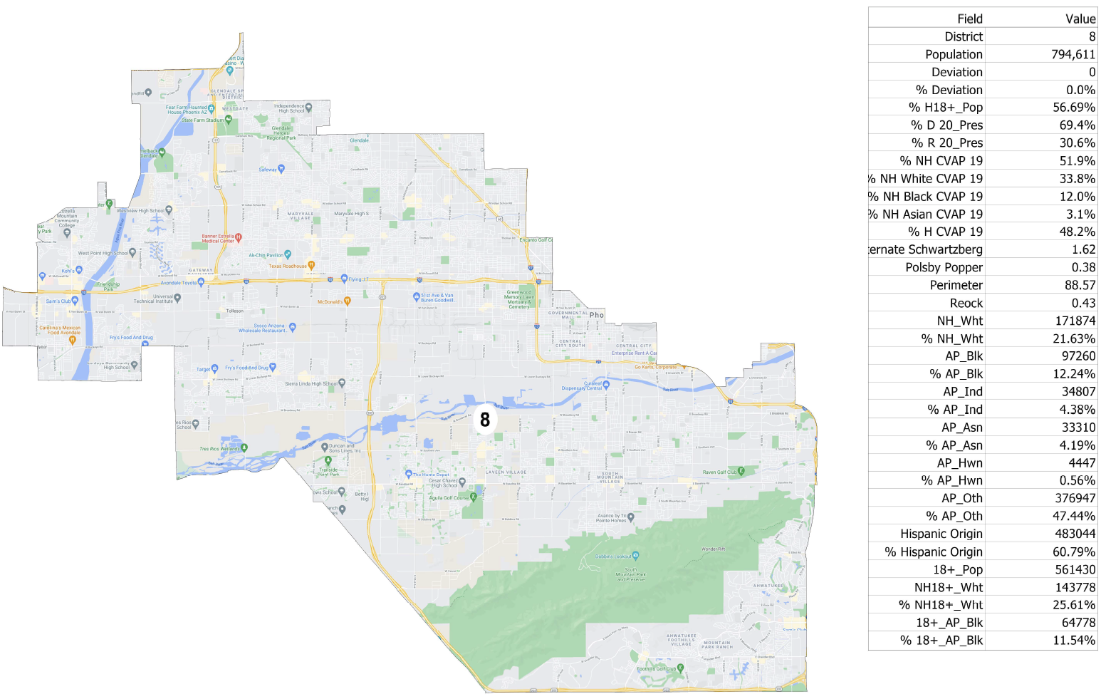
The proposed District 8 does not meet the competitiveness metric that is asked of it by the state constitution. Based on the 2020 election, the Democratic population of District 8 is a very safe 69.4%, and the Republican population is 30.6% This massive 38.8% difference is not a negligible amount, nor is it easily overcome by the Republicans in the district. However, the state constitution does not require this district be competitive. District 8 was drawn this way to prioritize other factors, namely in order to satisfy the Voting Rights Act and maintain the Hispanic majority that is currently enjoyed by the district (District 9 in the current enacted plan).
  - Conclusion
The goal of this plan was to keep communities together. While it certainly had to make trade-offs – the shape of District 2, the splitting of the Tohono O'Odham Nation Reservation, and the dip in average compactness – these elements were sacrificed in favor of greater principles of good governance. It aimed to split as few political subdivisions as possible, maintain the same number of Hispanic majority districts in the enacted 2011 plan, and achieve strictly equal population across all districts.

Justin Levitt, All About Redistricting, Loyola L. School, https://redistricting.lls.edu/state/arizona/?cycle=2010&level=Congress&startdate=2012-04-09 (last visited Nov. 16, 2021).
Id.
Arizona State Legislature v. Arizona Independent Redistricting Com’n, 135 S. Ct. 2652 (2015).
Power on the Line(s), Making Redistricting Work for Us 48, NAACP Legal Defense and Educational Fund, inc. (2021), https://www.maldef.org/wp-content/uploads/2021/05/FINAL-LDF_04142021_RedistrictingGuide-22e.pdf (last visited Jan. 2, 2022).
Id.
Ariz. Const. art. IV, pt. 2, § 1(3)-(8).
Wesberry v. Sanders, 376 U.S. 1, 7-8 (1964) (“We hold that, construed in its historical context, the command of Art. I, § 2, that Representatives be chosen ‘by the People of the several States’ means that as nearly as is practicable one man's vote in a congressional election is to be worth as much as another’s.”).
Karcher v. Daggett, 462 U.S. 725, 734 (1983). (“We thus reaffirm that there are no de minimis population variations, which could practicably be avoided, but which nonetheless meet the standards of Art. I, §2, without justification.”).
Population Clock, United States Census Bureau, https://www.census.gov/popclock/ (last visited Nov. 17, 2021).
Id. § 1(14)(B).
Ariz. Const. art. IV, pt. 2, § 1(14); Ariz. Minority Coal. for Fair Redistricting v. Ariz. Ind. Redistricting Comm’n, 121 P.3d 843 (Ariz. Ct. App. 2005).
Id.
Ariz. Const. art. IV, pt. 2, § 1(14).
Ariz. Const. art. IV, pt. 2, § 1(14); Ariz. Minority Coal. for Fair Redistricting v. Ariz. Ind. Redistricting Comm’n, 208 P.3d 676 (Ariz. 2009).
Section 2 of the Voting Rights Act states that “No voting qualification or prerequisite to voting … shall be imposed by any State or political subdivision to deny or abridge the right of any citizen of the United States to vote on account of race or color, or [status as a member of a language minority group].” 52 U.S.C. § 10301(a).
Power on the Line(s), Making Redistricting Work for Us 35, NAACP Legal Defense and Educational Fund, inc. (2021), https://www.maldef.org/wp-content/uploads/2021/05/FINAL-LDF_04142021_RedistrictingGuide-22e.pdf (last visited Jan. 2, 2022).
Thornburg v. Gingles, 478 U.S. 30 (1986).
Tennant v. Jefferson County Com'n, 567 U.S. 758, 764 (2012).
Arizona 2020 Congressional Districts, Dave’s Redistricting, https://davesredistricting.org/maps#stats::283ef00f-9b80-4547-984f-74c25f554eef (last visited Nov. 17, 2021).
State of Arizona Official Canvass, 2020 General Election – Nov. 3, 2020, Ariz. Secretary of State, https://azsos.gov/sites/default/files/2020_General_State_Canvass.pdf (noting 32,010 votes for Joe Biden in Yuma, and 23,732 votes for Joe Biden in Cochise).
Shaw v. Reno, 509 U.S. 630 (1993).
509 U.S. at 642.
Miller v. Johnson, 515 U.S. 900, 916 (1995) (“The plaintiff's burden is to show, either through circumstantial evidence of a district's shape and demographics or more direct evidence going to legislative purpose, that race was the predominant factor motivating the legislature's decision to place a significant number of voters within or without a particular district.”).
Id.
Id. at 913.
Id. at 916.
42 U.S.C. § 1973(b) (2011).
Justin Levitt, Professor Justin Levitt’s Guide to Drawing the Electoral Lines, Loyola L. School (2019), http://redistricting.lls.edu/.
Id.
Power on the Line(s), Making Redistricting Work for Us 26, NAACP Legal Defense and Educational Fund, inc. (2021), https://www.maldef.org/wp-content/uploads/2021/05/FINAL-LDF_04142021_RedistrictingGuide-22e.pdf (last visited Jan. 2, 2022).
QuickFacts, Phoenix city, Arizona, United States Census Bureau, https://www.census.gov/quickfacts/phoenixcityarizona (last visited Dec. 30, 2021).
Levitt, supra note 28.
Power on the Line(s), Making Redistricting Work for Us 25, NAACP Legal Defense and Educational Fund, inc. (2021), https://www.maldef.org/wp-content/uploads/2021/05/FINAL-LDF_04142021_RedistrictingGuide-22e.pdf (last visited Jan. 2, 2022).
Id. at 26.
Indeed, District 2 has a Roeck compactness score of 0.10.
Ariz. Const. art. IV, pt. 2, § 1(14); Ariz. Minority Coal. for Fair Redistricting v. Ariz. Ind. Redistricting Comm’n, 208 P.3d 676 (Ariz. 2009).
Ariz. Const. art. IV, pt. 2, § 1(14); Ariz. Minority Coal. for Fair Redistricting v. Ariz. Ind. Redistricting Comm’n, 121 P.3d 843 (Ariz. Ct. App. 2005)
Ariz. Const. art. IV, pt. 2, § 1(14); Ariz. Minority Coal. for Fair Redistricting v. Ariz. Ind. Redistricting Comm’n, 208 P.3d 676 (Ariz. 2009).

